Easy line control and monitoring
Line monitoring based on PackML – B&R makes it easy
With just a few mouse clicks, a convenient line monitoring system can be implemented using the APROL process and factory automation system from B&R. The solution is based on OMAC's PackML standard, which can be applied to virtually any machine.
To remain competitive, owners of machinery and equipment must eliminate all sources of inefficiency. A line monitoring system provides the information they need to identify and eliminate problems early on. The increased efficiency in turn boosts production output.
The standard PackML machine data interface in APROL contains control modules for machines and lines that provide convenient access to relevant details. Faceplates and sub-faceplates display key data and important details.

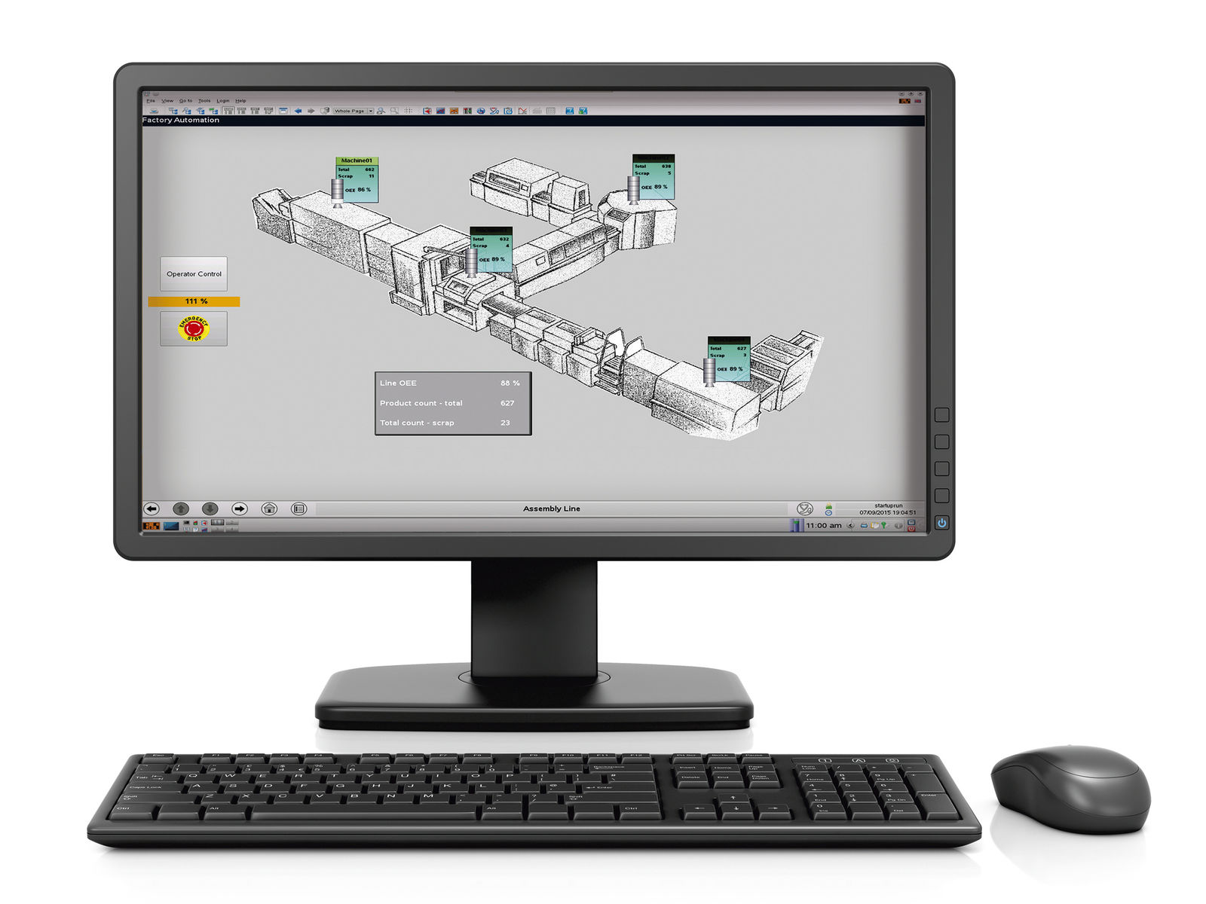
From the line overview, details for each machine are just a click away.

About B&R
B&R, a division of ABB Group, is a global leader in industrial automation headquartered in Austria. B&R combines state-of-the-art technology with advanced engineering to provide customers in virtually every industry with complete solutions for machine and factory automation, motion control, HMI and integrated safety technology. With Industrial IoT communication standards including OPC UA, POWERLINK and openSAFETY as well as its Automation Studio software, B&R is constantly redefining the future of automation engineering. The innovative spirit that keeps B&R at the forefront of industrial automation is driven by a commitment to simplifying processes and exceeding customer expectations.
For more information, visit www.br-automation.com.

