Complex kinematics, easy operation
New mapp components: Set up and control up to 15 axes
B&R has further expanded its portfolio of modular mapp software components. The new mapp RoboX and mapp Teach make it faster and easier than ever to get robotic systems configured and ready for operation.
mapp RoboX can be used to control any kinematic system with up to 15 axes. Developers enjoy complete design freedom while still benefiting from all the conveniences of mapp technology. The robot is simple to parameterize, with visualization and diagnostics already on board. This saves valuable time, both in development and during operation.
Fast commissioning
For the next step there is mapp Teach, which provides intuitive teach-in functionality to define and manage the robot's movement sequences and get it up and running in no time.
Fast development
mapp technology consists of individually encapsulated blocks that streamline development of new applications. The components provide basic functionality that can be configured graphically – cutting development times by an average of 67%. All mapp components are connected via mapp links. Each mapp component retrieves the data it needs from other components using a client-server model.

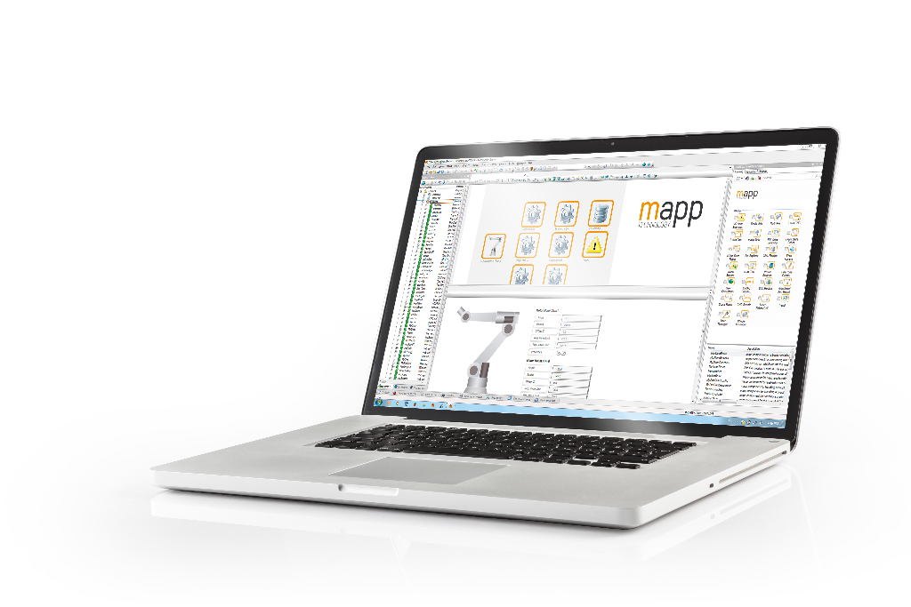
The new mapp RoboX and mapp Teach make it faster and easier than ever to get robotic systems configured and ready for operation.

About B&R
B&R, a division of ABB Group, is a global leader in industrial automation headquartered in Austria. B&R combines state-of-the-art technology with advanced engineering to provide customers in virtually every industry with complete solutions for machine and factory automation, motion control, HMI and integrated safety technology. With Industrial IoT communication standards including OPC UA, POWERLINK and openSAFETY as well as its Automation Studio software, B&R is constantly redefining the future of automation engineering. The innovative spirit that keeps B&R at the forefront of industrial automation is driven by a commitment to simplifying processes and exceeding customer expectations.
For more information, visit www.br-automation.com.

