Control system for mobile automation
B&R presents new product line at bauma
At this year's bauma, B&R will be presenting its newly developed modular control and I/O system for mobile automation. Another highlight at Booth 314 in Hall A3 will be B&R's revolutionary mapp technology, which accelerates software development by an average of 67%.
mapp technology simplifies development by encapsulating functionality in modular components. Simply drag-and-drop components into the application to create alarm systems, recipe systems and much more – and then configure them with a few clicks. In addition to cutting development time, this also improves both the quality and reusability of the software. mapp technology is fully compatible with the new control and I/O system for mobile automation.
Safety included
Users will also enjoy unrestricted access to integrated safety technology and comprehensive diagnostics. The open POWERLINK bus protocol makes it possible to transmit all the data via a single backbone network.

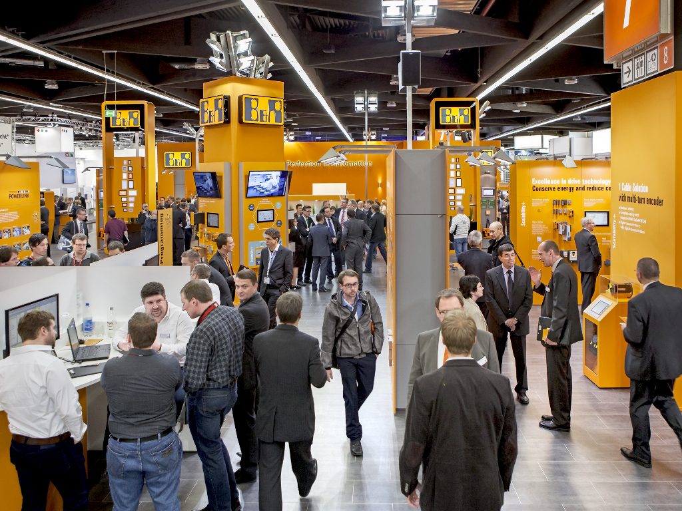
At this year's bauma, B&R will be presenting its newly developed modular control and I/O system for mobile automation.

About B&R
B&R, a division of ABB Group, is a global leader in industrial automation headquartered in Austria. B&R combines state-of-the-art technology with advanced engineering to provide customers in virtually every industry with complete solutions for machine and factory automation, motion control, HMI and integrated safety technology. With Industrial IoT communication standards including OPC UA, POWERLINK and openSAFETY as well as its Automation Studio software, B&R is constantly redefining the future of automation engineering. The innovative spirit that keeps B&R at the forefront of industrial automation is driven by a commitment to simplifying processes and exceeding customer expectations.
For more information, visit www.br-automation.com.

