Solutions for smart machines and factories
B&R presents an array of innovations at the 2016 Hannover Messe
The road to the smart factories, networked machines and efficient processes of Industry 4.0 leads through uncharted territory. With the innovations and updates B&R will be presenting at the 2016 Hannover Messe (Hall 9, Booth D28), the automation specialists offer a vision and a roadmap to get there quickly, smoothly and sustainably.
With a host of new mapp components, B&R continues to lead the way in modular, fast and secure programming for intelligent, fully networked machines and plants. The new mapp CodeBox, for example, allows machine functions to be added or modified without having to reopen the original project in a development tool.
Web meets automation
The new 100% web-based HMI solution – mapp View – offers all the functionality you'll need for human-machine communication in tomorrow's smart factory. Automation engineers can easily create user interfaces that display perfectly on any device or operating system.
B&R will also be presenting new functions for its ACOPOS P3 servo drives and other solutions on the topics of Industry 4.0 and predictive maintenance.

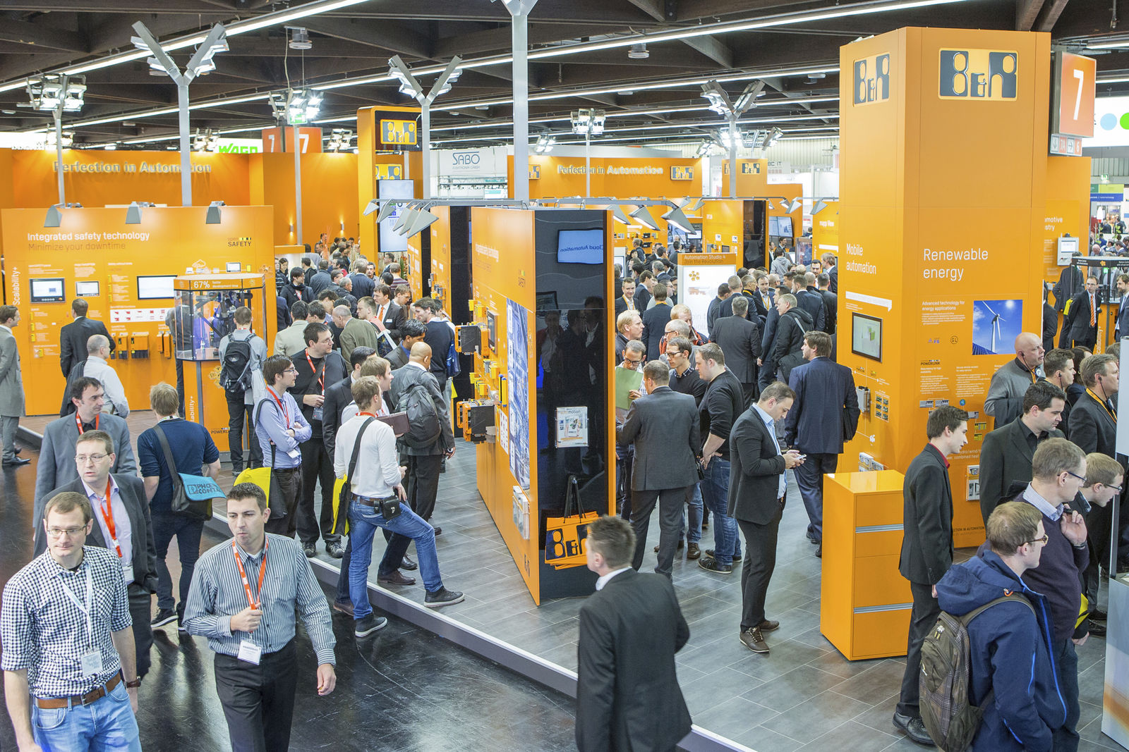
At the Hannover Messe, B&R will be presenting an array of innovations that pave the way to Industry 4.0.

About B&R
B&R, a division of ABB Group, is a global leader in industrial automation headquartered in Austria. B&R combines state-of-the-art technology with advanced engineering to provide customers in virtually every industry with complete solutions for machine and factory automation, motion control, HMI and integrated safety technology. With Industrial IoT communication standards including OPC UA, POWERLINK and openSAFETY as well as its Automation Studio software, B&R is constantly redefining the future of automation engineering. The innovative spirit that keeps B&R at the forefront of industrial automation is driven by a commitment to simplifying processes and exceeding customer expectations.
For more information, visit www.br-automation.com.

