B&R invests in openness
Modular and safety devices from 3rd-party vendors are now even easier to integrate
With POWERLINK, it's easy to integrate many different 3rd-party devices into B&R automation solutions. The same now applies to safety components with an openSAFETY interface as well as modular devices. This makes implementing multi-vendor applications easier than ever.
Manufacturer-independent safety technology
OEMs often combine safety components from different vendors to create a safety solution. With Automation Studio, any openSAFETY device can be seamlessly integrated and configured using a device description file. This extends B&R's support for optimal integration of 3rd-party safety devices such as light curtains, rotary encoders, laser scanners and drives.
The same applies to modular devices, which can be connected and configured using the graphical editor in Automation Studio. This improves clarity and makes commissioning of the entire system more efficient.
Automatic firmware updates
Another big step in usability is the expansion of B&R's proven firmware handling function to include all 3rd-party POWERLINK and openSAFETY devices. The firmware on these devices is now updated automatically at startup and can also be manually reverted to an earlier version if necessary.

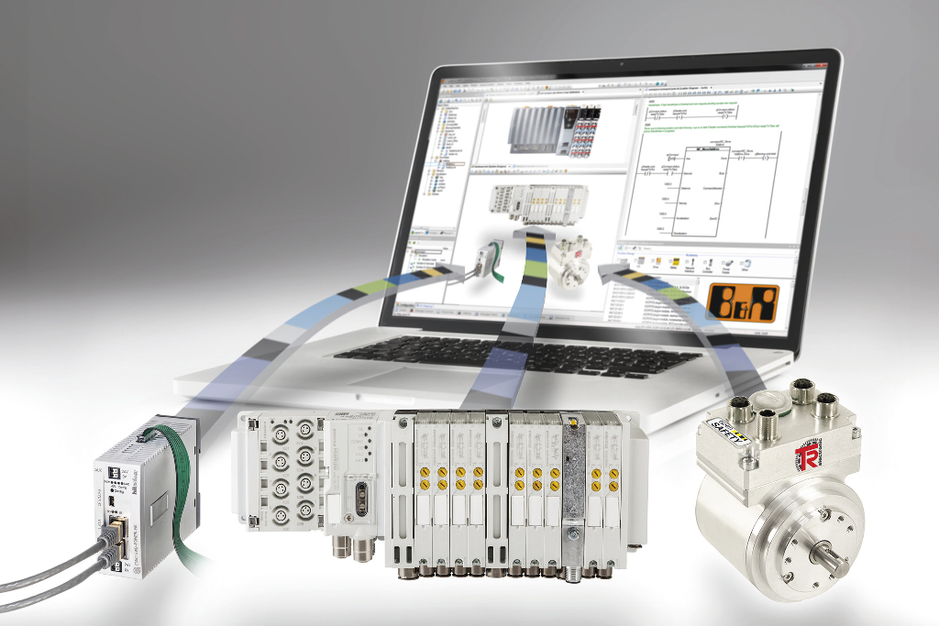
With POWERLINK, it's easy to integrate many different 3rd-party devices into B&R automation solutions.

About B&R
B&R, a division of ABB Group, is a global leader in industrial automation headquartered in Austria. B&R combines state-of-the-art technology with advanced engineering to provide customers in virtually every industry with complete solutions for machine and factory automation, motion control, HMI and integrated safety technology. With Industrial IoT communication standards including OPC UA, POWERLINK and openSAFETY as well as its Automation Studio software, B&R is constantly redefining the future of automation engineering. The innovative spirit that keeps B&R at the forefront of industrial automation is driven by a commitment to simplifying processes and exceeding customer expectations.
For more information, visit www.br-automation.com.

