First field device with OPC UA and Pub/Sub
B&R adds the vendor-independent communication protocol to their X20 I/O system
B&R made an announcement at the Hannover Messe confirming development of the world's first field device for OPC UA. The new X20 I/O system bus controller makes it possible to implement OPC UA communication from the sensor layer to the ERP layer without any interfaces whatsoever.
Pub/Sub for efficient data transfer
The X20BC008U bus controller functions as an OPC UA server and provides all information about connected I/O modules to OPC UA clients from any manufacturer. This includes, for example, controllers, SCADA systems, ERP systems or cloud applications.
Interfaces, gateways and the associated loss of information are a thing of the past. All production process data is transferred using a single protocol. With the new publish-subscribe model (Pub/Sub), data can be distributed in a very efficient manner. The X20BC008U bus controller can be used with all controllers and I/O modules from the X20 and X67 product lines without limitations.

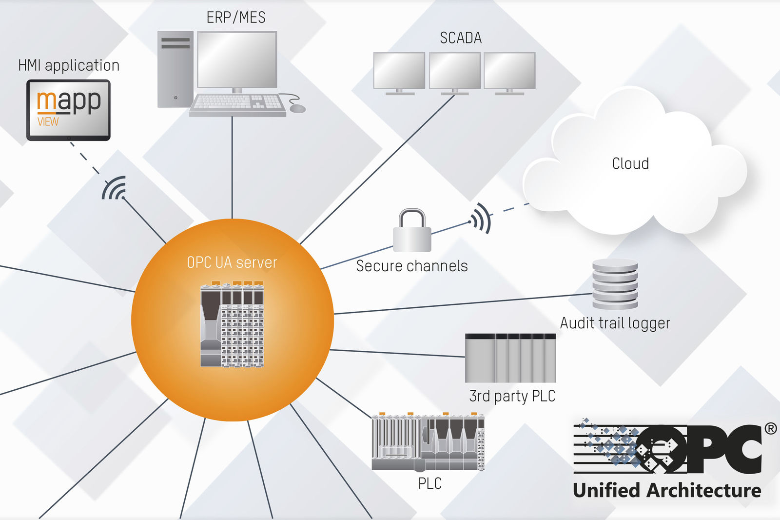
The X20BC008U bus controller collects data from connected I/O modules, and functions as an OPC UA server that provides this information to OPC UA clients from any manufacturer.

About B&R
B&R, a division of ABB Group, is a global leader in industrial automation headquartered in Austria. B&R combines state-of-the-art technology with advanced engineering to provide customers in virtually every industry with complete solutions for machine and factory automation, motion control, HMI and integrated safety technology. With Industrial IoT communication standards including OPC UA, POWERLINK and openSAFETY as well as its Automation Studio software, B&R is constantly redefining the future of automation engineering. The innovative spirit that keeps B&R at the forefront of industrial automation is driven by a commitment to simplifying processes and exceeding customer expectations.
For more information, visit www.br-automation.com.

