Intelligent housing design for streamlined service
Operator terminal for automotive production
B&R has developed a new operator terminal tailored to the needs of maintenance experts and service technicians in the field of automotive production. It offers fast and easy access to the display, industrial PC and operating elements. Operators can replace individual components without stopping the line, or quickly upgrade to a more powerful industrial PC.
Replace units independently
The new operator terminal comprises two independent units: The PC unit and the expansion unit. With four quick-release fasteners, service personnel can quickly open the rear access panel to reach the cables for the display and PC. The expansion unit is also readily accessible. The PC and expansion units have separate power supplies, so the safety circuit for the line remains closed when replacing the HMI hardware.
Compact, flexible design
The PC and expansion units are integrated in a sleek housing and can be adapted to the operating standards in place at the respective factory. With a display size of 15", the outer dimensions of the entire assembly are 442 x 511 x 86 millimeters. The swing arm flange can be installed on the top or bottom to allow for either pendant or pedestal mounting. The mounting orientation can also be changed on site.

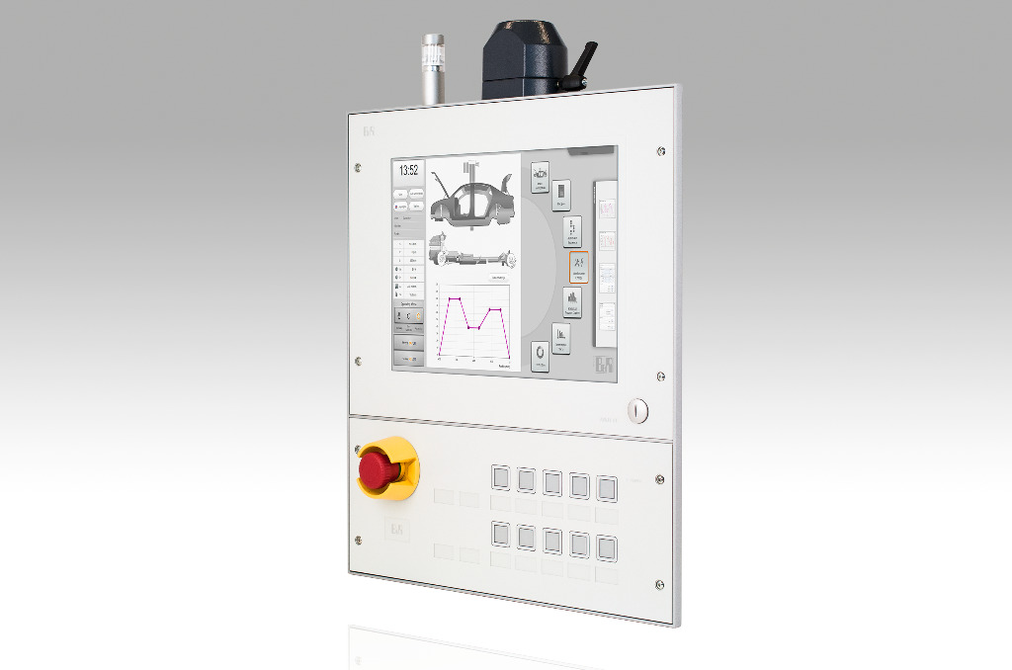
Service-friendly B&R operator terminal. A rear access panel with four quick-release fasteners provides easy access to the PC and expansion units.

About B&R
B&R, a division of ABB Group, is a global leader in industrial automation headquartered in Austria. B&R combines state-of-the-art technology with advanced engineering to provide customers in virtually every industry with complete solutions for machine and factory automation, motion control, HMI and integrated safety technology. With Industrial IoT communication standards including OPC UA, POWERLINK and openSAFETY as well as its Automation Studio software, B&R is constantly redefining the future of automation engineering. The innovative spirit that keeps B&R at the forefront of industrial automation is driven by a commitment to simplifying processes and exceeding customer expectations.
For more information, visit www.br-automation.com.

