B&R opens new office in Mumbai
Always near the customers
B&R has opened a new office in Mumbai. The new facility is located in Thane’s industrial belt and will cater to the areas in and around Mumbai with the help of a complete team from sales, application, support and training. This expansion is a part of company’s growth strategy for the Indian market and philosophy to be near the customers.
P V Sivaram, Managing Director, B&R India said, “We always believe in delivering best of the technologies, professional consultation and expert application support to our customers, that’s why our direct office will benefit numerous machine builders and manufacturers in this region”.
B&R has also announced recently its foray into process & factory automation business in India. An automation specialist and a leader in innovative technologies, B&R now offers complete solution for smart machines and smart factories. B&R India has its head-office at Pune and six other offices in India. The global headquarters as well as the manufacturing center is at Eggelsberg, Austria.

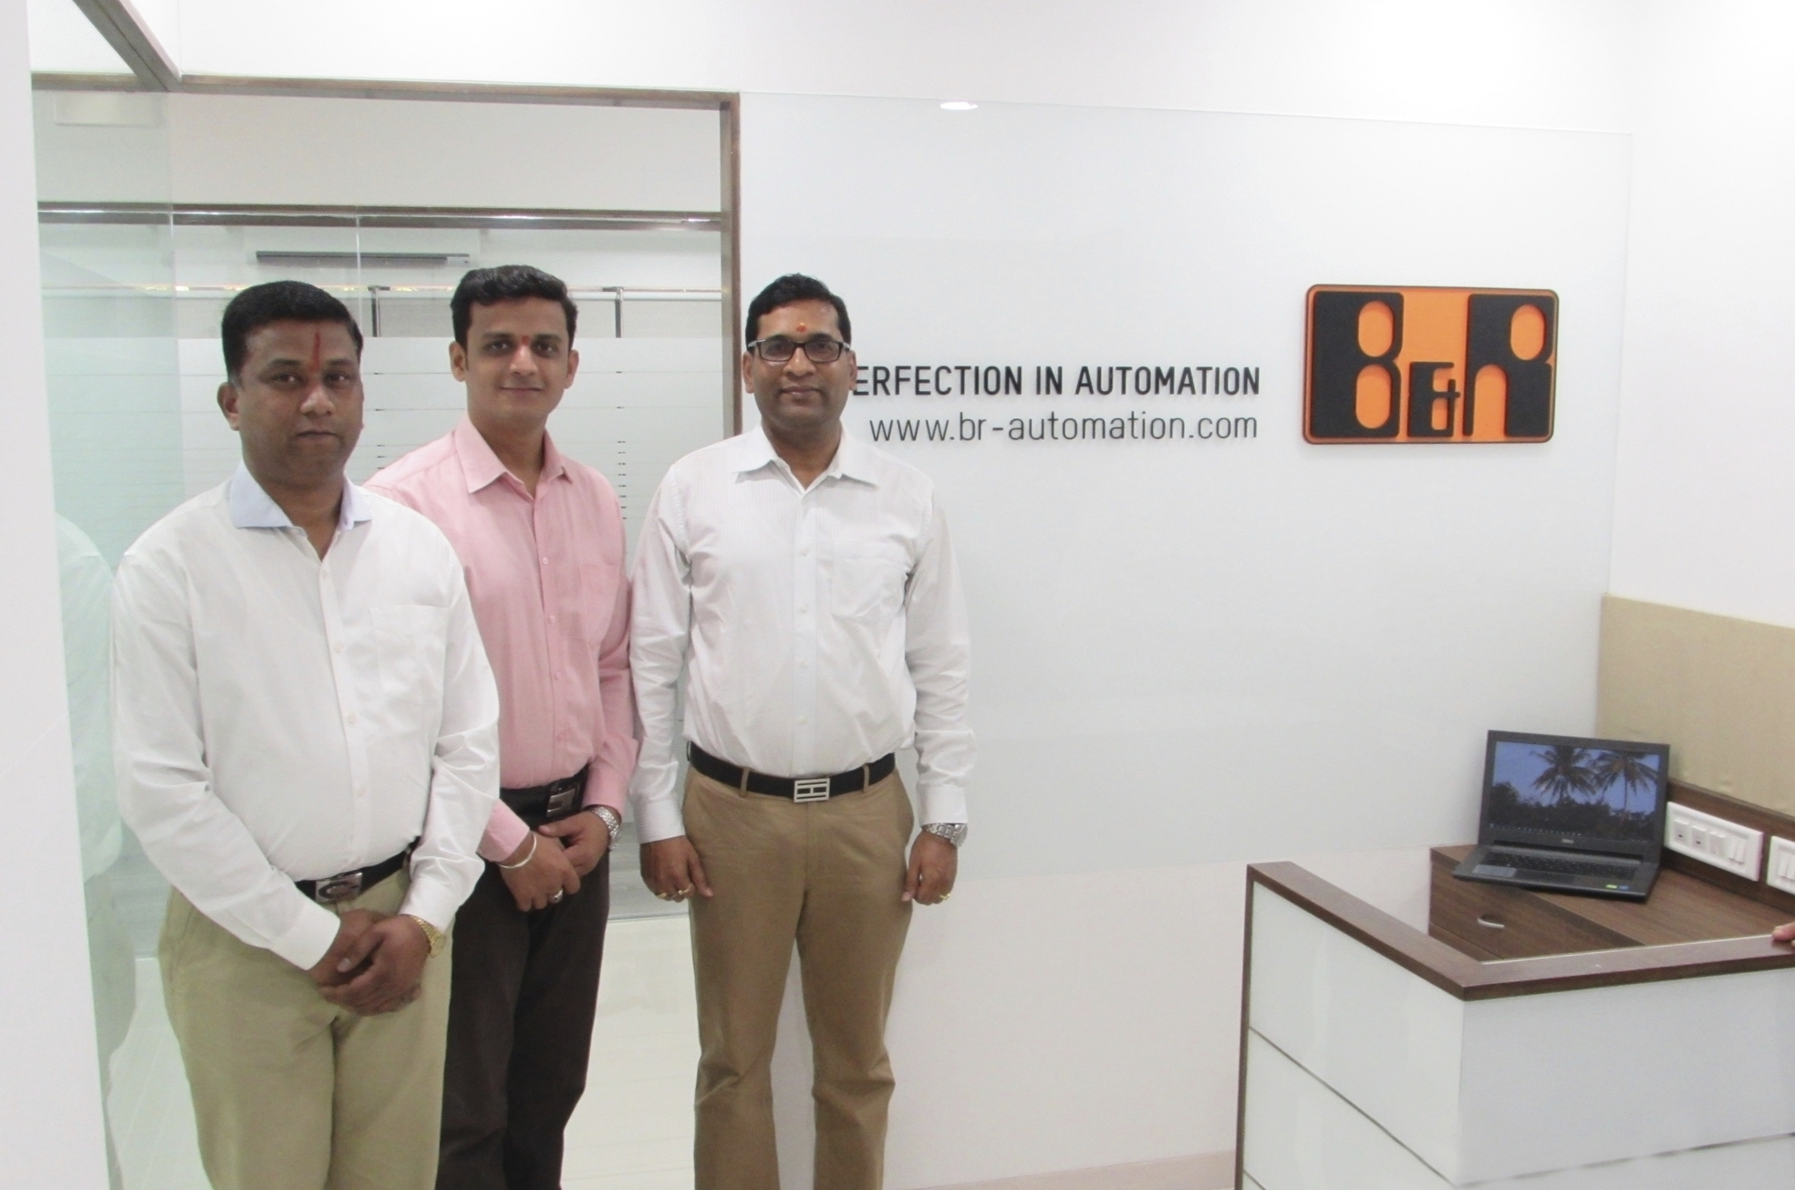
B&R team Mumbai is all set and excited to serve its customers
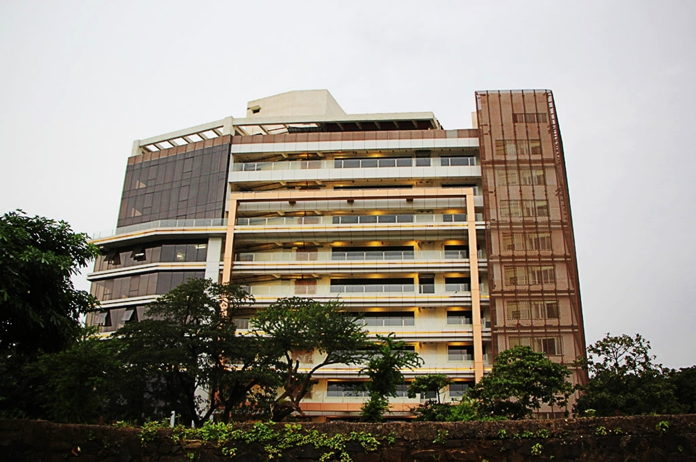
B&R office is located at Odyssey IT Park, Wagle Estate, Thane

About B&R
B&R, a division of ABB Group, is a global leader in industrial automation headquartered in Austria. B&R combines state-of-the-art technology with advanced engineering to provide customers in virtually every industry with complete solutions for machine and factory automation, motion control, HMI and integrated safety technology. With Industrial IoT communication standards including OPC UA, POWERLINK and openSAFETY as well as its Automation Studio software, B&R is constantly redefining the future of automation engineering. The innovative spirit that keeps B&R at the forefront of industrial automation is driven by a commitment to simplifying processes and exceeding customer expectations.
For more information, visit www.br-automation.com.

