Smart manufacturing needs seamless networking
B&R at IEEE Industry Forum: Strategies for the implementation of smart factories
At the 2016 IEEE Industry Forum, representatives from industry, academia and politics met in Taiwan to discuss the topics of automation and smart manufacturing. B&R outlined ways that the requirements of tomorrow's intelligent production technology can be met with advanced automation solutions.
"To implement smart manufacturing, you need a seamless network throughout the entire factory. The tight integration between OPC UA, POWERLINK and openSAFETY makes it possible to provide full transparency all the way from the ERP system down to the sensor," says B&R's international sales manager Werner Paulin.
In presenting its intelligent automation solutions for machinery and equipment used in smart manufacturing, B&R stressed the importance of being able to simulate every aspect of the automation system. Not only does this make work easier for software developers, it also improves efficiency and shortens time to market.

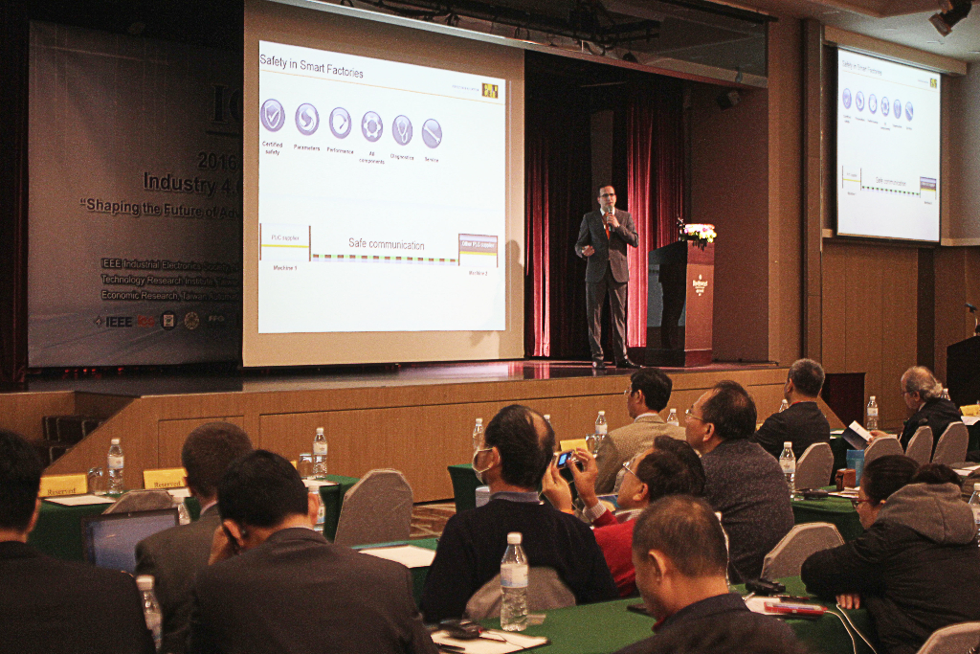
The IEEE Industry Forum is an informative platform for representatives from industry, academia and politics. (Source: B&R)

About B&R
B&R, a division of ABB Group, is a global leader in industrial automation headquartered in Austria. B&R combines state-of-the-art technology with advanced engineering to provide customers in virtually every industry with complete solutions for machine and factory automation, motion control, HMI and integrated safety technology. With Industrial IoT communication standards including OPC UA, POWERLINK and openSAFETY as well as its Automation Studio software, B&R is constantly redefining the future of automation engineering. The innovative spirit that keeps B&R at the forefront of industrial automation is driven by a commitment to simplifying processes and exceeding customer expectations.
For more information, visit www.br-automation.com.

