B&R posts double-digit growth
Automation specialist continues to outpace market growth
B&R recorded sales of €585 million in 2015 for an impressive 10% growth over the previous year. "We are proud to be the world's largest privately owned company in the field of industrial control and monitoring."
The B&R workforce continues to grow as well. By the end of 2015, B&R had a total of 2,820 employees around the world – 170 more than the previous year. "We've invested heavily in expanding our sales network, particularly in the US," emphasized Gucher.
Strong in the States
B&R's presence in the partner country of this year's Hannover Messe dates back to 1987 and has since grown into a nationwide network of 25 offices. The US has contributed a steadily increasing share of B&R's sales over the years, currently representing 16%of the company's total revenue.
Expansion in process control
"In addition to our geographic growth," added Gucher, "we're also reaching into new market segments." Over the past few months, B&R has continued to roll out its APROL process control system across Asia and Europe. "After years of steadily building up our team of process and factory automation experts, we're now perfectly positioned to make big advances in these areas."
Intelligent transport system powered by linear motors
B&R has a long history of pioneering new trends in automation technology. In addition to its groundbreaking web-based HMI solution – mapp View – B&R's Hannover Messe highlights also include a highly flexible intelligent transport solution based on linear motor technology that will play a key role in future smart manufacturing solutions.
"This technology represents a huge leap in flexibility for in-plant logistics," explained Gucher. "Compared to a conventional conveyor system with chains and belts, our solution is nothing short of a complete reinvention of how products move through the plant." Customers will profit from higher production speeds, increased productivity, greater flexibility and lower maintenance costs – thanks to B&R's commitment to truly industrial design quality.

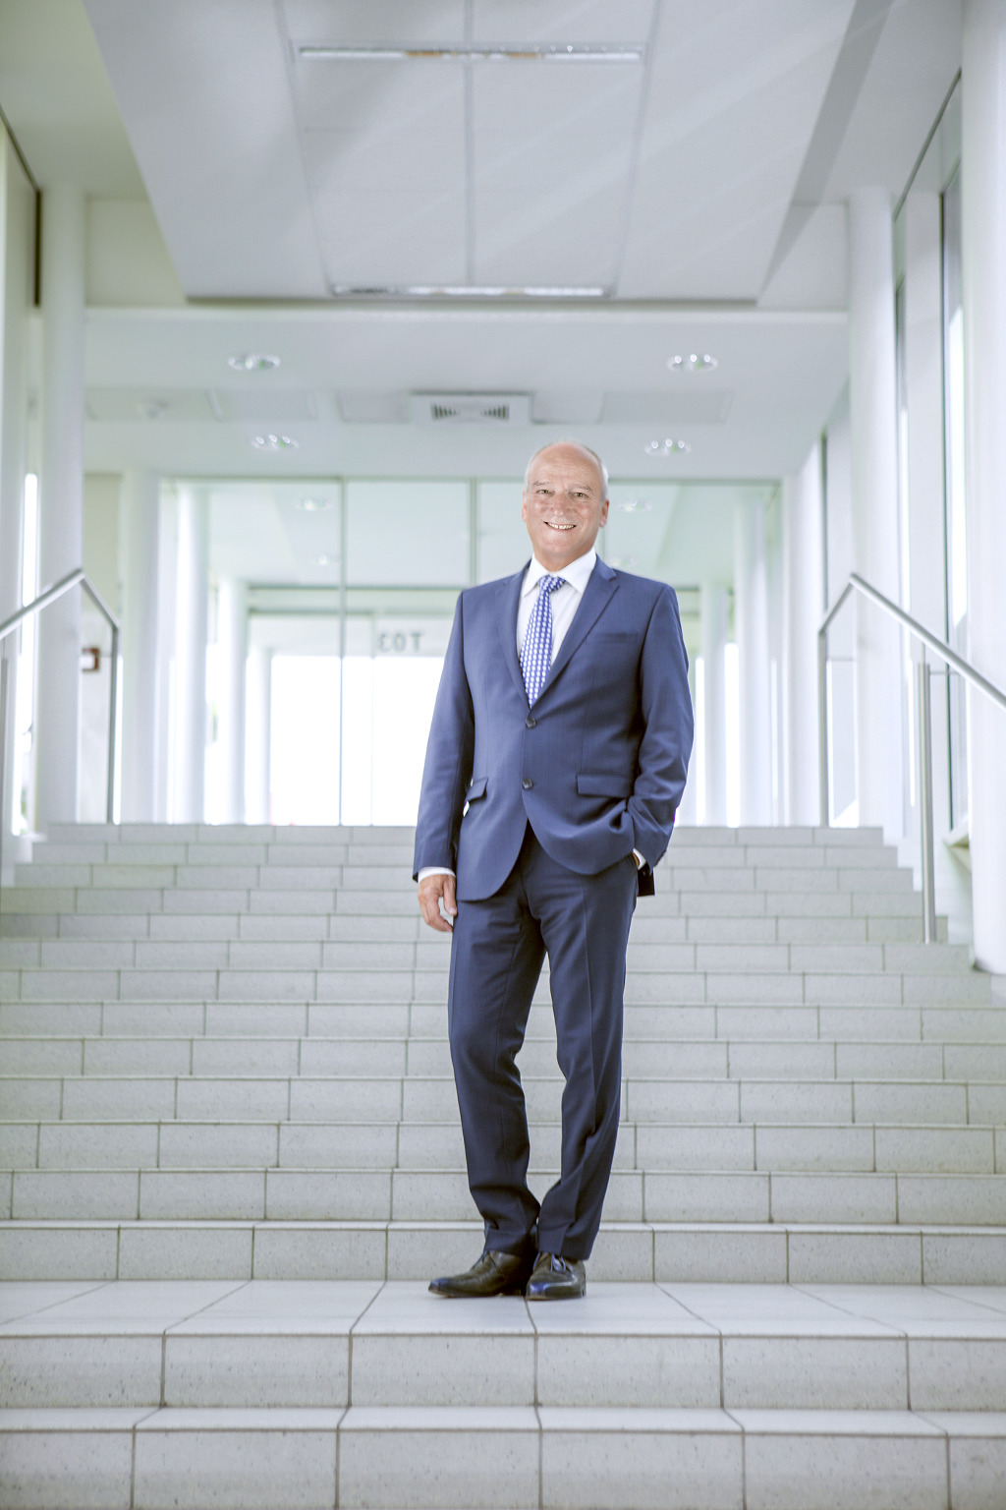
General Manager Peter Gucher announced the company's 2015 figures at the B&R press conference in Hanover: €585 million in sales.
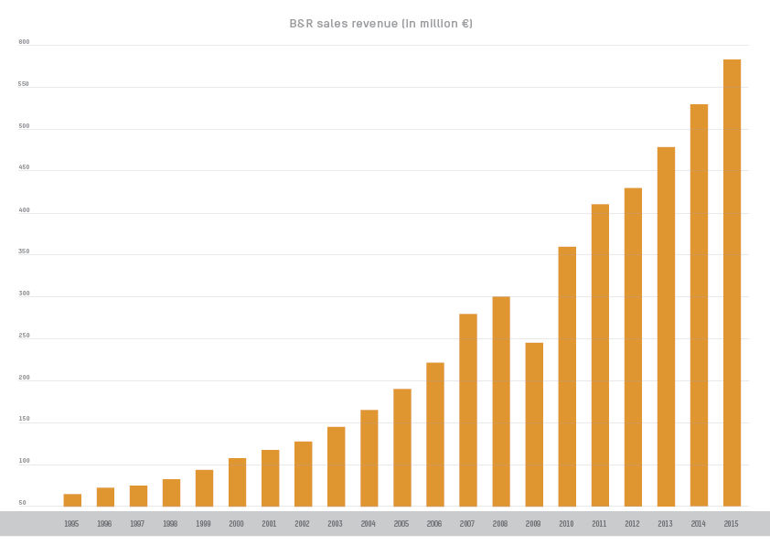
That's a double-digit increase over the previous year.

B&R Hakkında
ABB Grubunun bir bölümü olan B&R, merkezi Avusturya'da bulunan endüstriyel otomasyon alanında global bir liderdir. B&R, neredeyse her sektördeki müşterilere makine ve fabrika otomasyonu, hareket kontrolü, HMI ve entegre güvenlik teknolojisi için eksiksiz çözümler sunmak üzere en son teknolojiyi ileri mühendislikle birleştiriyor. OPC UA, POWERLINK ve openSAFETY gibi Endüstriyel IoT iletişim standartlarının yanı sıra Automation Studio yazılımıyla B&R, otomasyon mühendisliğinin geleceğini sürekli olarak yeniden tanımlıyor. B&R'ı endüstriyel otomasyonun ön saflarında tutan yenilikçi ruh, süreçleri basitleştirme ve müşteri beklentilerini aşma taahhüdünden kaynaklanmaktadır.
Daha fazla bilgi için www.br-automation.com adresini ziyaret edin.

