Next generation industrial transport technology
B&R focuses on best-in-class reliability and easy service
B&R's low-maintenance technology is based on 14 years of field experience and offers the industry-proven reliability required for today’s competitive 24/7 production environments. The systems are designed for extremely low MTTR rates and ensure maximum uptime. Segments and movers can be easily exchanged without disassembling the track.
Scalability and seamless robotic integration
In the era of smart manufacturing, integration of automation and IT ecosystems is no longer an option but an absolute requirement. Low-latency, hard real-time synchronization with all types of servo axes including CNC and robotic systems guarantees high-precision, high-quality production output. B&R's transport technology is based on a highly decentralized architecture that allows extensive track lengths to accommodate the requirements of any machine.
Collaboration with ATS
B&R is using the SuperTrak linear track conveyance system from the Canadian company ATS Automation in order to advance the next generation of industrial transport technology and strongly enhance the market penetration of this exciting technology. With many years of practical experience implementing its SuperTrak technology, ATS perfectly complements B&R's automation expertise and core competencies in signal and power electronics, motor design and software.

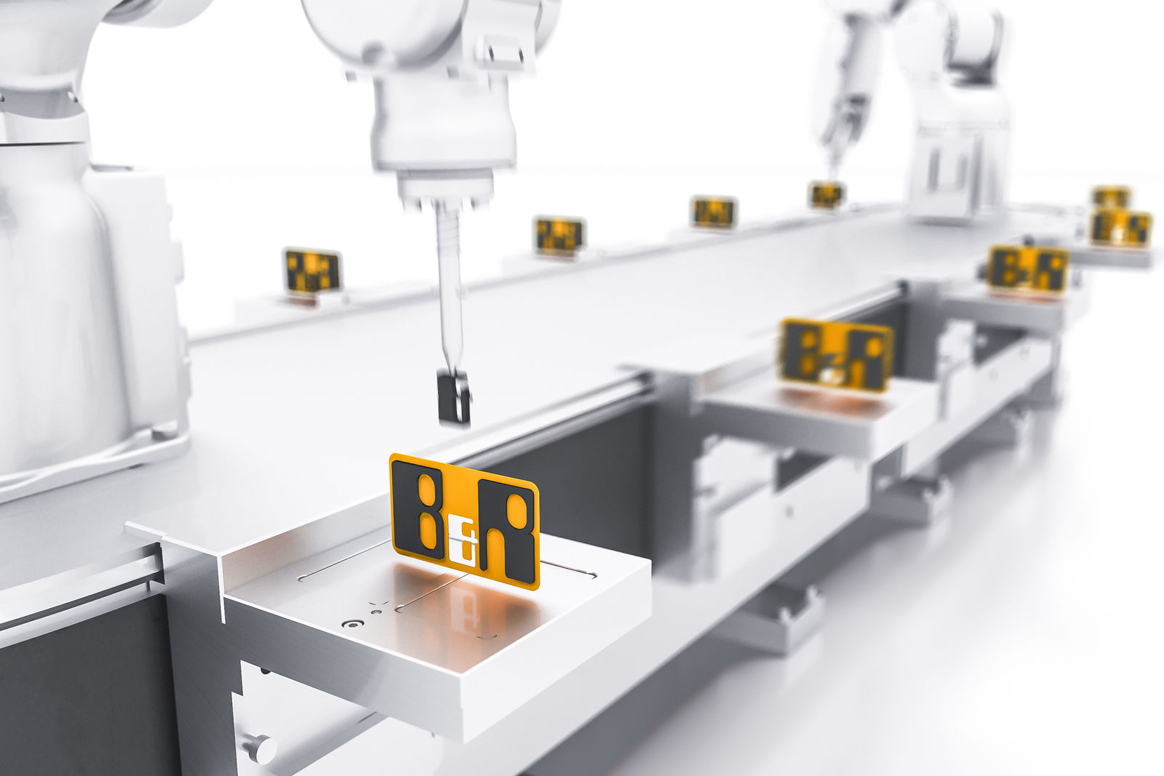
B&R's service-friendly intelligent transport technology combines optimized productivity and flexibility with industrial-grade reliability to ensure maximum uptime.

About B&R
B&R, a division of ABB Group, is a global leader in industrial automation headquartered in Austria. B&R combines state-of-the-art technology with advanced engineering to provide customers in virtually every industry with complete solutions for machine and factory automation, motion control, HMI and integrated safety technology. With Industrial IoT communication standards including OPC UA, POWERLINK and openSAFETY as well as its Automation Studio software, B&R is constantly redefining the future of automation engineering. The innovative spirit that keeps B&R at the forefront of industrial automation is driven by a commitment to simplifying processes and exceeding customer expectations.
For more information, visit www.br-automation.com.

