Next generation industrial transport technology
B&R focuses on best-in-class reliability and easy service
B&R's low-maintenance technology is based on 14 years of field experience and offers the industry-proven reliability required for today’s competitive 24/7 production environments. The systems are designed for extremely low MTTR rates and ensure maximum uptime. Segments and movers can be easily exchanged without disassembling the track.
Scalability and seamless robotic integration
In the era of smart manufacturing, integration of automation and IT ecosystems is no longer an option but an absolute requirement. Low-latency, hard real-time synchronization with all types of servo axes including CNC and robotic systems guarantees high-precision, high-quality production output. B&R's transport technology is based on a highly decentralized architecture that allows extensive track lengths to accommodate the requirements of any machine.
Collaboration with ATS
B&R is using the SuperTrak linear track conveyance system from the Canadian company ATS Automation in order to advance the next generation of industrial transport technology and strongly enhance the market penetration of this exciting technology. With many years of practical experience implementing its SuperTrak technology, ATS perfectly complements B&R's automation expertise and core competencies in signal and power electronics, motor design and software.

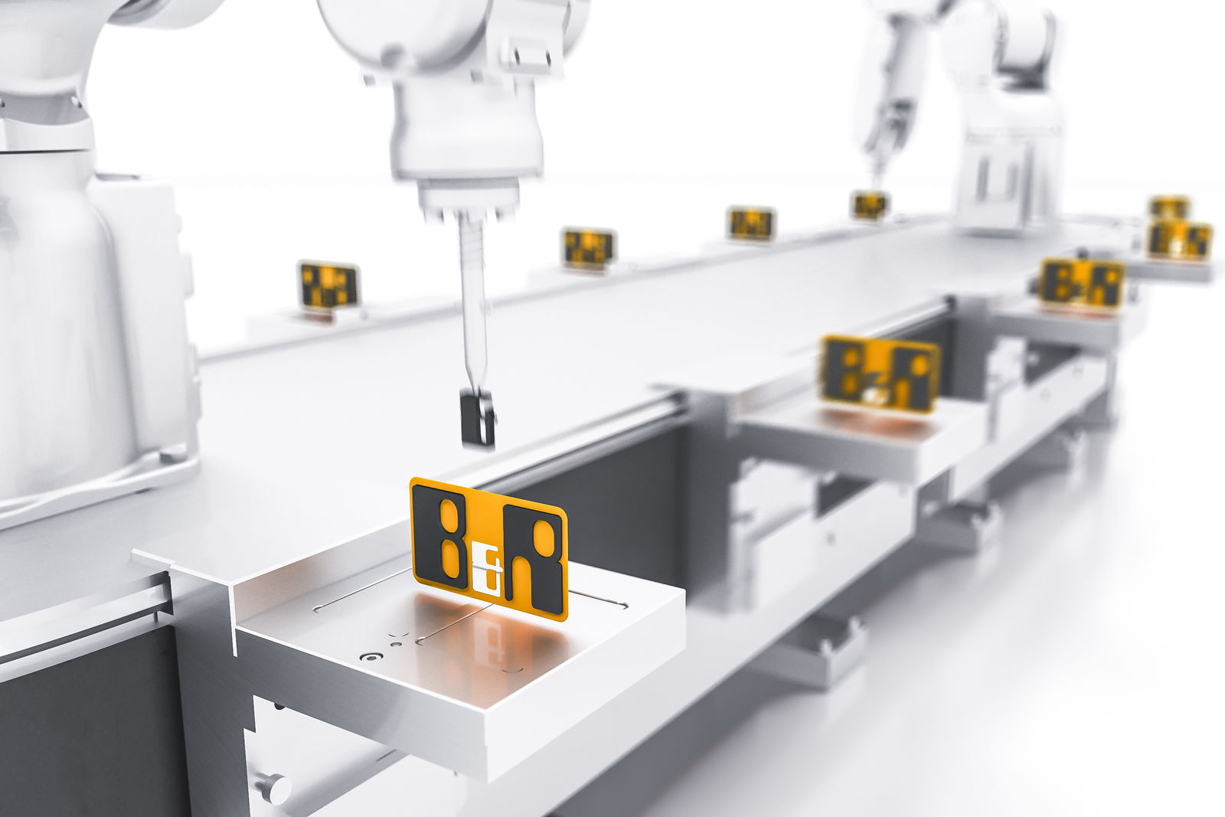
B&R's service-friendly intelligent transport technology combines optimized productivity and flexibility with industrial-grade reliability to ensure maximum uptime.

B&R Hakkında
ABB Grubunun bir bölümü olan B&R, merkezi Avusturya'da bulunan endüstriyel otomasyon alanında global bir liderdir. B&R, neredeyse her sektördeki müşterilere makine ve fabrika otomasyonu, hareket kontrolü, HMI ve entegre güvenlik teknolojisi için eksiksiz çözümler sunmak üzere en son teknolojiyi ileri mühendislikle birleştiriyor. OPC UA, POWERLINK ve openSAFETY gibi Endüstriyel IoT iletişim standartlarının yanı sıra Automation Studio yazılımıyla B&R, otomasyon mühendisliğinin geleceğini sürekli olarak yeniden tanımlıyor. B&R'ı endüstriyel otomasyonun ön saflarında tutan yenilikçi ruh, süreçleri basitleştirme ve müşteri beklentilerini aşma taahhüdünden kaynaklanmaktadır.
Daha fazla bilgi için www.br-automation.com adresini ziyaret edin.

