Integrated safety technology in a compact unit
B&R servo actuator with advanced safety functions
B&R now offers its compact ACOPOSmotor servo actuator with integrated network-based safety functions. Advanced safety solutions can now be implemented with minimum space requirements. ACOPOSmotor safety functions are certified up to SIL 3 / PL e / Cat 4.
Intelligent encoder system
For the encoder system, B&R uses safety encoders with an EnDat 2.2 interface. The digital encoders are resistant to interference and highly precise. Since they are mounted securely and each encoder is checked for adherence to installation guidelines, errors in the connection between encoder and motor shaft can be ruled out. Position data can therefore also be used for the safe absolute position.
Compact and robust
ACOPOSmotor units offer IP65-rated protection thanks to their fanless design and oil seal. Daisy chaining considerably reduces the number of cables required. The units are also extremely compact, because the electronics are cooled directly via the motor.

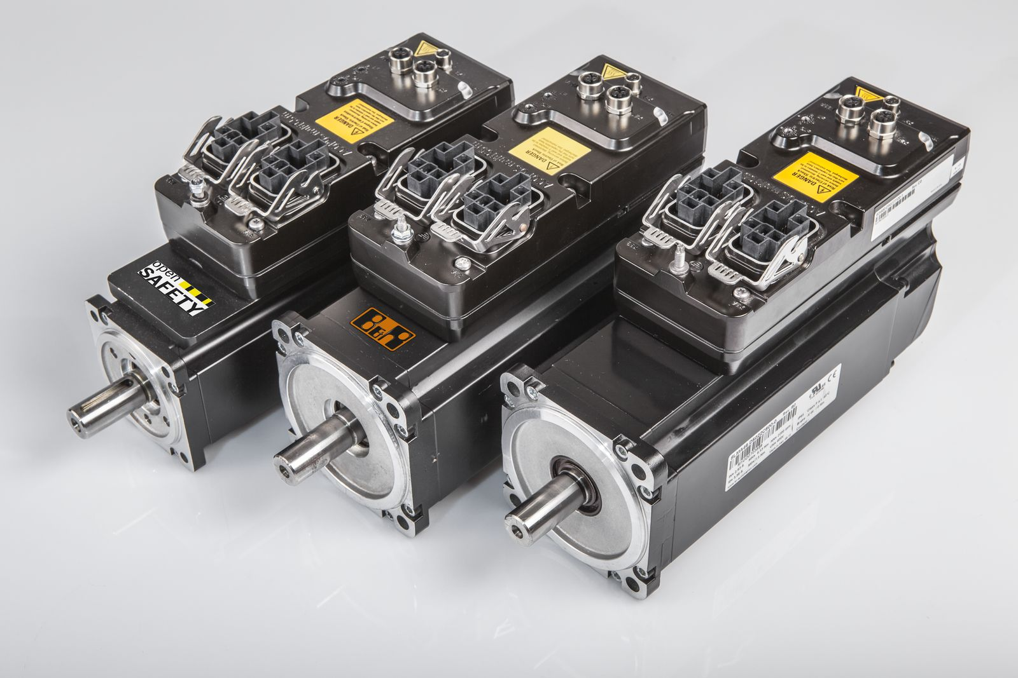
An ACOPOSmotor combines the motor, drive and safety technology in a single compact unit.

About B&R
B&R, a division of ABB Group, is a global leader in industrial automation headquartered in Austria. B&R combines state-of-the-art technology with advanced engineering to provide customers in virtually every industry with complete solutions for machine and factory automation, motion control, HMI and integrated safety technology. With Industrial IoT communication standards including OPC UA, POWERLINK and openSAFETY as well as its Automation Studio software, B&R is constantly redefining the future of automation engineering. The innovative spirit that keeps B&R at the forefront of industrial automation is driven by a commitment to simplifying processes and exceeding customer expectations.
For more information, visit www.br-automation.com.

