Automation Studio receives Industrial Usability Award
B&R makes hardware configuration user friendly
For its especially user-friendly approach to hardware configuration, System Designer was distinguished with 1st place by the Industrial Usability Award jury. Incorporated in the B&R Automation Studio development environment, System Designer helps developers configure a project's automation hardware quickly and error-free. The photorealistic topology view shows the hardware just as it will appear in the control cabinet. This earns it extra points for usability and makes work easier for the tool's various user groups.
Clear overview of complex architectures
Having a clear overview of a system's architecture, especially a complex one, is particularly helpful when it comes time to make changes. "It makes a developer's work considerably easier," says Dr. Gernot Bachler, who heads B&R's automation software business unit. "They simply click-and-drag modules and devices from the well-sorted Hardware Catalog, and then place them either in the tree structure or in the 2D control cabinet view." The topology can then be labeled and printed.
Reduced costs, accelerated time to market
System Designer was developed in cooperation with usability expert Dr. Elke Deubzer from the PMO Institute for Usability Engineering and Organizational Development. "Intuitive, user-friendly interfaces help different user groups learn and execute their assigned tasks quickly and easily, ultimately reducing time-to-market," says Dr. Elke Deubzer.

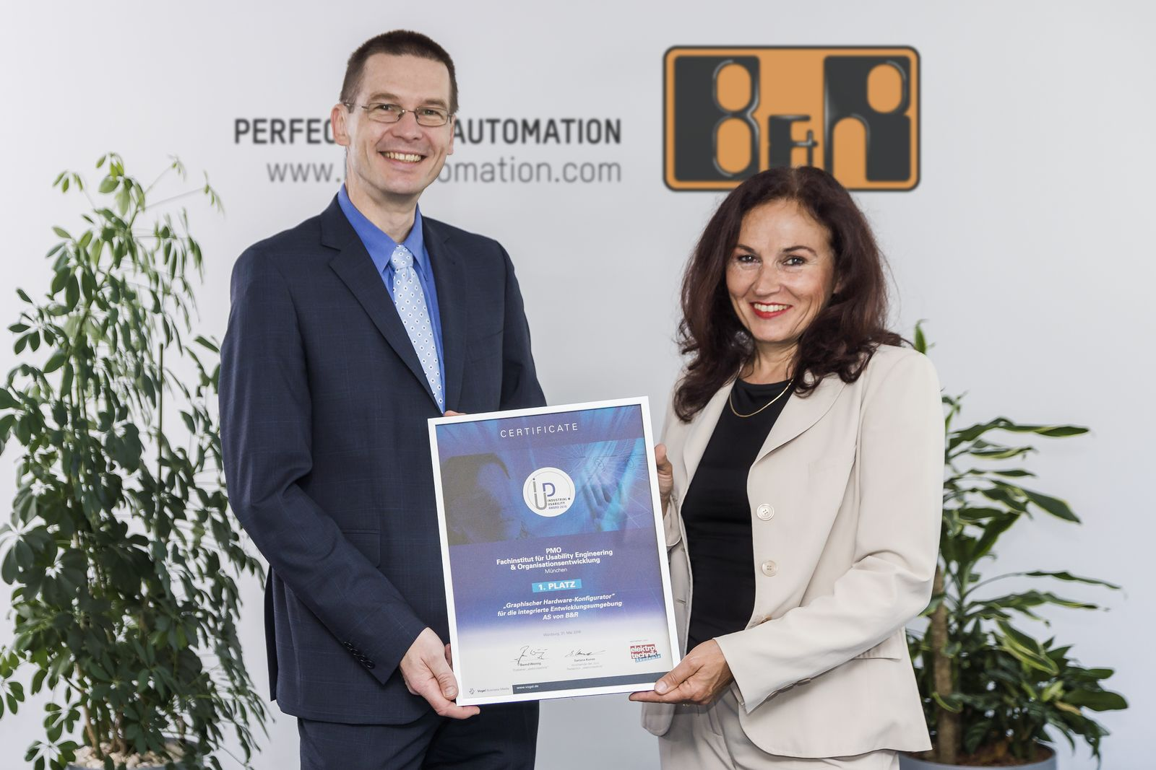
Industrial Usability Awards: 1st place goes to Automation Studio. Dr. Elke Deubzer (PMO) and Dr. Gernot Bachler (B&R) proudly display the award.

About B&R
B&R, a division of ABB Group, is a global leader in industrial automation headquartered in Austria. B&R combines state-of-the-art technology with advanced engineering to provide customers in virtually every industry with complete solutions for machine and factory automation, motion control, HMI and integrated safety technology. With Industrial IoT communication standards including OPC UA, POWERLINK and openSAFETY as well as its Automation Studio software, B&R is constantly redefining the future of automation engineering. The innovative spirit that keeps B&R at the forefront of industrial automation is driven by a commitment to simplifying processes and exceeding customer expectations.
For more information, visit www.br-automation.com.

