Intelligent automation solutions for Maritime 4.0
SMM: B&R presents its web-based HMI solution and integrated shipboard control system
In Hall B6, Booth 305 of the SMM trade fair, B&R will be presenting its new, 100% web-based HMI solution, mapp View, as well as its scalable APROL process control system. Solutions from the automation specialist help builders of machines and equipment create smart ships, networked machinery and efficient processes on the way to Maritime 4.0.
Web-based user interfaces made easy
The mapp View HMI solution enables any automation engineer to create web-based HMI applications without any knowledge of the underlying HTML5, CSS and JavaScript technology. Integrated visualization components provided by mapp View cover the full range of HMI functionality. These widgets are placed using drag-and-drop and then configured. Since the content and layout are independent of one another, the design can easily be changed at any time.
Big data: Efficiently filtering a flood of data
B&R will also be showing how fully integrated distributed control systems for smart ships can be implemented easily based on its APROL process control system. Users can choose from a selection of ready-to-use solutions for tasks such as process data acquisition, energy monitoring and condition monitoring. Or they can expand the application into a completely integrated distributed shipboard control system.
All of the vessel's operating data is collected, prepared and analyzed in the integrated business intelligence suite. This data can be presented in the form of interactive dashboards, graphics or reports, and can also be viewed on mobile devices.

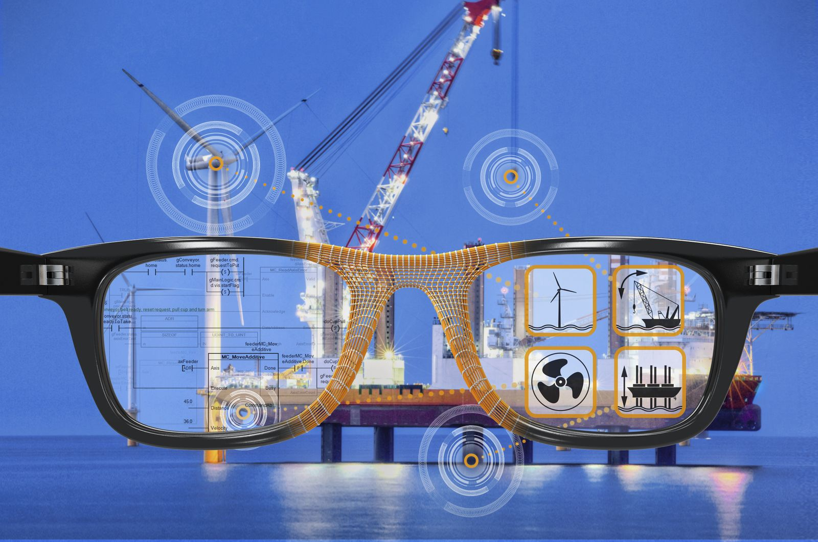
Among its highlights at the SMM in Hamburg, B&R will be showcasing its web-based HMI solution – mapp View – which allows developers to create modern user interfaces without having to know HTML.

About B&R
B&R, a division of ABB Group, is a global leader in industrial automation headquartered in Austria. B&R combines state-of-the-art technology with advanced engineering to provide customers in virtually every industry with complete solutions for machine and factory automation, motion control, HMI and integrated safety technology. With Industrial IoT communication standards including OPC UA, POWERLINK and openSAFETY as well as its Automation Studio software, B&R is constantly redefining the future of automation engineering. The innovative spirit that keeps B&R at the forefront of industrial automation is driven by a commitment to simplifying processes and exceeding customer expectations.
For more information, visit www.br-automation.com.

