Intelligent automation solutions for Maritime 4.0
SMM: B&R presents its web-based HMI solution and integrated shipboard control system
In Hall B6, Booth 305 of the SMM trade fair, B&R will be presenting its new, 100% web-based HMI solution, mapp View, as well as its scalable APROL process control system. Solutions from the automation specialist help builders of machines and equipment create smart ships, networked machinery and efficient processes on the way to Maritime 4.0.
Web-based user interfaces made easy
The mapp View HMI solution enables any automation engineer to create web-based HMI applications without any knowledge of the underlying HTML5, CSS and JavaScript technology. Integrated visualization components provided by mapp View cover the full range of HMI functionality. These widgets are placed using drag-and-drop and then configured. Since the content and layout are independent of one another, the design can easily be changed at any time.
Big data: Efficiently filtering a flood of data
B&R will also be showing how fully integrated distributed control systems for smart ships can be implemented easily based on its APROL process control system. Users can choose from a selection of ready-to-use solutions for tasks such as process data acquisition, energy monitoring and condition monitoring. Or they can expand the application into a completely integrated distributed shipboard control system.
All of the vessel's operating data is collected, prepared and analyzed in the integrated business intelligence suite. This data can be presented in the form of interactive dashboards, graphics or reports, and can also be viewed on mobile devices.

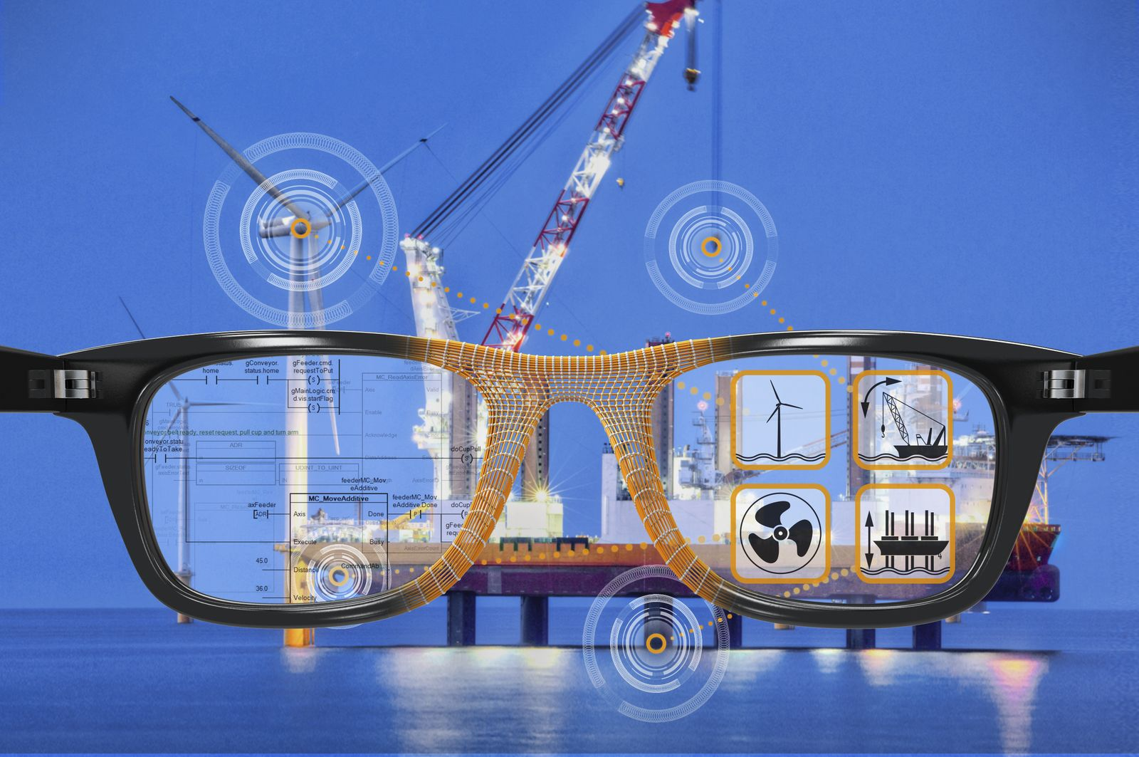
Among its highlights at the SMM in Hamburg, B&R will be showcasing its web-based HMI solution – mapp View – which allows developers to create modern user interfaces without having to know HTML.

B&R Hakkında
ABB Grubunun bir bölümü olan B&R, merkezi Avusturya'da bulunan endüstriyel otomasyon alanında global bir liderdir. B&R, neredeyse her sektördeki müşterilere makine ve fabrika otomasyonu, hareket kontrolü, HMI ve entegre güvenlik teknolojisi için eksiksiz çözümler sunmak üzere en son teknolojiyi ileri mühendislikle birleştiriyor. OPC UA, POWERLINK ve openSAFETY gibi Endüstriyel IoT iletişim standartlarının yanı sıra Automation Studio yazılımıyla B&R, otomasyon mühendisliğinin geleceğini sürekli olarak yeniden tanımlıyor. B&R'ı endüstriyel otomasyonun ön saflarında tutan yenilikçi ruh, süreçleri basitleştirme ve müşteri beklentilerini aşma taahhüdünden kaynaklanmaktadır.
Daha fazla bilgi için www.br-automation.com adresini ziyaret edin.

