More yield and less wear with ACOPOS P3
WindEnergy: B&R presents new solutions for azimuth control
At the WindEnergy expo in Hamburg (Hall B6, Booth B6.393), B&R will be demonstrating how wind turbine wear can be minimized through optimal yaw control. This is made possible by intelligent control concepts based on the ACOPOS P3 servo drive.
The ACOPOS P3 is designed to operate flawlessly under harsh offshore conditions such as continuous 1 g vibrations. The coated circuit boards are impervious to humid, salty air.
Software development fast and easy
Using the modular software blocks of mapp Technology, wind turbine manufacturers can implement active yaw systems with minimal time and effort. "Joined by intelligent links, mapp components make software development easier and faster. By placing a wide variety of standard functions at your fingertips with only a few configurations to make, mapp eliminates many potential sources of error," explains Peter Kronberger, B&R's global technology manager for the energy industry.
Central acquisition of data
APROL PDA is an open and scalable system for process data acquisition. All the data generated by a wind turbine is collected seamlessly in a central location. To see what other advantages B&R's data logger has to offer, stop by the booth for a demonstration.

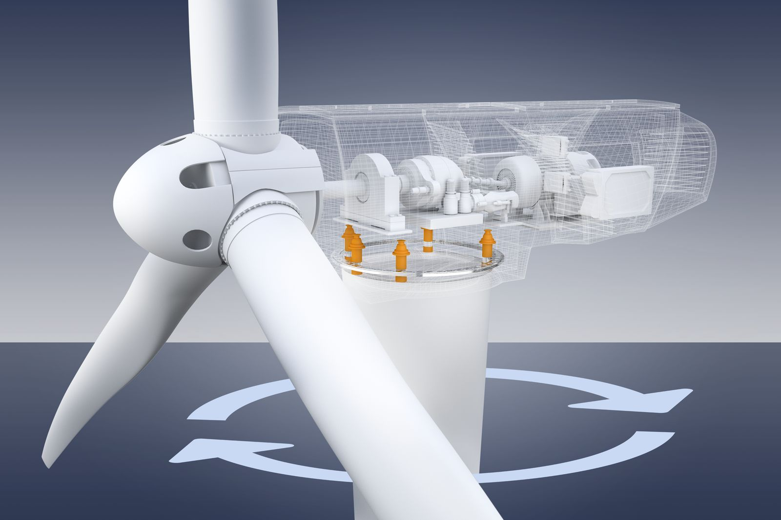
B&R's new solutions for azimuth control minimize wear by optimizing the yaw system.

About B&R
B&R, a division of ABB Group, is a global leader in industrial automation headquartered in Austria. B&R combines state-of-the-art technology with advanced engineering to provide customers in virtually every industry with complete solutions for machine and factory automation, motion control, HMI and integrated safety technology. With Industrial IoT communication standards including OPC UA, POWERLINK and openSAFETY as well as its Automation Studio software, B&R is constantly redefining the future of automation engineering. The innovative spirit that keeps B&R at the forefront of industrial automation is driven by a commitment to simplifying processes and exceeding customer expectations.
For more information, visit www.br-automation.com.

