Develop application software significantly faster
K 2016: B&R presents mapp Technology for the plastics industry
At K 2016, from October 19-26, B&R will be demonstrating how to greatly simplify the development of applications for injection presses, extruders and blow molding machines (Hall 12, Booth B16). Modular software blocks can reduce development times by an average of two-thirds.
Develop 3-times faster
For commonly recurring programming tasks, B&R offers modular software blocks that can be configured with a few clicks of the mouse. These mapp components simplify development of application software for all types of machinery and equipment. "With our specially developed mapp components for plastics machinery, the potential savings in engineering costs is even greater," says Patrick Bruder, B&R's specialist for the plastics industry.
EUROMAP – A step toward the digital factory
The unprecedented levels of machine-to-machine and plant-wide networking that distinguish IoT and I4.0 solutions can only be achieved with uniform communication standards. Based on OPC UA, the new EUROMAP recommendations – including EUROMAP 77 – are the perfect solution for this requirement. At K 2016, B&R will be presenting new mapp components to support the recommendations. "All the customer has to do is set a few parameters, and they've got a fully functioning EUROMAP interface," says Bruder.

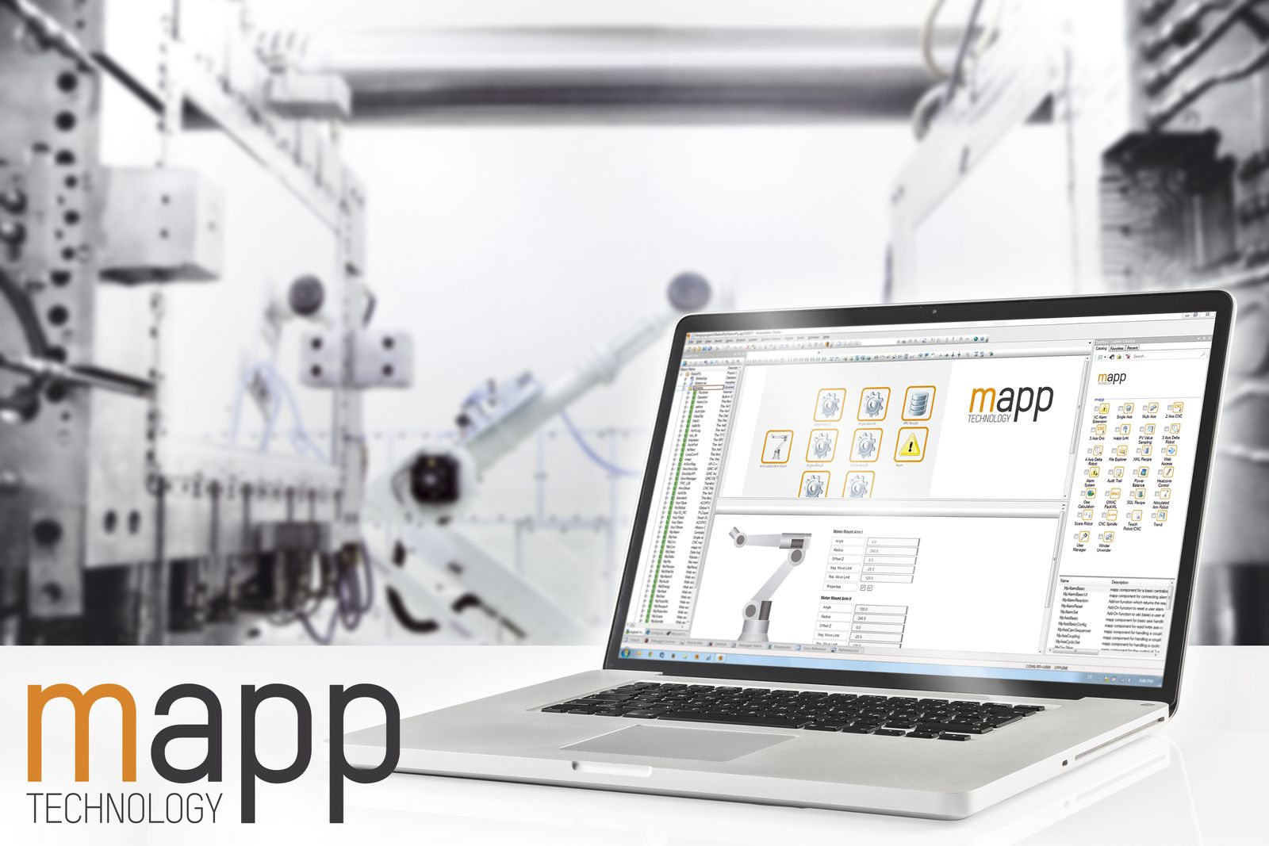
Specially developed mapp components for plastics machinery mean even greater savings potential for software engineering costs.

About B&R
B&R, a division of ABB Group, is a global leader in industrial automation headquartered in Austria. B&R combines state-of-the-art technology with advanced engineering to provide customers in virtually every industry with complete solutions for machine and factory automation, motion control, HMI and integrated safety technology. With Industrial IoT communication standards including OPC UA, POWERLINK and openSAFETY as well as its Automation Studio software, B&R is constantly redefining the future of automation engineering. The innovative spirit that keeps B&R at the forefront of industrial automation is driven by a commitment to simplifying processes and exceeding customer expectations.
For more information, visit www.br-automation.com.

