Safety for compact stepper motors
B&R's compact drive for stepper motors featuring Safe Torque Off (STO)
The compact ACOPOSmicro Stepper drive is now available with Safe Torque Off (STO). Over time, this safety function will be added to all ACOPOSmicro drives.
B&R has integrated safe pulse disabling in ACOPOSmicro Stepper drives for shutting down safely and preventing unwanted startup. Safety ratings up to SIL2 / PLD / CAT 3 can be achieved depending on the wiring.
Stop function for Category 0
Safe pulse disabling interrupts the power being sent to the drive. Electrical torque can then no longer be generated, so the drive coasts to a stop. The requirements for preventing unexpected startup in accordance with EN 1037 as well as the requirements concerning Category 0 stop functions in accordance with EN 60204-1 are met. The requirements concerning the STO safety function in accordance with EN 61800-5-2 are also met.

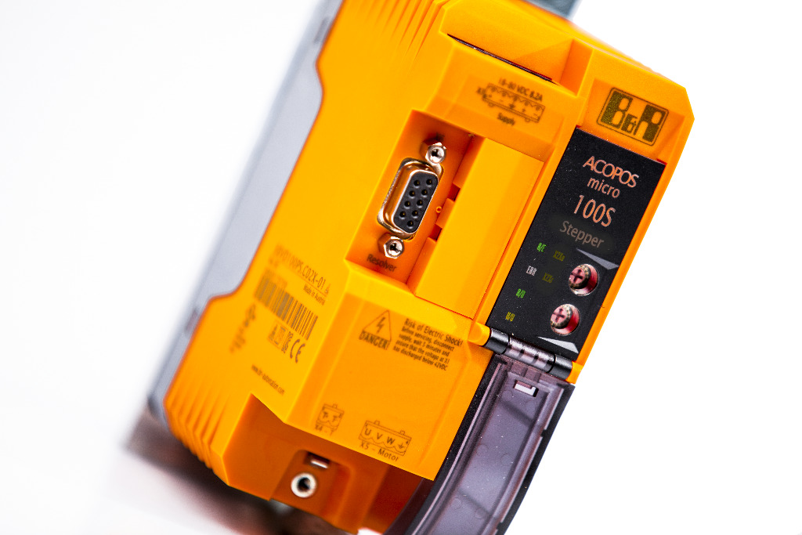
Now also available with Safe Torque Off (STO): The ACOPOSmicro Stepper from B&R.

About B&R
B&R, a division of ABB Group, is a global leader in industrial automation headquartered in Austria. B&R combines state-of-the-art technology with advanced engineering to provide customers in virtually every industry with complete solutions for machine and factory automation, motion control, HMI and integrated safety technology. With Industrial IoT communication standards including OPC UA, POWERLINK and openSAFETY as well as its Automation Studio software, B&R is constantly redefining the future of automation engineering. The innovative spirit that keeps B&R at the forefront of industrial automation is driven by a commitment to simplifying processes and exceeding customer expectations.
For more information, visit www.br-automation.com.

