Optimizing availability and capacity utilization
Asset performance monitoring for pumps and heat exchangers with APROL
B&R's APROL process control system makes it possible to monitor assets constantly. This helps reduce maintenance costs and downtime and optimize the availability and utilization of machinery and equipment.
Process control systems deal with a multitude of assets that are often found in hard-to-reach locations. Failure of a single asset could bring an entire plant to a standstill. Continuous monitoring of plant equipment with APROL Asset Performance Monitoring (APM) allows operators to keep an eye on the asset's current operating data with targeted real-time parameters.
Identifying level of fouling
In addition to providing operators with vital information about a plant's assets, it can easily prevent downtime by identifying the level of fouling on a heat exchanger or a cavitation-critical operating point for a centrifugal pump.
The software blocks of the APM functions utilize data that is already being collected via the process control system. Problems with assets are identified early by applying definable performance thresholds to measurement data.

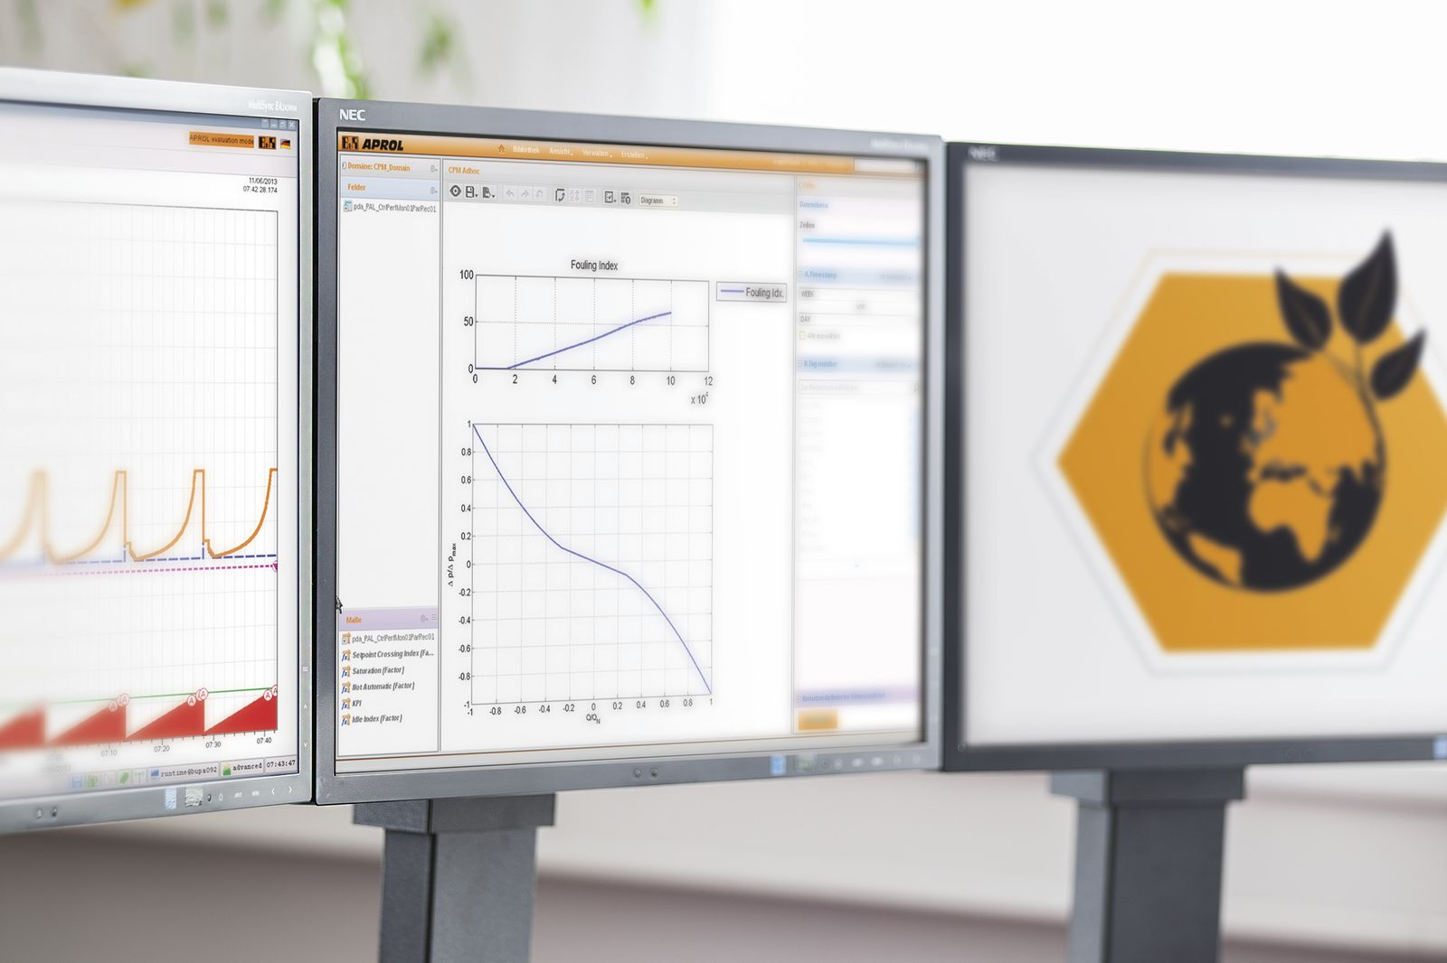
Asset performance monitoring for pumps and heat exchangers can help reduce maintenance costs and downtime.

About B&R
B&R, a division of ABB Group, is a global leader in industrial automation headquartered in Austria. B&R combines state-of-the-art technology with advanced engineering to provide customers in virtually every industry with complete solutions for machine and factory automation, motion control, HMI and integrated safety technology. With Industrial IoT communication standards including OPC UA, POWERLINK and openSAFETY as well as its Automation Studio software, B&R is constantly redefining the future of automation engineering. The innovative spirit that keeps B&R at the forefront of industrial automation is driven by a commitment to simplifying processes and exceeding customer expectations.
For more information, visit www.br-automation.com.

