No access for unauthorized users
Easily and securely manage users and roles in OPC UA
The new user role system in the B&R Automation Studio software development environment simplifies management of OPC UA access rights. This feature prevents unauthorized users from accessing an OPC UA system, modifying data or performing certain actions.
Any number of roles can be defined, which can then be assigned individual access rights for each node. Typical access rights include reading, writing or browsing. It is even possible to completely hide a node so that it is invisible to members of a specific role group. To make configuration even easier, the rights of a parent node can be inherited by its children.
User role system
A user is assigned one or more roles, with additional protection provided by an encrypted password. The user role system can also be updated during operation. This includes, for example, assigning a username and password to a new system operator. These functions are available directly in the application program on the controller using function blocks.
Security with certificates
In order to ensure secure and trusted data exchange, digital certificates in accordance with the X.509 standard can be used in the OPC UA system. The Transport Layer Security (TLS) subsystem in Automation Studio and Automation Runtime support the management of these certificates. Certificates can be displayed, created and transferred to the certificate store on the OPC UA server.

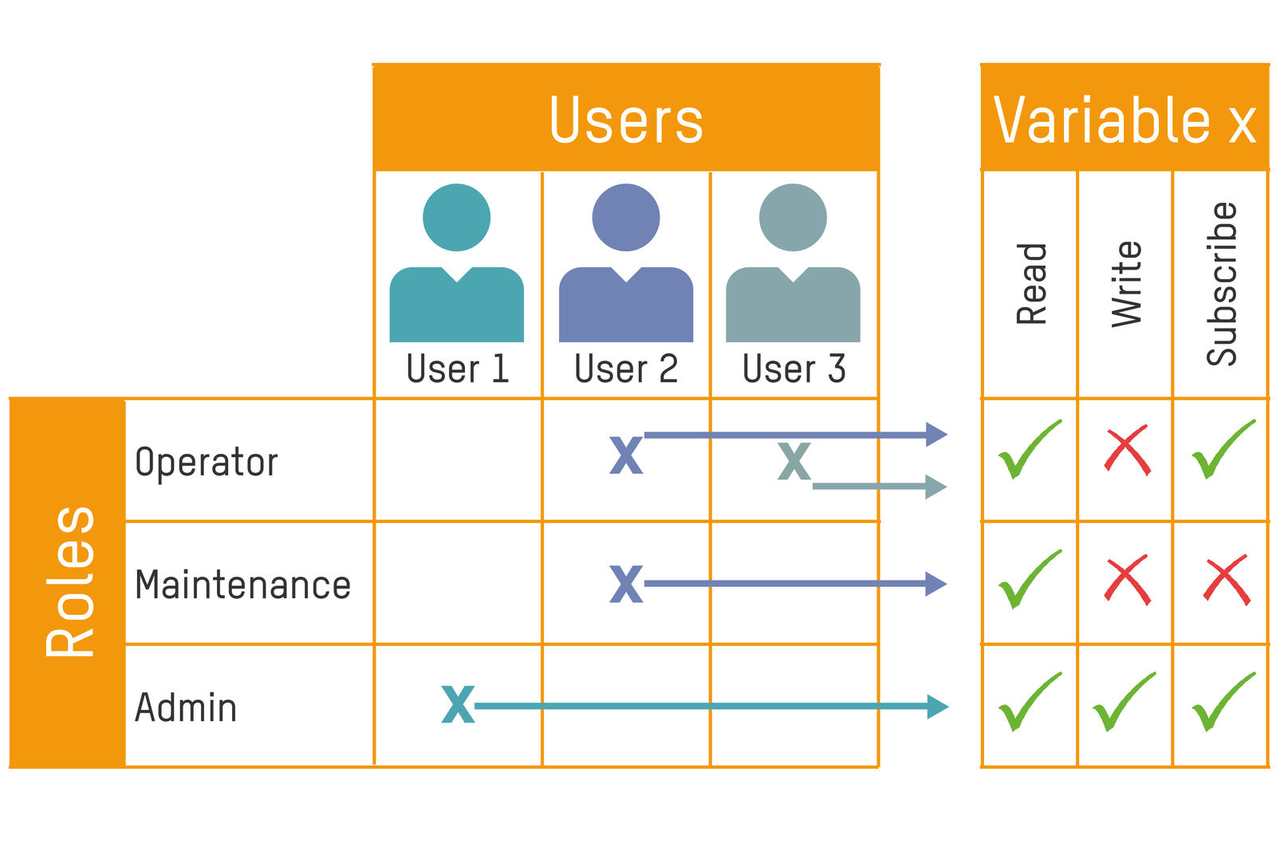
A user can be assigned one or more roles.

About B&R
B&R, a division of ABB Group, is a global leader in industrial automation headquartered in Austria. B&R combines state-of-the-art technology with advanced engineering to provide customers in virtually every industry with complete solutions for machine and factory automation, motion control, HMI and integrated safety technology. With Industrial IoT communication standards including OPC UA, POWERLINK and openSAFETY as well as its Automation Studio software, B&R is constantly redefining the future of automation engineering. The innovative spirit that keeps B&R at the forefront of industrial automation is driven by a commitment to simplifying processes and exceeding customer expectations.
For more information, visit www.br-automation.com.

