Comprehensive system diagnostics for industrial PCs
Performance data and diagnostics in B&R's HMI Service Center
To offer optimum support whenever service is required, all informational and diagnostics features will be provided via the newly developed HMI Service Center. The HMI Service Center is a software tool used to test B&R's industrial PCs and Automation Panels.
Industrial PCs from B&R have always offered extensive system diagnostics that go above and beyond those of a standard PC. Not only is it possible to read information like serial numbers and part numbers, but also statistical data like power-on cycles and temperature sensor values. This data is managed by the Maintenance Controller. The goal is maximum system transparency for the user.
Easy to use
It could hardly be easier to use: Simply start the Automation PC or Panel PC with the USB flash drive inserted. The system boots from the embedded operating system found on the flash drive. The clearly structured user interface that appears provides access to all the necessary information and additional diagnostics features.

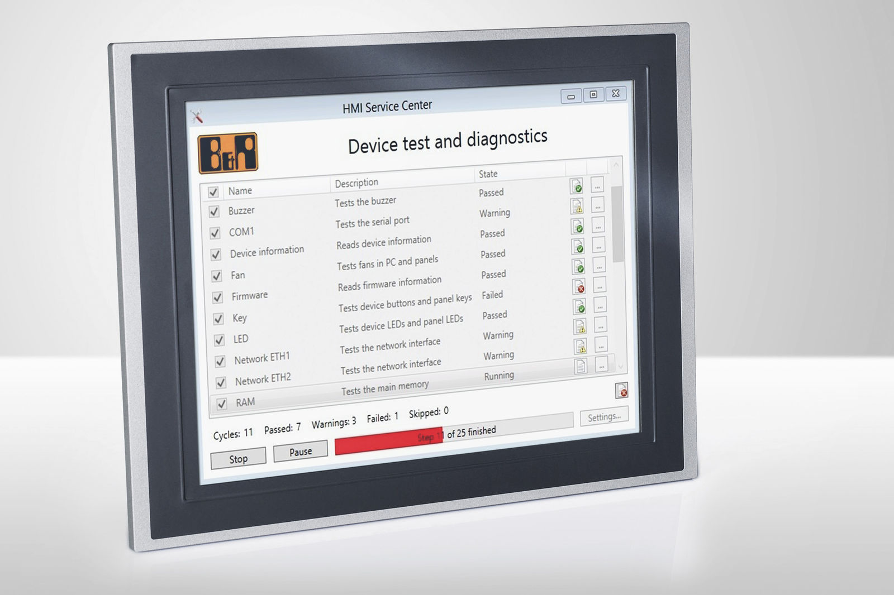
The HMI Service Center displays the tests available for the PC along with a short description and the PC's status.

About B&R
B&R, a division of ABB Group, is a global leader in industrial automation headquartered in Austria. B&R combines state-of-the-art technology with advanced engineering to provide customers in virtually every industry with complete solutions for machine and factory automation, motion control, HMI and integrated safety technology. With Industrial IoT communication standards including OPC UA, POWERLINK and openSAFETY as well as its Automation Studio software, B&R is constantly redefining the future of automation engineering. The innovative spirit that keeps B&R at the forefront of industrial automation is driven by a commitment to simplifying processes and exceeding customer expectations.
For more information, visit www.br-automation.com.

