Handheld HMI for flexible performance
B&R presents new series of Mobile Panels
B&R has added three new mobile units to its HMI portfolio. The Mobile Panel 7100 series of handheld HMI units stands out with an exceptionally ergonomic, light and shockproof design. These new models are B&R's answer for applications in harsh industrial environments that require the performance of an industrial PC.
Optimal display
The new Mobile Panels are available in a range of sizes. The 7140 and 7150 feature a 7" WSVGA and 10.1" WXGA display, respectively. Both of them use the innovative mapp View HMI software. The 7151 model has a 10.1" display and runs a Windows-based operating system.
Robust design for harsh industrial environments
Mobile Panels make optimum use of limited space, featuring an integrated touch screen as well as dedicated keys for frequently used functions. Operating elements like the key switch and stop button are recessed in the rounded, double-walled housing able to absorb hard impacts. The IP65-rated mobile HMI units also provide integrated interfaces including USB 2.0 and Ethernet 10/100.

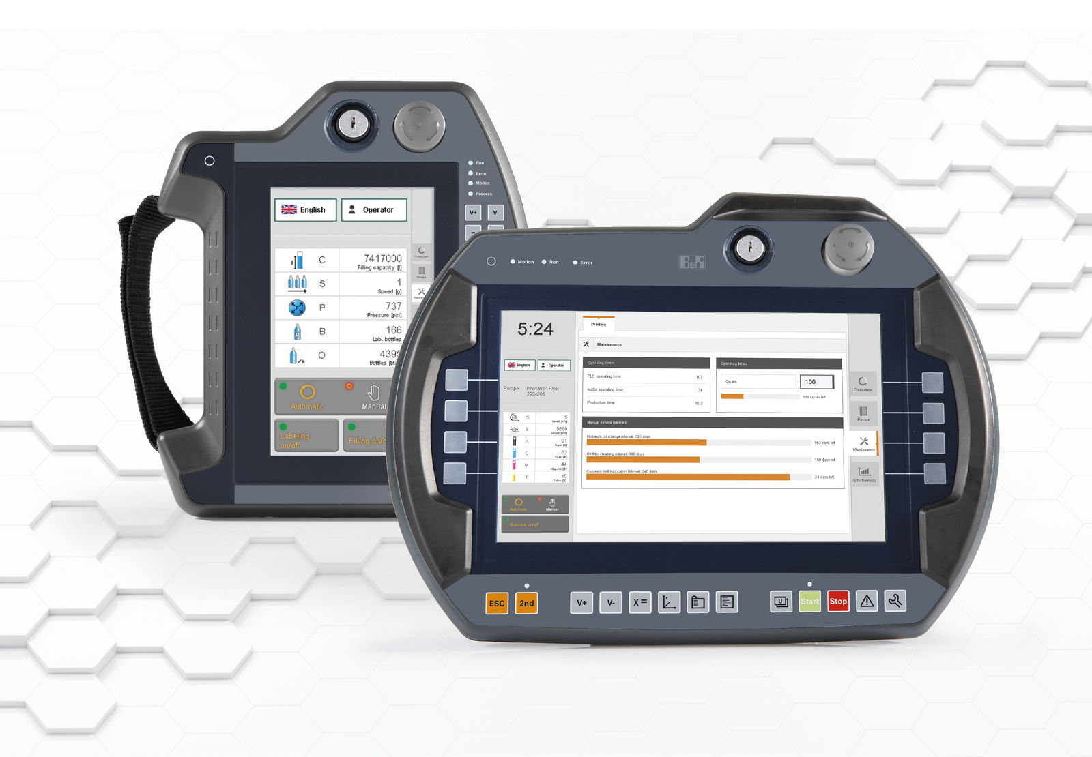
The user interface on the B&R Mobile Panel 7100 offers a combination of integrated touch screen and dedicated function keys.

About B&R
B&R, a division of ABB Group, is a global leader in industrial automation headquartered in Austria. B&R combines state-of-the-art technology with advanced engineering to provide customers in virtually every industry with complete solutions for machine and factory automation, motion control, HMI and integrated safety technology. With Industrial IoT communication standards including OPC UA, POWERLINK and openSAFETY as well as its Automation Studio software, B&R is constantly redefining the future of automation engineering. The innovative spirit that keeps B&R at the forefront of industrial automation is driven by a commitment to simplifying processes and exceeding customer expectations.
For more information, visit www.br-automation.com.

