EUROMAP 79: Real-time communication for the plastics industry
EUROMAP working group hosted by B&R
In mid-September, the EUROMAP working group gathered at the B&R headquarters in Eggelsberg, Austria to discuss its recommendation for a real-time communication interface for injection molding machines and robots. The new EUROMAP 79 recommendation is based on the OPC UA open standard with the real-time TSN extension and will enable deterministic real-time communication.
Hardware interfaces have exhausted their potential
As the umbrella organization for Europe's manufacturers of plastics and rubber machinery, EUROMAP develops recommendations that are recognized as industry standards. Until now, communication between injection presses and handling robots has been handled via a plug-and-socket connection standardized in the EUROMAP 67 recommendation. As machines and processes grow in complexity, however, the performance limitations of these hardware interfaces are becoming increasingly evident. This was the motivation for the EUROMAP working group to begin development of a new interface.
OPC UA TSN handles time-critical communication
The new EUROMAP 79 recommendation is based on OPC UA TSN. "With OPC UA TSN, injection molded parts can be extracted with levels of speed and precision that would have been unthinkable with the earlier EUROMAP interface," says Patrick Bruder, plastics industry expert at B&R.

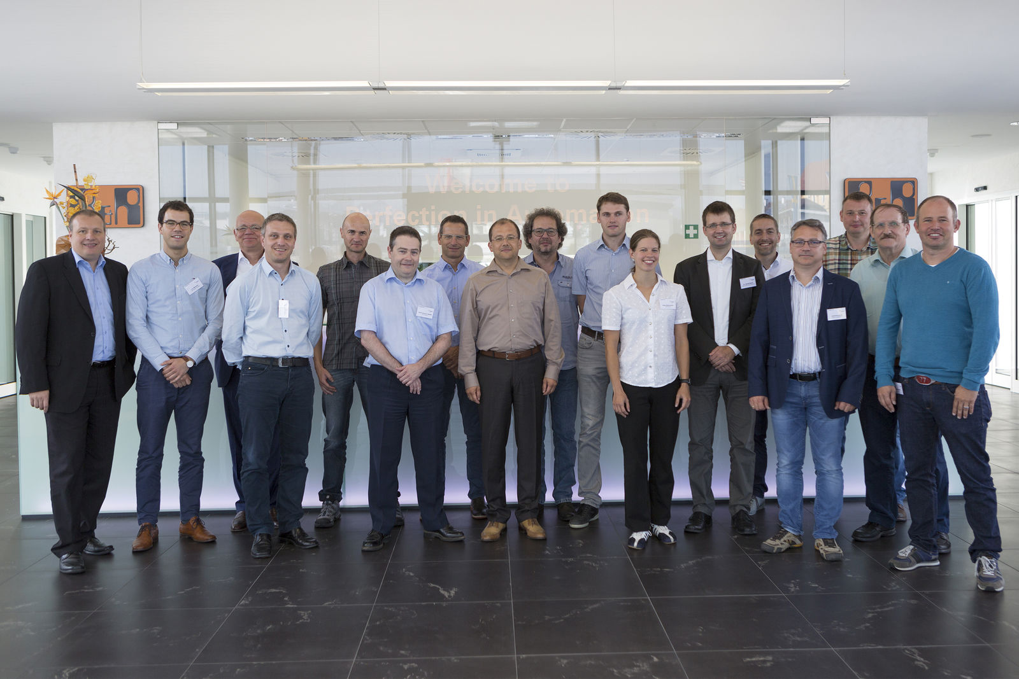
The EUROMAP working group is working on an interface that will enable real-time communication between injection molding machines and robots.

About B&R
B&R, a division of ABB Group, is a global leader in industrial automation headquartered in Austria. B&R combines state-of-the-art technology with advanced engineering to provide customers in virtually every industry with complete solutions for machine and factory automation, motion control, HMI and integrated safety technology. With Industrial IoT communication standards including OPC UA, POWERLINK and openSAFETY as well as its Automation Studio software, B&R is constantly redefining the future of automation engineering. The innovative spirit that keeps B&R at the forefront of industrial automation is driven by a commitment to simplifying processes and exceeding customer expectations.
For more information, visit www.br-automation.com.

