High-performance control, even with a sine wave filter
B&R upgrades current control loop for ACOPOS P3 servo drives
B&R has upgraded the current control loop for ACOPOS P3 servo drives. Users can implement a sine wave filter without negatively affecting drive control performance. This gives machines the advantages of a sine wave filter while the ACOPOS P3 retains its usual high performance.
Better efficiency
By converting the voltage signal from a square waveform to a largely sinusoidal one, sine wave filters help improve energy efficiency, reduce strain on the motor and decrease electromagnetic noise on the motor cable. They also smooth out the current curve, which reduces both acoustic noise and motor losses. The overall efficiency of the servo drive is thus improved.
High overall performance
The ACOPOS P3 takes the characteristic curve of the sine wave filter into account, allowing the full bandwidth of the current control loop to be utilized and ensuring that it is stable and robust. B&R thus ensures high overall performance of the ACOPOS P3.
In some circumstances, other manufacturers require the current control loop to be operated at a lower bandwidth when using a sine wave filter in order to ensure a stable and robust control results. This has a negative effect on servo drive performance.

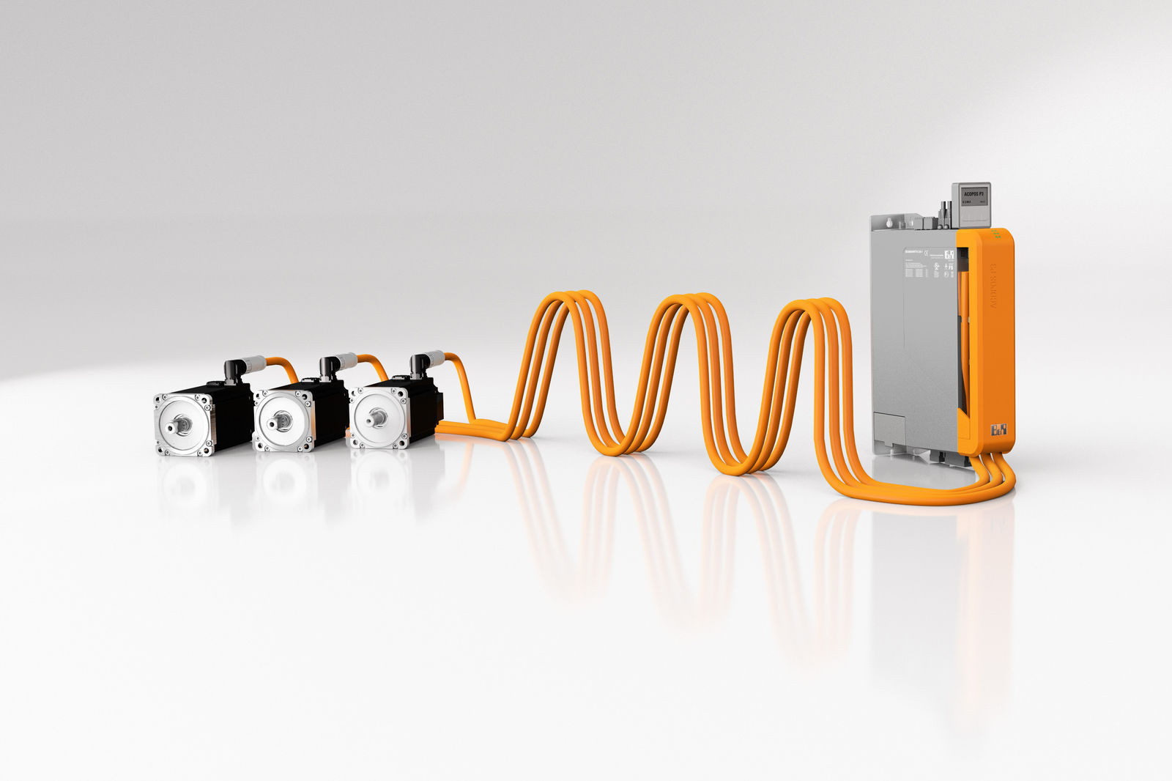
The ACOPOS P3 servo drive allows users to apply a sine wave filter without impacting drive control performance.

About B&R
B&R, a division of ABB Group, is a global leader in industrial automation headquartered in Austria. B&R combines state-of-the-art technology with advanced engineering to provide customers in virtually every industry with complete solutions for machine and factory automation, motion control, HMI and integrated safety technology. With Industrial IoT communication standards including OPC UA, POWERLINK and openSAFETY as well as its Automation Studio software, B&R is constantly redefining the future of automation engineering. The innovative spirit that keeps B&R at the forefront of industrial automation is driven by a commitment to simplifying processes and exceeding customer expectations.
For more information, visit www.br-automation.com.

