Process control in the cloud
Secure global data access with B&R APROL
It will soon be possible to install and run APROL in the cloud. With data and reports generated by the process control system available anywhere in the world, geographically dispersed teams can collaborate with remarkable efficiency.
APROL can be installed on virtual machines offered by any well-established cloud hosting company. A local APROL installation performs preprocessing and compression, so that only significant data is transmitted to the cloud database. This approach, which is based on the concepts of fog and edge computing, helps keep data transfer costs to a minimum.
APROL supports the MQTT, AMQP and OPC UA protocols. An unlimited number of local APROL nodes can send data to the central cloud-based APROL installation. Reports from the business intelligence solutions in local and cloud-based APROL installations can be opened via a REST API.
最大安全
The system architecture with local APROL nodes and one cloud installation ensures maximum plant security while at the same time making all of APROL's analysis, reporting and business intelligence functions available via the cloud.
Centralized data management allows all information to be accessed remotely from anywhere in the world. Database content can be analyzed using data mining tools offered by the cloud service provider.
Efficient engineering
Cloud-based APROL solutions provide access to all of APROL's concurrent engineering features, so users with development teams distributed around the world can complete large projects with maximum efficiency.

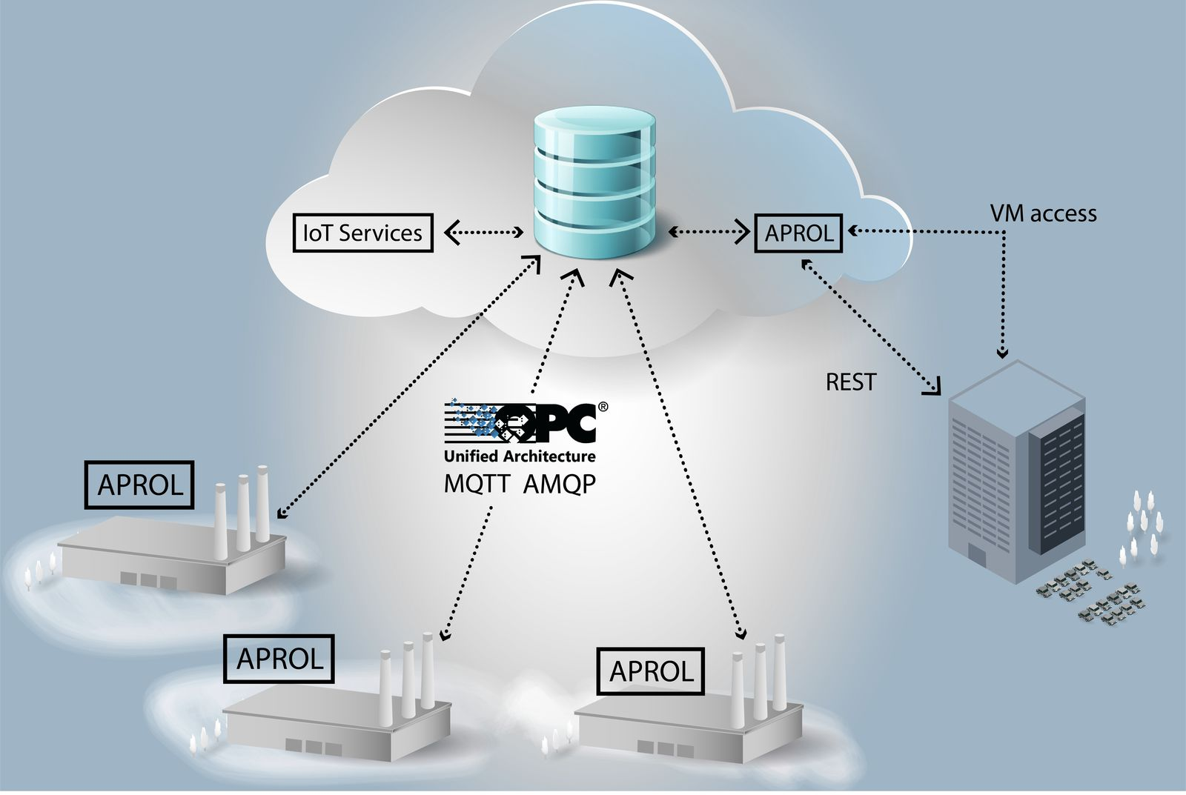
A cloud-based APROL solution offers maximum flexibility with maximum security.

关于贝加莱
贝加莱是一家总部位于奥地利并在全球拥有分公司的创新型自动化企业。2017年7月，贝加莱成为ABB集团的机械自动化事业部。作为工业自动化领域的全球领导者，贝加莱将前沿技术与领先工程相结合，为几乎每个行业的客户提供面向机器与工厂自动化、运动控制、HMI和集成安全技术的完整解决方案。借助于OPC UA、POWERLINK、openSAFETY等工业物联网通信标准，以及强大的Automation Studio软件开发平台，贝加莱不断重新定义自动化工程的未来。受简化流程和超出客户预期的承诺驱动，贝加莱始终保持创新精神并处于工业自动化领域的前沿。
获取更多信息，请访问www.br-automation.com。

