Efficient production at any batch size
B&R at the SPS IPC Drives
B&R will be presenting the SuperTrak industrial transport system at the SPS IPC Drives trade fair. Dependable, precise and remarkably low maintenance – it enables agile, efficient production at any batch size. Other highlights on display at the B&R booth (Hall 7 / Booth 206) include a multitude of new mapp components and connected manufacturing solutions based on OPC UA communication.
Two years ago, B&R radically simplified the development of machine software with the introduction of mapp Technology. These precoded and thoroughly tested software components have since been making life easier for OEMs by taking low-level programming tasks for basic functions off their hands. Encouraged by outstanding market acceptance in this short time, B&R has continued to expand its software framework – offering even greater savings to customers developing applications in the areas of CNC, robotics, complex closed-loop control and HMI.
Solutions for connected manufacturing
B&R will also be taking the opportunity to present numerous communication solutions for the connected factory envisaged by Industry 4.0. By combining OPC UA and openSAFETY to create Safe Line Automation, B&R offers seamless and scalable safety throughout integrated production lines. B&R will also be presenting a cloud solution for its APROL process control system.
Advanced system architecture for commercial vehicles
With B&R's X90 system, manufacturers of construction, agricultural and municipal vehicles can now benefit from B&R's 35 years of automation experience. In addition to the new control and I/O system, these applications can profit from B&R's Automation Studio development environment, mapp software framework and global support network.

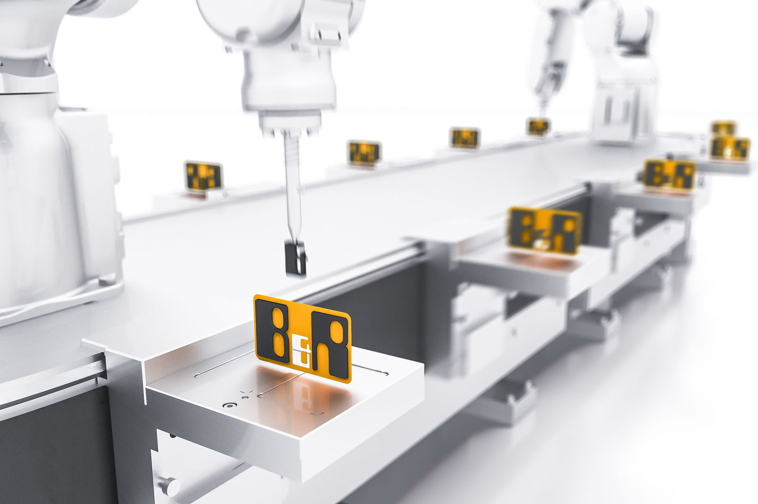
At the SPS IPC Drives trade fair, B&R will be presenting the SuperTrak industrial transport system and numerous solutions for connected manufacturing.

About B&R
B&R, a division of ABB Group, is a global leader in industrial automation headquartered in Austria. B&R combines state-of-the-art technology with advanced engineering to provide customers in virtually every industry with complete solutions for machine and factory automation, motion control, HMI and integrated safety technology. With Industrial IoT communication standards including OPC UA, POWERLINK and openSAFETY as well as its Automation Studio software, B&R is constantly redefining the future of automation engineering. The innovative spirit that keeps B&R at the forefront of industrial automation is driven by a commitment to simplifying processes and exceeding customer expectations.
For more information, visit www.br-automation.com.

