B&R presents trending technologies for packaging automation at PACK EXPO 2016

Ease of use, Industrial Internet of Things connectivity, flexibility, open robotics integration with SuperTrak® industrial transport, Augmented Reality, networked safety, plus student robotic competi-tion and career networking event
At this year’s PACK EXPO International show, from November 6-9 in Chicago’s McCormick Place, B&R In-dustrial Automation Corp. will exhibit automation technologies that are trending in packaging machinery de-sign at booth N-6141. B&R specializes in standards-based, scalable and modular control systems integrat-ing CNC, logic, general motion, open and mapp robotics, human-machine interface (HMI), safety, I/O and data acquisition in a unified software development environment.
Automation innovations that support key packaging trends
Consumer packaged goods (CPG) makers face many operational challenges identified by PMMI’s OpX Leadership Network, whose Total Cost of Ownership workgroup is sponsored by B&R. B&R’s automation platform provides solutions that differentiate packaging machinery builders in the marketplace.
These solutions help
• Overcome the persistent skills gap by simplifying machinery development, operation and mainte-nance through expanded mapp (modular application) Technology functionalities.
• Achieve new levels of uptime and OEE through networked safety -- encompassing safe motion and safe robotics -- to merely slow packaging lines down instead of stopping them.
• Increase the efficiency of product and package transport, value-added processing and machine-to-machine integration through synchronization of open robotics with SuperTrak® linear industrial transport technology.
• Support CPGs’ corporate Internet of Things strategies through standards such as OPC UA and best practices being identified by the Industrial Internet Consortium (IIC). B&R co-chairs the IIC’s new Smart Factory Task Group.
• Enable the need to accommodate short product life cycles and shorter runs with more frequent changeovers through automation that replaces manual changeover procedures and tools with reci-pe-driven, pushbutton automated changeovers.
• Future proof B&R equipped machinery by providing an open, Web-enabled control and HMI platform that supports mainstream technologies such as Augmented Reality and Secure Remote Access.
Student robotics competition
Exclusively sponsored by B&R, PMMI will host teams from the 2016 FIRST Robotics competition at the “Future Innovators — Robotics Showcase” in booth N-4585.The teams of high school students will display and demonstrate the robots they entered in this year’s “FIRST Robotics national robotics competition. FIRST Robotics inspires youth to leadership in science and technology by engaging them in exciting, mentor-based programs that foster science, engineering and technology skills, as well as critical life skills including self-confidence, communication and leadership.B&R will demonstrate the state of the art in open robotics with a B&R controlled Comau robotic cell, inspiring the student competitors to fulfill their future career ambitions in robotics in packaging applications. Each day of the show will see two teams demonstrating their robots in half-day shifts with a one-hour overlap for “friendly competition.” PMMI’s Education & Training Foundation will donate $500 to each high school to support the teams.
The Future Innovators project seeks to promote high school engineering programs to attendees and exhibi-tors, encouraging them to support their local schools in developing future innovators, and to encourage young innovators while introducing them to PACK EXPO and packaging/processing as a career choice.
Student-employer networking event
All registered PACK EXPO International/Pharma EXPO exhibitors and attendees are welcome and invited to join the PMMI NextGEN Networking Fair, exclusively sponsored by B&R, on Sunday, November 6, from 3–5 p.m. in the Education & Workforce Development Pavilion, on the mezzanine level.
The event is for CPGs looking for skilled workers and machine builders needing to fill the void when baby boomers finally retire. In its first year, this B&R sponsored networking event will provide students an oppor-tunity to meet and interact with PMMI members, as well as PACK EXPO exhibitors and attendees. Light refreshments will be served.

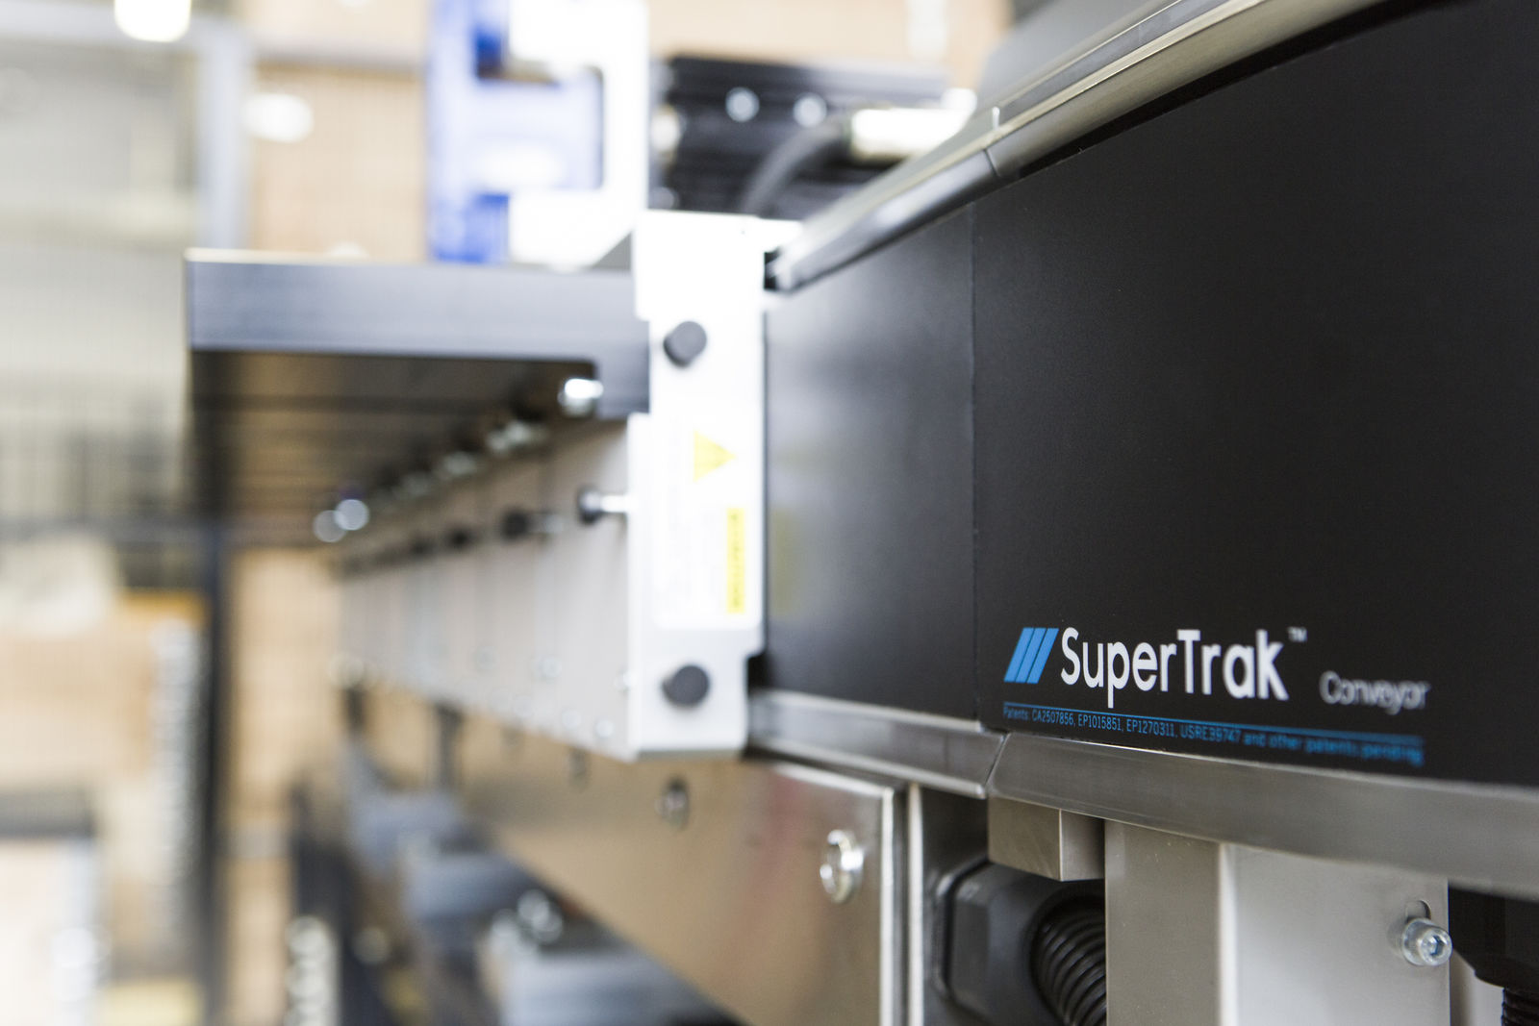
At the PACK EXPO International show, B&R will showcase its latest automation technologies including the advanced linear track conveyance system- SuperTrak® .

About B&R
B&R, a division of ABB Group, is a global leader in industrial automation headquartered in Austria. B&R combines state-of-the-art technology with advanced engineering to provide customers in virtually every industry with complete solutions for machine and factory automation, motion control, HMI and integrated safety technology. With Industrial IoT communication standards including OPC UA, POWERLINK and openSAFETY as well as its Automation Studio software, B&R is constantly redefining the future of automation engineering. The innovative spirit that keeps B&R at the forefront of industrial automation is driven by a commitment to simplifying processes and exceeding customer expectations.
For more information, visit www.br-automation.com.

