Leading automation and information technology suppliers drive OPC UA TSN for unified Industrial Internet of Things (IIoT) communication to the controller level
ABB, Bosch Rexroth, B&R, CISCO, General Electric, KUKA, National Instruments (NI), Parker Hannifin, Schneider Electric, SEW-EURODRIVE and TTTech are jointly promoting OPC UA over Time Sensitive Networking (TSN) as the unified communication solution between industrial controllers and to the cloud. Based on open standards, this solution enables industry to use devices from different vendors that are fully interoperable. The participating companies intend to support OPC UA TSN in their future generations of products.
Industrial automation solutions have traditionally been differentiated and separated from one another by different incompatible and non-interoperable standards used for communication between devices. As a result, customers have often found themselves locked into proprietary ecosystems. Vendors have had to develop multiple versions of essentially the same product to support these ecosystems. This has been limiting innovation and the integration of new solutions, with customers not being able to optimize their automation solution to its full value.
To address this, ABB, Bosch Rexroth, B&R, CISCO, General Electric, KUKA, NI, Parker Hannifin, Schneider Electric, SEW-EURODRIVE and TTTech have started an open technical collaboration under the umbrella of the Industrial Internet Consortium (IIC) and the OPC Foundation. This group of companies are aiming for an open, unified, standards-based and interoperable IIoT solution for deterministic and real-time peer-to-peer communication between industrial controllers and to the cloud. The cooperation considers OPC UA TSN as the unified standard for industrial automation and IIoT connectivity. OPC UA TSN is the combination of enhanced OPC UA Publisher/Subscriber (Pub/Sub) technology with the IEEE TSN Ethernet standards. It provides all of the open, standard building blocks required to unify communication for industrial automation and it enables the broad convergence of information technology (IT) and operational technology (OT) that is fundamental to realizing the Industrial Internet of Things and Industrie 4.0.
The group of companies intends to support OPC UA TSN in their future generations of products. First pilots of these products are already being integrated in an IIC testbed. The group’s objective is to show compatible controller to controller communication between devices from different vendors using OPC UA TSN over standard IT infrastructure. Other companies that share this common vision of unified communication between industrial controllers and to cloud are welcome to join and contribute to this collaboration.

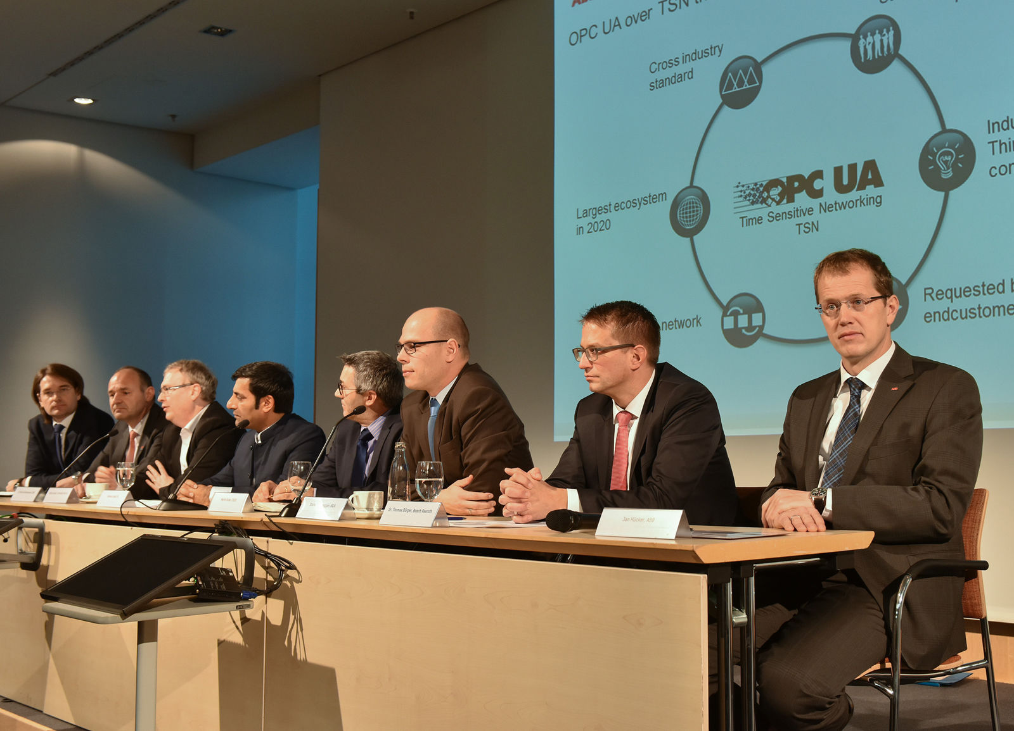
ABB, Bosch Rexroth, B&R, CISCO, General Electric, KUKA, National Instruments (NI), Parker Hannifin, Schneider Electric, SEW-EURODRIVE and TTTech are jointly promoting OPC UA over Time Sensitive Networking (TSN) as the unified communication solution between industrial controllers and to the cloud.

About B&R
B&R, a division of ABB Group, is a global leader in industrial automation headquartered in Austria. B&R combines state-of-the-art technology with advanced engineering to provide customers in virtually every industry with complete solutions for machine and factory automation, motion control, HMI and integrated safety technology. With Industrial IoT communication standards including OPC UA, POWERLINK and openSAFETY as well as its Automation Studio software, B&R is constantly redefining the future of automation engineering. The innovative spirit that keeps B&R at the forefront of industrial automation is driven by a commitment to simplifying processes and exceeding customer expectations.
For more information, visit www.br-automation.com.

