High performance through efficient quality management
B&R among first Austrian companies with ISO 9001:2015 certification
B&R is among the first Austrian companies to pass an ISO 9001:2015 recertification audit by TÜV AUSTRIA. Compliance with the latest version of the ISO 9001 quality management standard helps ensure that B&R customers will continue to enjoy the availability and quality they expect from the company's products and services.
Success through quality
The recertification audit for the 2015 version of the standard determined that the existing processes and procedures had been optimally adapted to new requirements in areas such as process and risk management. "B&R's leadership and employees have implemented the ISO 9001:2015 standard in an exemplary QM system," affirms TÜV AUSTRIA auditor Edgar Jochinger, who was particularly impressed by B&R's internal audit system. "Through internal auditing, B&R ensures continual improvement of its quality management system," says Jochinger.
Update brings added flexibility
The 2015 update makes the ISO 9001 standard more adaptable to companies of all types and sizes. Some of the more significant changes affect areas such as risk management and the systematic handling of knowledge. "When we first reviewed the requirements of the new version, we saw that we were already meeting them. B&R already had established procedures for risk management and knowledge management, and conceptually the management system was organized accordingly. Successful certification for ISO 9001:2015 confirms that," says Richard Ross, head of quality management at B&R.

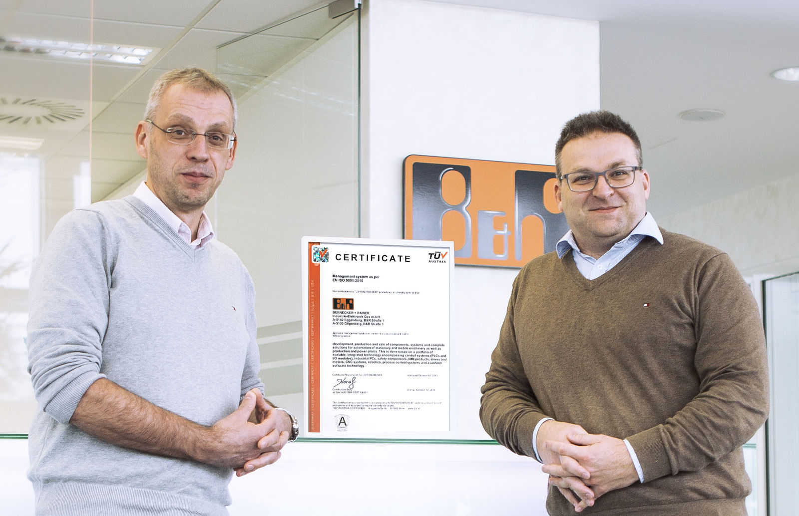
B&R is among the first Austrian companies to pass an ISO 9001:2015 recertification audit by TÜV AUSTRIA. Richard Ross and Edmund Schatz from B&R's quality management team are proud of the accomplishment.

About B&R
B&R, a division of ABB Group, is a global leader in industrial automation headquartered in Austria. B&R combines state-of-the-art technology with advanced engineering to provide customers in virtually every industry with complete solutions for machine and factory automation, motion control, HMI and integrated safety technology. With Industrial IoT communication standards including OPC UA, POWERLINK and openSAFETY as well as its Automation Studio software, B&R is constantly redefining the future of automation engineering. The innovative spirit that keeps B&R at the forefront of industrial automation is driven by a commitment to simplifying processes and exceeding customer expectations.
For more information, visit www.br-automation.com.

