The perfect motor for any application
B&R is adding two new sizes to its standard series of servo motors
B&R is adding two new sizes to its 8LS series of servo motors. Size A offers extremely high torque with a flange size of 70 mm and an extremely compact design, while size 9 rounds off the upper end of the performance spectrum with up to 75 kW of power. Both of these options make it possible for machine manufacturers and system integrators to adapt motors betters to actual requirements.
More performance for specific applications
Compact size A motors are the perfect choice where high torque density is needed in a very tight footprint. The fully sealed stator allows a high degree of efficiency as well as high continuous torque. With a maximum torque of up to 1,000 Nm, size 9 motors open up entirely new applications with high demands on power and dynamics. They can be combined with any of B&R's many gearbox options and shipped as pre-assembled motor-gearbox combinations.
Safety included
All motors from the 8LS series are offered with an optional digital encoder and scalable safety functions. Motors up to size 7 are also available with B&R's robust single-cable solution, which combines the cables for the motor and encoder. This minimizes cabling and substantially reduces installation costs.

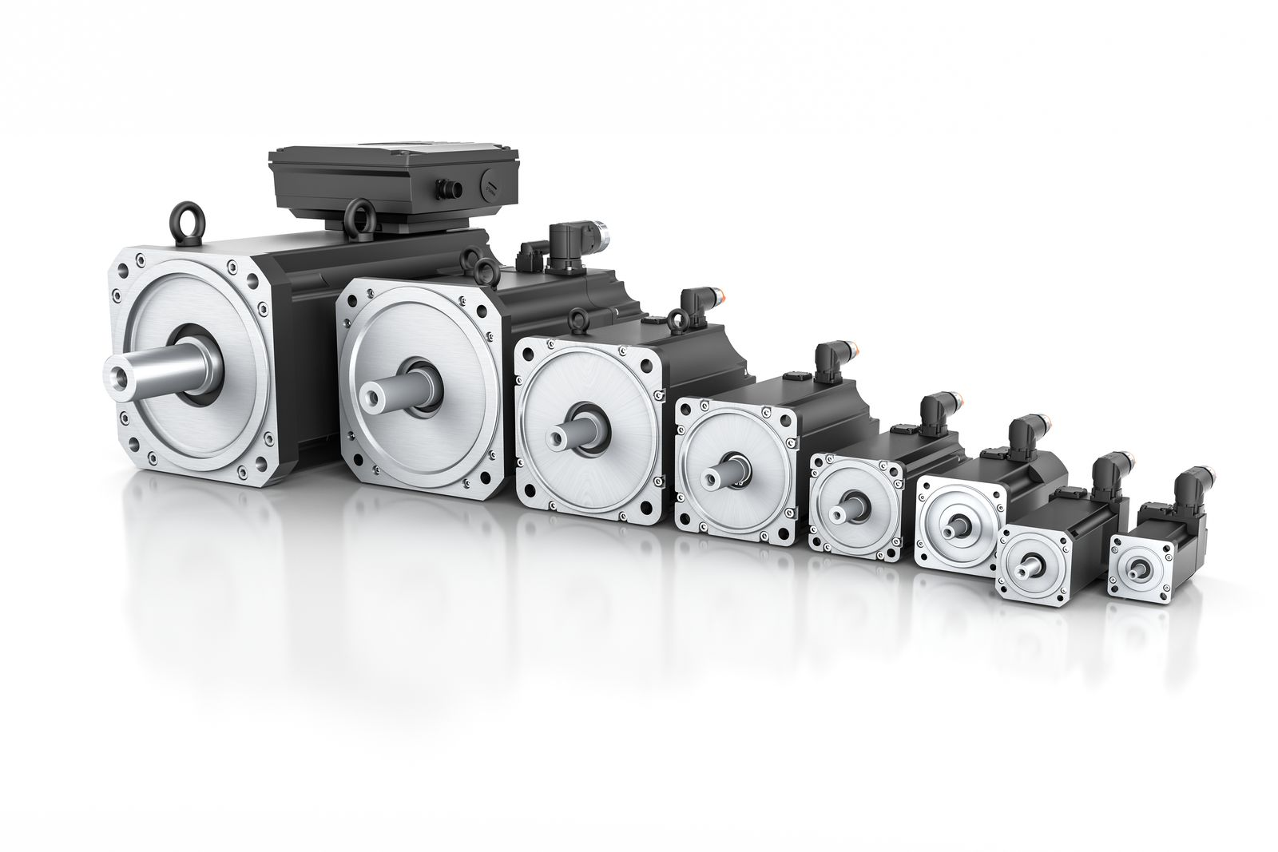
With two new sizes, the 8LS motor series covers an even wider and more finely graduated performance spectrum.

About B&R
B&R, a division of ABB Group, is a global leader in industrial automation headquartered in Austria. B&R combines state-of-the-art technology with advanced engineering to provide customers in virtually every industry with complete solutions for machine and factory automation, motion control, HMI and integrated safety technology. With Industrial IoT communication standards including OPC UA, POWERLINK and openSAFETY as well as its Automation Studio software, B&R is constantly redefining the future of automation engineering. The innovative spirit that keeps B&R at the forefront of industrial automation is driven by a commitment to simplifying processes and exceeding customer expectations.
For more information, visit www.br-automation.com.

