Muting function blocks save costs
New muting modes from B&R make light curtains flexible
With its new function blocks for programming network-integrated light curtains, B&R simplifies production of small batch sizes. Box muting, teach-in muting and small object muting functions make it possible for objects of different sizes and shapes to pass through a light curtain without triggering a safety reaction.
Reduced hardware overhead
Network-integrated light curtains can now evaluate each beam of the light curtain individually. Without any additional sensors, the light curtain detects the object profile and sends the data to the safety controller. The result is less hardware and easier installation.
Muting modes as function blocks
Each muting mode is preprogrammed as a certified function block. B&R's advanced muting modes provide all the most commonly required options and make light curtains considerably more flexible than conventional muting technology. For example, long as well as short objects can now be transported through a light curtain. Once installed, no more work is needed.

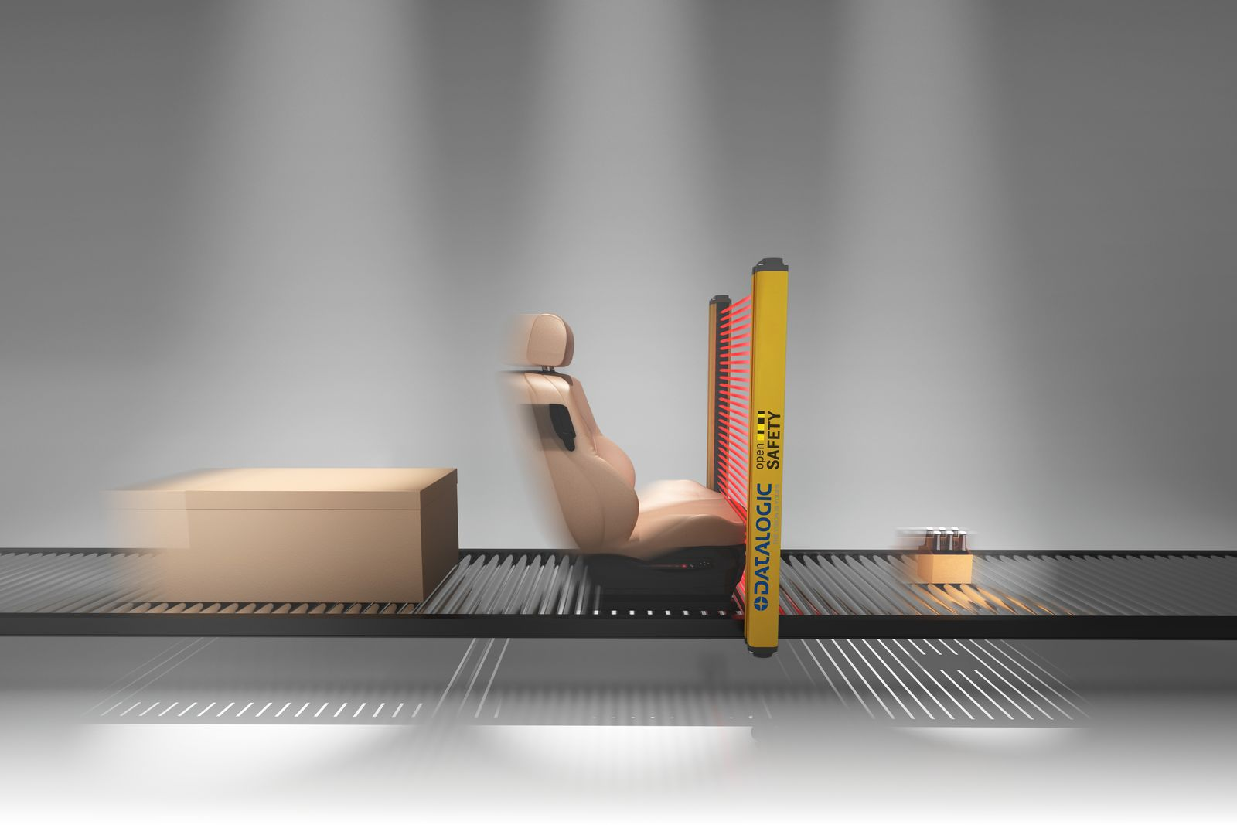
New function blocks for programming network-integrated light curtains make it possible for objects of different sizes and shapes to pass through a light curtain without triggering a safety reaction.

About B&R
B&R, a division of ABB Group, is a global leader in industrial automation headquartered in Austria. B&R combines state-of-the-art technology with advanced engineering to provide customers in virtually every industry with complete solutions for machine and factory automation, motion control, HMI and integrated safety technology. With Industrial IoT communication standards including OPC UA, POWERLINK and openSAFETY as well as its Automation Studio software, B&R is constantly redefining the future of automation engineering. The innovative spirit that keeps B&R at the forefront of industrial automation is driven by a commitment to simplifying processes and exceeding customer expectations.
For more information, visit www.br-automation.com.

