Reduce alarm rates efficiently
B&R process control system facilitates sustainable alarm management
The alarm statistics report provides a clear overview of alarms in the B&R APROL process control system. Intelligent alarm filters are an easy way to reduce complexity. A sustainable approach to alarm management can relieve plant personnel and improve safety.
Clearly organized and intuitive
APROL helps users process alarms efficiently and reliably. The alarm statistics report provides an overview of alarms that is clearly organized and intuitive. It provides key performance indicators (KPIs) for efficient alarm management per the requirements of EEMUA 191, ANSI/ISA 18.2 and IEC 62682.
Fewer consequential alarms
The consequential alarm report effectively identifies cause-and-effect relationships between alarms to help minimize the occurrence of consequential alarms. APROL alarm reports are available via the intuitive web-based user interface that requires no additional software other than a web browser. With APROL, implementing alarm management could hardly be easier.

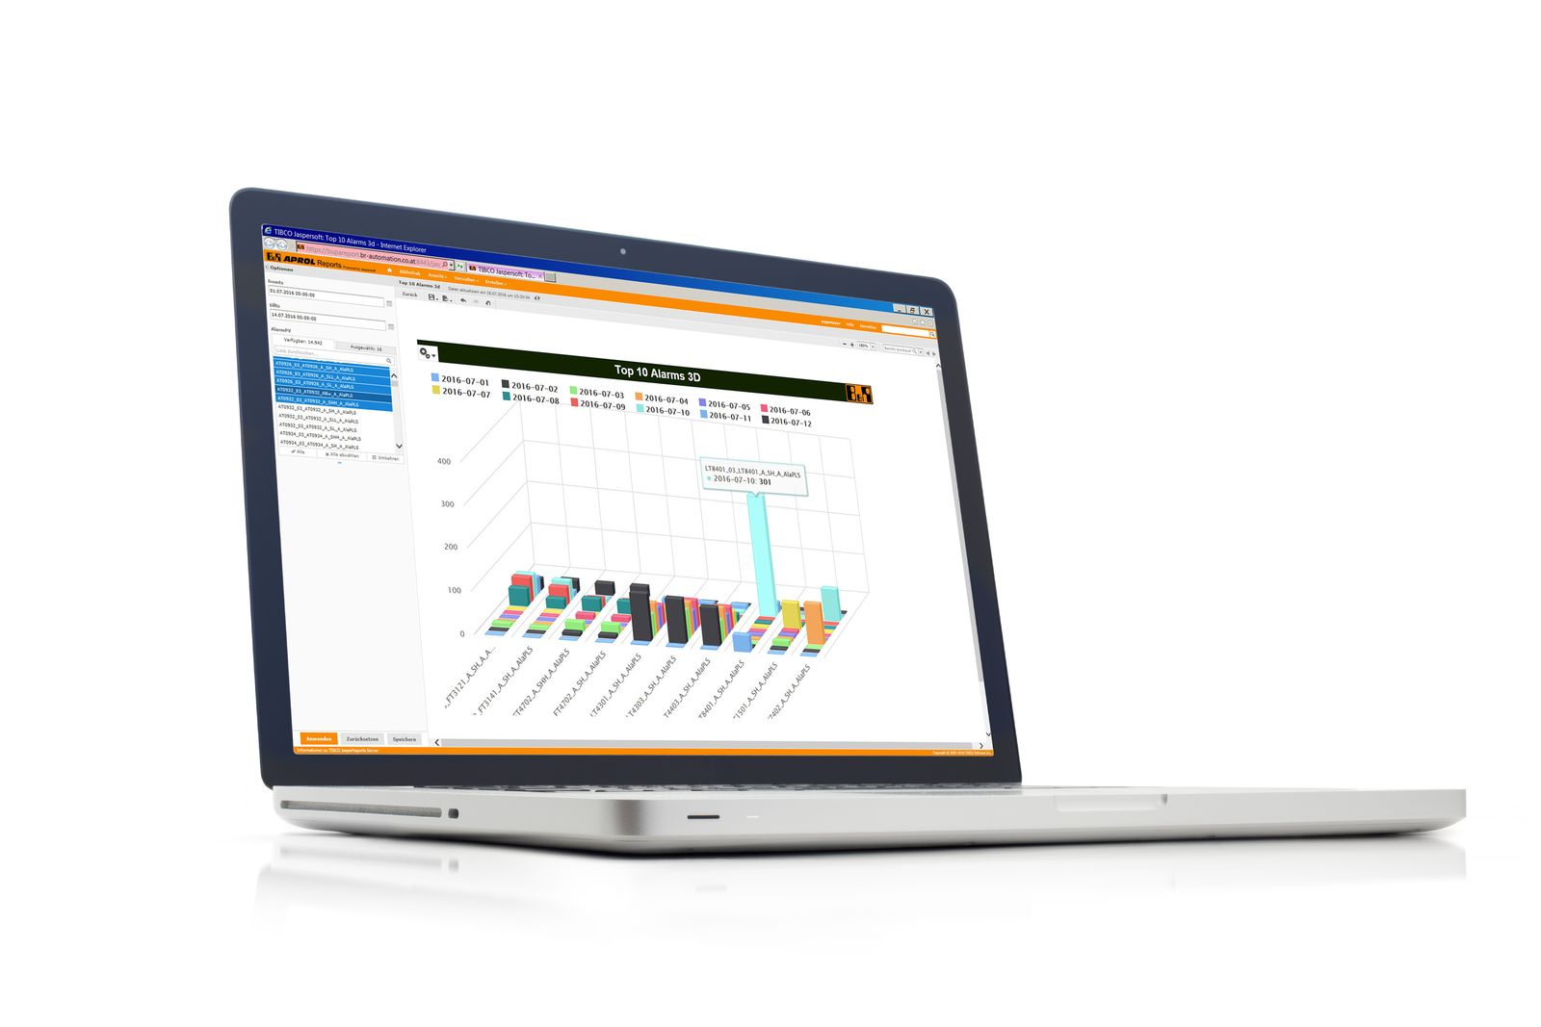
APROL helps users process alarms efficiently and reliably. The alarm statistics report provides an overview of alarms that is clearly organized and intuitive.

About B&R
B&R, a division of ABB Group, is a global leader in industrial automation headquartered in Austria. B&R combines state-of-the-art technology with advanced engineering to provide customers in virtually every industry with complete solutions for machine and factory automation, motion control, HMI and integrated safety technology. With Industrial IoT communication standards including OPC UA, POWERLINK and openSAFETY as well as its Automation Studio software, B&R is constantly redefining the future of automation engineering. The innovative spirit that keeps B&R at the forefront of industrial automation is driven by a commitment to simplifying processes and exceeding customer expectations.
For more information, visit www.br-automation.com.

