Versatile panel technology for easy maintenance
B&R presents the Automation Panel 1000
B&R is expanding its Automation Panel family with a new series of widescreen formats from 7" HD to 24" Full HD. Automation Panel 1000 devices offer easy and flexible mounting options. The slender design is available with a single-touch or multi-touch screen. Adding a PC unit turns an Automation Panel into a full-fledged Panel PC with scalable processing power.
Flexible use with all product series
The core component is the panel itself, which is available in widescreen variants ranging form 7" WVGA to 24" Full HD. Adding a modular SDL/DVI receiver makes it an operator terminal. When using SDL3 digital signal transmission technology, it is even possible to bridge more then 100 meters between terminal and PC. Standard Ethernet cables are used. Panel PCs offer scalable computing power from Intel Atom up to Core i7.
Easy service
The modular platform – consisting of panel, SDL/SDL3 receiver and PC unit delivers a considerable reduction in maintenance costs. In the event of an upgrade, there is no need to replace the entire Panel PC. With a uniform interface, B&R has established a flexible system platform for future PC architectures. Since the display and PC components are separate, it is possible to upgrade the PC technology and keep the display unit.

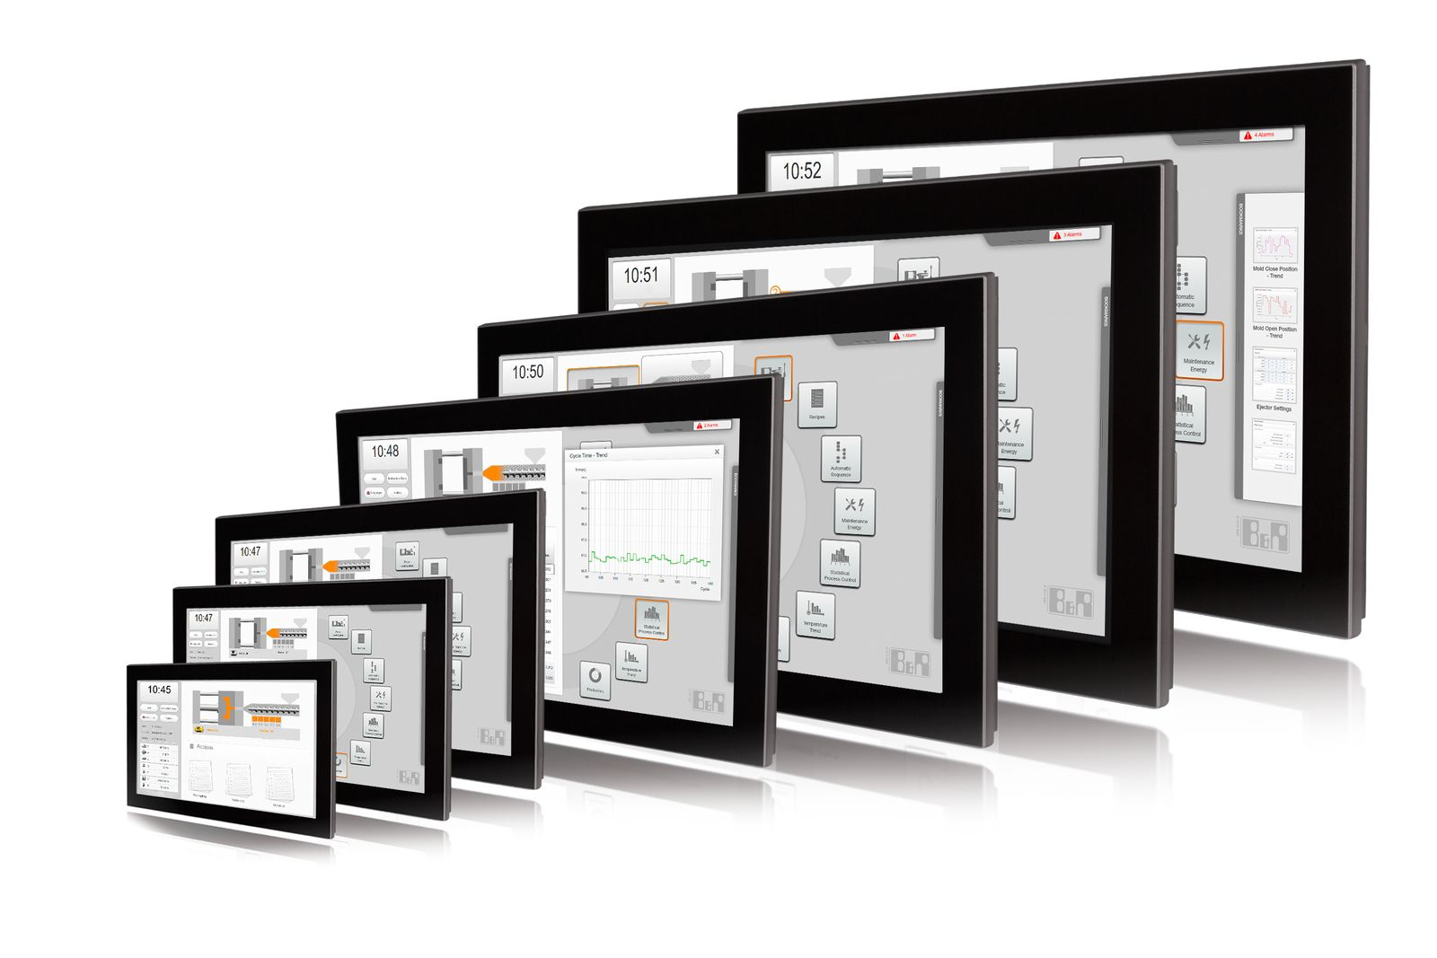
The modular platform of the Automation Panel 1000 results in a unique portfolio with extraordinary flexibility.

About B&R
B&R, a division of ABB Group, is a global leader in industrial automation headquartered in Austria. B&R combines state-of-the-art technology with advanced engineering to provide customers in virtually every industry with complete solutions for machine and factory automation, motion control, HMI and integrated safety technology. With Industrial IoT communication standards including OPC UA, POWERLINK and openSAFETY as well as its Automation Studio software, B&R is constantly redefining the future of automation engineering. The innovative spirit that keeps B&R at the forefront of industrial automation is driven by a commitment to simplifying processes and exceeding customer expectations.
For more information, visit www.br-automation.com.

