Advanced servo technology in the smallest spaces
Compact servo motors allow precise positioning
B&R is expanding its servo motor portfolio with the addition of the 8WS compact motor series. This makes it possible to implement servo applications that require highly precise synchronization and accurate positioning in limited space. Potential applications include gluing and dosing systems; grippers; measurement and testing equipment; filling systems and robot axes.
Protection up to IP69K
These brushless motors are offered in four different diameters ranging from 17 to 40 millimeters. The robust, compact 8WS-series motors are specially designed for harsh industrial environments and are available in all sizes with IP54 or IP66/67 protection. The 40-millimeter variant is available in a hygienic design with IP69K protection for use in food and beverage production.
Full functionality
The motors are designed for 60 VDC and cover a power range from 7 to 205 watts of continuous power. The integrated absolute encoder has a resolution of 4096 positions per revolution. The a double-shielded hybrid motor cable – available in two lengths – is connected directly to the motor and can be used in cable drag chains.
Direct gearbox mounting
All motors in the 8WS series can be shipped with a directly mounted 1- to 3-stage planetary gearbox. The seamlessly welded housing allows for a compact design of the motor-gearbox unit and opens up additional application possibilities.

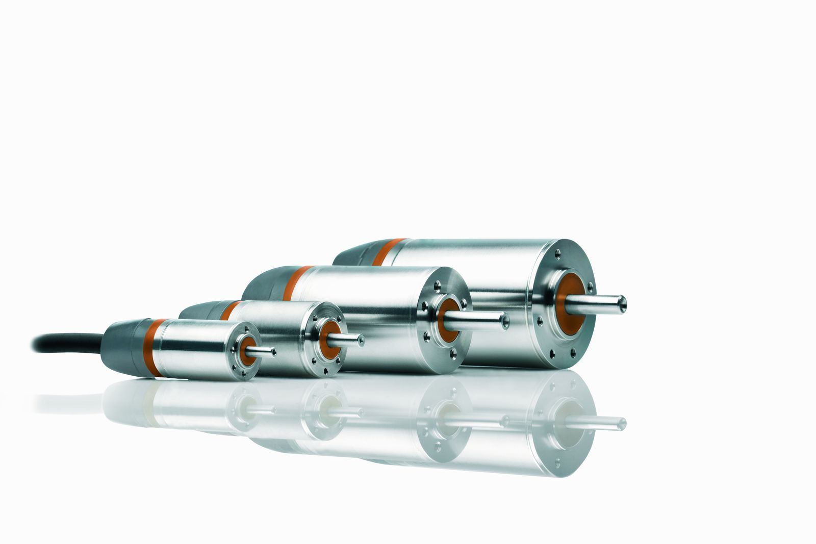
B&R's 8WS-series motors enable servo applications in extremely small spaces.

About B&R
B&R, a division of ABB Group, is a global leader in industrial automation headquartered in Austria. B&R combines state-of-the-art technology with advanced engineering to provide customers in virtually every industry with complete solutions for machine and factory automation, motion control, HMI and integrated safety technology. With Industrial IoT communication standards including OPC UA, POWERLINK and openSAFETY as well as its Automation Studio software, B&R is constantly redefining the future of automation engineering. The innovative spirit that keeps B&R at the forefront of industrial automation is driven by a commitment to simplifying processes and exceeding customer expectations.
For more information, visit www.br-automation.com.

