Compact, versatile, powerful
Automation PC 3100: B&R introduces its new series of industrial PCs
B&R is expanding its industrial PC portfolio with a new series. The Automation PC 3100 and Panel PC 3100 combine the advantages of a compact system with the performance of the latest Core i-series processors. They are available as either a compact box PC (Automation PC 3100) or as a panel PC (Panel PC 3100).
Versatility through modularity
The new industrial PCs offer a variety of modular interface options. Two slots can accommodate cards for serial interfaces, Ethernet, CAN and POWERLINK. The slots can also be used for a UPS solution or an audio interface.
The PCs also offer slots for two CFast-format storage devices with up to 256 GB each. The CFast cards can be operated as a RAID set as backup protection against failure.
Broad performance spectrum
The processors are based on Intel's seventh Core-i generation. They can be scaled over a very wide range, from Celeron to Core i7. All variants are fanless, so the industrial PCs feature no rotating parts. With their high performance and compact dimensions, the 3100-series fits in perfectly between the ultra-compact 2100-series and the high-end 900/910-series. Machinery and equipment builders will now have an even easier time tailoring their industrial PC technology to specific requirements.
Scalable Panel PCs
Whereas the Automation PC 3100 is designed to control remote panels, the Panel PC 3100 can be combined with any cabinet-mounted Automation Panel 10.1" or larger to form a complete panel PC solution. The options range from 4:3 VGA displays to Full HD widescreen panels, either single- or multi-touch.

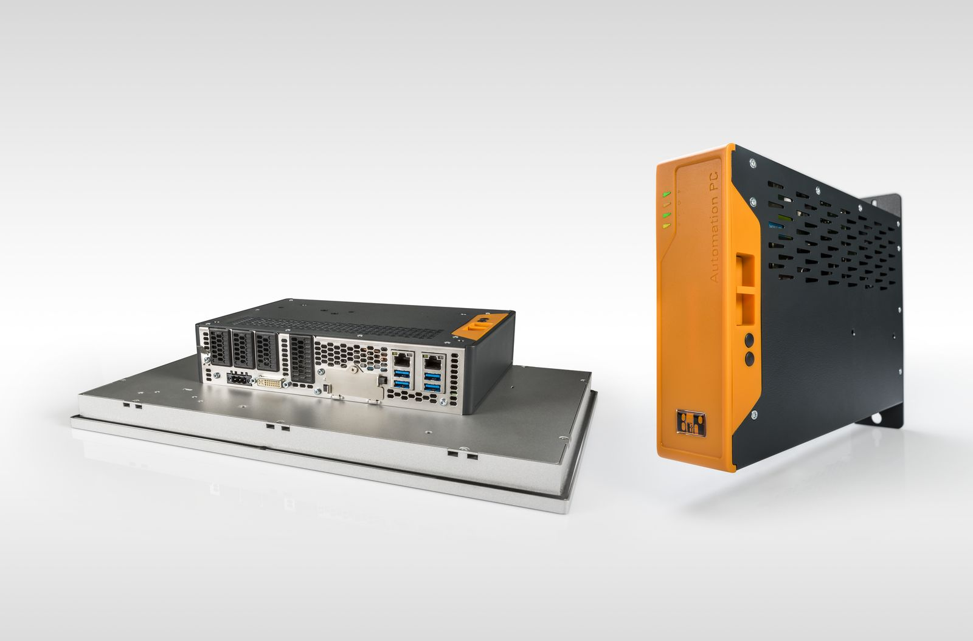
With its new 3100-series of industrial PCs, B&R delivers high performance and a wide variety of interface options in a compact housing.

About B&R
B&R, a division of ABB Group, is a global leader in industrial automation headquartered in Austria. B&R combines state-of-the-art technology with advanced engineering to provide customers in virtually every industry with complete solutions for machine and factory automation, motion control, HMI and integrated safety technology. With Industrial IoT communication standards including OPC UA, POWERLINK and openSAFETY as well as its Automation Studio software, B&R is constantly redefining the future of automation engineering. The innovative spirit that keeps B&R at the forefront of industrial automation is driven by a commitment to simplifying processes and exceeding customer expectations.
For more information, visit www.br-automation.com.

