Smart upgrade for brownfield equipment
B&R presents IoT solutions for brownfield equipment at HMI
The new package of solutions from B&R makes it possible to integrate older, digitally-isolated machines into smart, connected manufacturing solutions. The automation specialist will be introducing Orange Box for the first time at Hannover Messe 2017 at Booth D28 in Hall 9.
Previously unconnected machines and lines can be upgraded for modern smart factory solutions with unprecedented ease. The new package of solutions from B&R makes it possible to read and utilize operating data from older, digitally-isolated machinery and systems in a smart factory. No changes are required to the existing hardware and software.
New industrial PC series
The B&R booth will also showcase its new 3100-series of industrial PCs, which unites the performance of the latest Core i processors with a compact design. The compact Automation PC 3100 and Panel PC 3100 are highly flexible, offering modular interface options and fanless operation.
Another B&R highlight at the Hannover Messe will be its next-generation industrial transport technology, which enables efficient production at any batch size. The independent shuttles transport products individually and can be precisely synchronized with robotics and CNC systems.

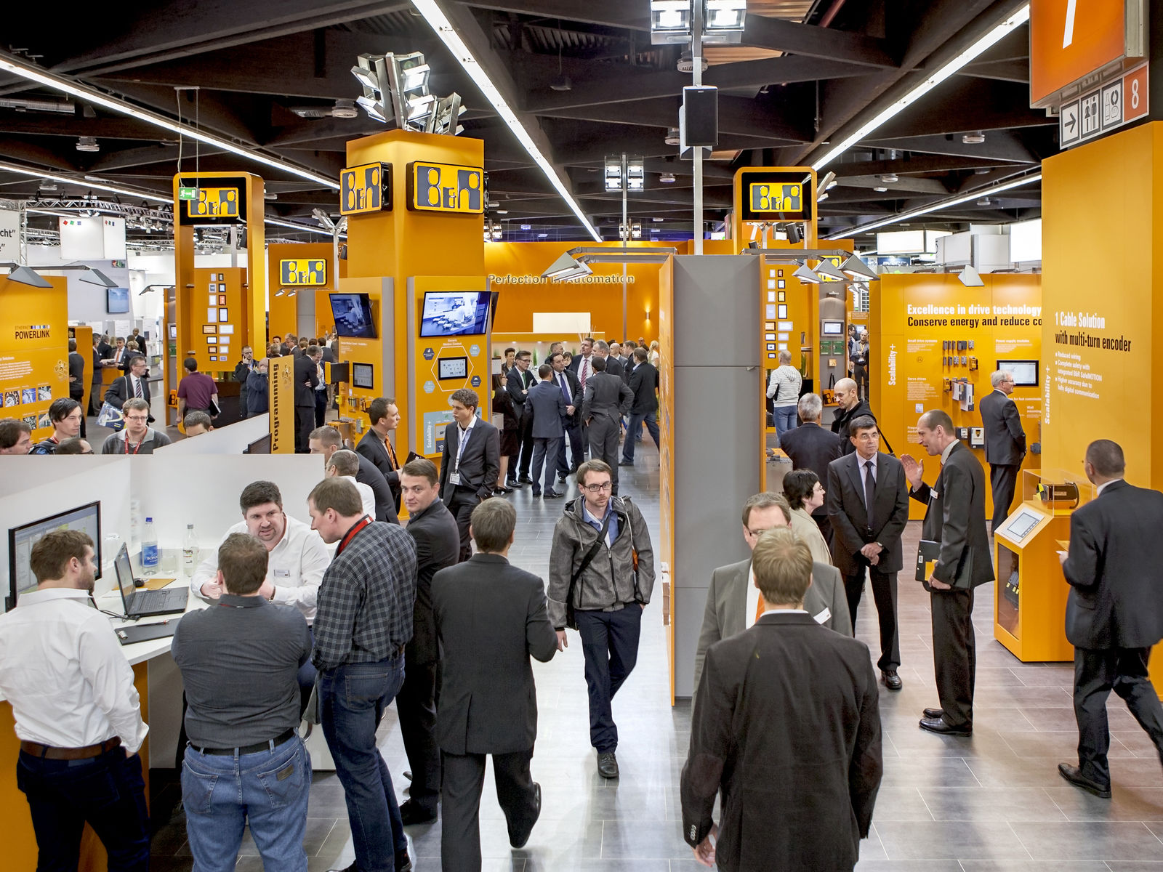
At the HMI trade fair (Hall 9, Booth D28), B&R will be introducing a new package of IoT solutions for existing machinery, which is often digitally isolated.

About B&R
B&R, a division of ABB Group, is a global leader in industrial automation headquartered in Austria. B&R combines state-of-the-art technology with advanced engineering to provide customers in virtually every industry with complete solutions for machine and factory automation, motion control, HMI and integrated safety technology. With Industrial IoT communication standards including OPC UA, POWERLINK and openSAFETY as well as its Automation Studio software, B&R is constantly redefining the future of automation engineering. The innovative spirit that keeps B&R at the forefront of industrial automation is driven by a commitment to simplifying processes and exceeding customer expectations.
For more information, visit www.br-automation.com.

