Operational excellence with SuperTrak
B&R presents intelligent transport technology at interpack
B&R presents SuperTrak at interpack (Booth E62, Hall 6). B&R's a versatile transport system represents a key contribution to Packaging 4.0. This smart manufacturing revolution promises CPG producers unprecedented levels of OEE and reduced TCO.
SuperTrak is a new generation of robust, operator-friendly intelligent transport technology based on long-stator linear motors. Unlike similar systems available thus far, it offers true industrial-grade reliability and easy serviceability. Its independently-controlled shuttles allow mass production of highly customized products, while also minimizing time lost on stoppages and product changeover.
Seamless connectivity
B&R will also be showing how open standards like POWERLINK, OMAC PackML and OPC UA will provide seamless connectivity – the lifeblood of industrial IoT solutions. From the sensor to the cloud, across multi-vendor lines and value chains, this connectivity will bring a dramatic leap in operating efficiency.
More about B&R's contributions to the future of the packaging industry can be found in the Packaging 4.0 white paper and the special edition of its customer magazine. Both publications will be available at Booth E62 in Hall 6 at interpack.

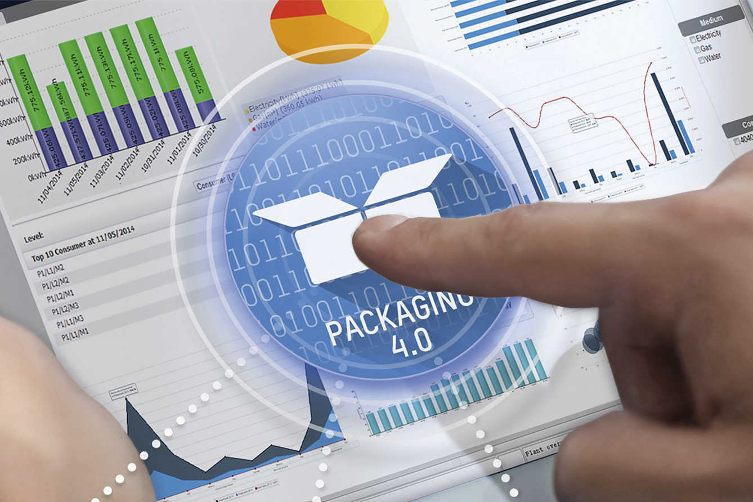
Packaging 4.0 promises CPG producers unprecedented OEE and reduced TCO.

About B&R
B&R, a division of ABB Group, is a global leader in industrial automation headquartered in Austria. B&R combines state-of-the-art technology with advanced engineering to provide customers in virtually every industry with complete solutions for machine and factory automation, motion control, HMI and integrated safety technology. With Industrial IoT communication standards including OPC UA, POWERLINK and openSAFETY as well as its Automation Studio software, B&R is constantly redefining the future of automation engineering. The innovative spirit that keeps B&R at the forefront of industrial automation is driven by a commitment to simplifying processes and exceeding customer expectations.
For more information, visit www.br-automation.com.

