Equipping wood processing machinery for the future
B&R presents advanced X90 control system at LIGNA
At this year's LIGNA, B&R will be presenting its X90 control system for forestry equipment. It offers easy configuration and reliable control for attachments and implements. Individual machines can be networked together and their data evaluated in higher-level systems. Other highlights to be found at Booth D20 in Hall 16 include scalable hardware and software solutions for the woodworking and wood processing industry.
The rugged X90 system offers versatile connectivity options with interfaces such as CAN, Ethernet and the real-time POWERLINK bus integrated as a standard feature. Using expansion boards, the system can be optimally adapted for a wide variety of applications. These are easy to set up for tasks such as the grapple hydraulics on a front-end loader using preconfigured software blocks that not only accelerate development but also ensure that the software is readily reusable for other configurations.
Compact servo drive
For stationary equipment, B&R presents the ACOPOS P3 servo drive. This combined single-/multi-axis system can control up to three axes. They are used in applications such as panel cutting, milling, planing and grinding. The ACOPOS P3 delivers a full range of performance from a very small footprint.
Scalable software saves time
At its booth, B&R will also be presenting modular software concepts with particular benefits for producers. In the case of WPC production, for example, once the extruder software is written, it can be used for any size machine.

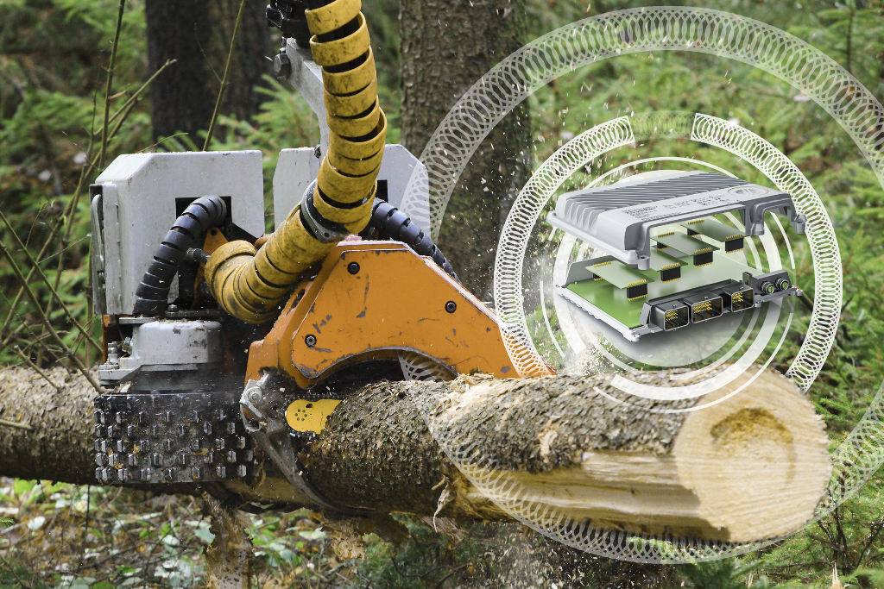
B&R's rugged X90 control system offers easy configuration and reliable control for forestry equipment attachments and implements.

About B&R
B&R, a division of ABB Group, is a global leader in industrial automation headquartered in Austria. B&R combines state-of-the-art technology with advanced engineering to provide customers in virtually every industry with complete solutions for machine and factory automation, motion control, HMI and integrated safety technology. With Industrial IoT communication standards including OPC UA, POWERLINK and openSAFETY as well as its Automation Studio software, B&R is constantly redefining the future of automation engineering. The innovative spirit that keeps B&R at the forefront of industrial automation is driven by a commitment to simplifying processes and exceeding customer expectations.
For more information, visit www.br-automation.com.

