Canadian ambassador visits B&R
The future of automation technology in Canada
Canadian Ambassador to Austria Mark Bailey recently visited industrial automation provider Bernecker + Rainer (B&R) in Eggelsberg. Meeting with Managing Director Hans Wimmer, Bailey learned about the company's latest products and other factors that have contributed to its rapid growth around the world – including in Canada.
Always near the customer
B&R is a key strategic partner for Canadian machine builders in industries ranging from packaging and plastics to special-purpose machinery. "Our highly qualified team of support, development and sales engineers accompany our customers through every step – from conceptual design to software implementation and even intelligent service concepts," says Christian Kastinger, who oversees B&R's sales activities in North America. "With our offices in Toronto and Montreal, we are close to our customers in the hotbeds of Canadian machine building."
B&R's impressive production
Wimmer and Kastinger led the ambassador on a tour of B&R's own smart manufacturing operations. "What I've seen here at B&R has been very impressive. Industry 4.0 and Industrial IoT are the talk of global industry, and here in these ultra-modern facilities you can experience them in action," says Canadian Ambassador to Austria Mark Bailey.

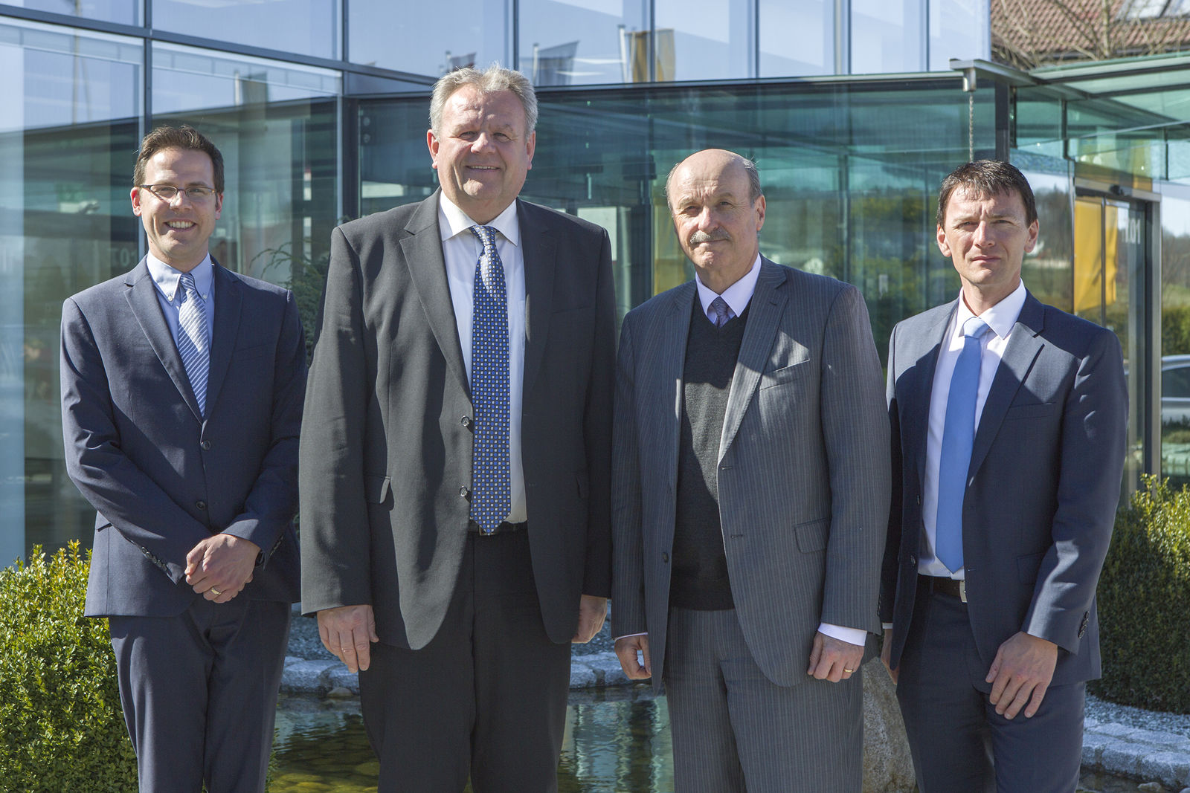
Visibly impressed: Canadian Ambassador Mark Bailey (3rd from left), after touring B&R together with embassy counselor Simon-Pierre Rhéaume (left) guided by Managing Director Hans Wimmer (2nd from left) and Sales Manager Christian Kastinger (right).

About B&R
B&R, a division of ABB Group, is a global leader in industrial automation headquartered in Austria. B&R combines state-of-the-art technology with advanced engineering to provide customers in virtually every industry with complete solutions for machine and factory automation, motion control, HMI and integrated safety technology. With Industrial IoT communication standards including OPC UA, POWERLINK and openSAFETY as well as its Automation Studio software, B&R is constantly redefining the future of automation engineering. The innovative spirit that keeps B&R at the forefront of industrial automation is driven by a commitment to simplifying processes and exceeding customer expectations.
For more information, visit www.br-automation.com.

