ABB acquires B&R
ABB acquires B&R to create a uniquely comprehensive automation portfolio for customers.
By combining B&R with ABB, we will be able to provide you with an unmatched, comprehensive industrial automation offering – globally and across the entire spectrum of technology and software solutions in the areas of measurement, control, actuation, robotics, electrification and digitalization.
For more information, please visit http://www.abb.com/ia4es

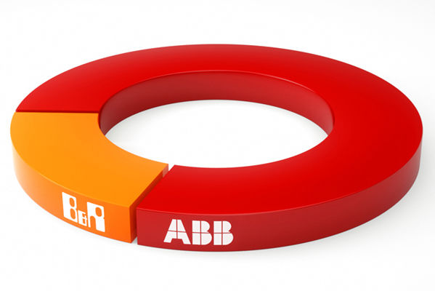
ABB acquires B&R to create a uniquely comprehensive automation portfolio for customers.

About B&R
B&R, a division of ABB Group, is a global leader in industrial automation headquartered in Austria. B&R combines state-of-the-art technology with advanced engineering to provide customers in virtually every industry with complete solutions for machine and factory automation, motion control, HMI and integrated safety technology. With Industrial IoT communication standards including OPC UA, POWERLINK and openSAFETY as well as its Automation Studio software, B&R is constantly redefining the future of automation engineering. The innovative spirit that keeps B&R at the forefront of industrial automation is driven by a commitment to simplifying processes and exceeding customer expectations.
For more information, visit www.br-automation.com.

