B&R makes investment push
Expanded production capacity and R&D infrastructure
B&R is investing in R&D, infrastructure and workforce expansion. At the Hannover Messe trade fair, Managing Director Hans Wimmer and General Manager Peter Gucher announced B&R's plans to up production capacity. The company will also be expanding its R&D offices in Salzburg. "These measures will bring our sales a big step closer to the billion mark."
Wimmer paints the acquisition of B&R by ABB as a unique opportunity for the company's employees and customers as well as its headquarters in Eggelsberg. The transaction is expected to be finalized early this summer. "ABB is a fantastic platform for the next chapter in our long history of growth," said Wimmer. "Together we'll be able to provide our customers with the full spectrum of solutions they need for the Industrial IoT." B&R will form its own business unit within the ABB Group and will continue to operate on the market as a legally independent entity. "That means our management structures and points of contact with our customers will remain unchanged," emphasized Wimmer.
Expansion in three locations
To handle the steadily increasing demand for B&R products, the company is currently boosting circuit board production capacity at its headquarters in Eggelsberg by 20 percent. A few kilometers away, the company's Gilgenberg site will be expanded to accommodate production lines for its mechatronic solutions. Further expansion and modernization is planned for B&R's R&D offices in Salzburg, making room for 50 new highly skilled positions in the development of industrial communication, robotics and control technology.
"B&R's impressive track record of growth has been fueled by our innovative products," said Gucher. One such innovation presented at this year's Hannover Messe was the Orange Box. B&R's Orange Box solutions make it easy for plant operators to retrofit brownfield equipment with smart manufacturing connectivity by collecting data from existing machines and lines and passing it on to higher-level systems or the cloud. "The Orange Box is extremely easy to install," said Gucher, "and software updates are as straightforward as with a smartphone. With the Orange Box, we can quickly get existing equipment up to speed for the Industrial Internet of Things."

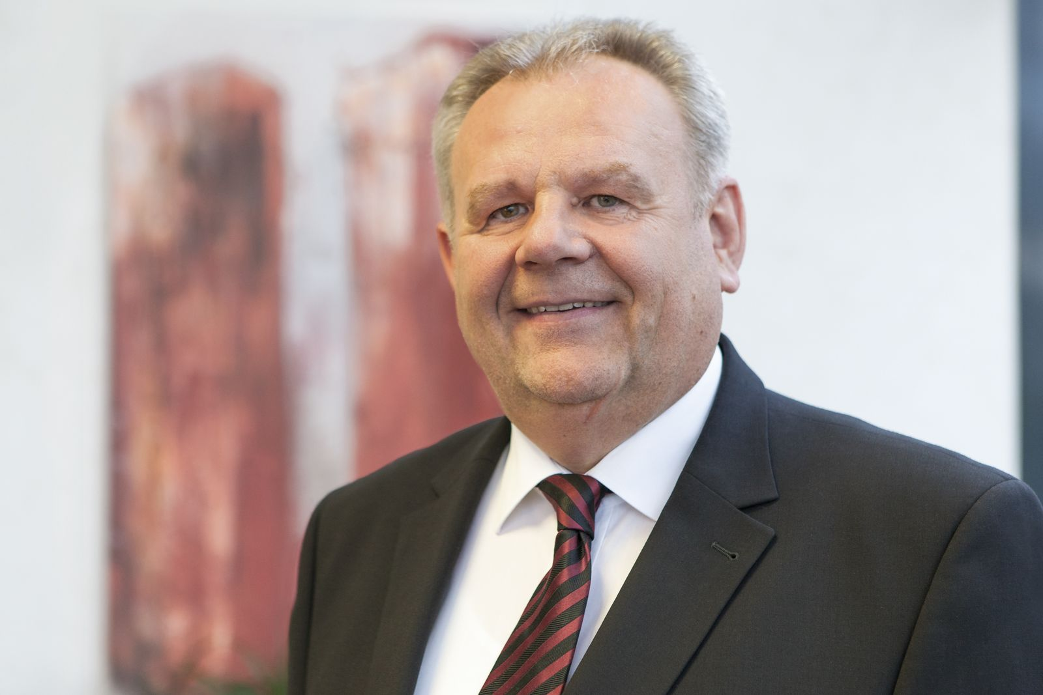
At the Hannover Messe trade fair, Managing Director Hans Wimmer announced B&R's plans to expand production capacity and R&D infrastructure.

About B&R
B&R, a division of ABB Group, is a global leader in industrial automation headquartered in Austria. B&R combines state-of-the-art technology with advanced engineering to provide customers in virtually every industry with complete solutions for machine and factory automation, motion control, HMI and integrated safety technology. With Industrial IoT communication standards including OPC UA, POWERLINK and openSAFETY as well as its Automation Studio software, B&R is constantly redefining the future of automation engineering. The innovative spirit that keeps B&R at the forefront of industrial automation is driven by a commitment to simplifying processes and exceeding customer expectations.
For more information, visit www.br-automation.com.

