Boost productivity with anti-sloshing
Transport liquids faster without spills
With B&R's industrial transport system, it is now possible to transport liquids quickly with no spills. SuperTrak is the only system on the market to offer anti-sloshing technology. This technology suppresses the formation of oscillations on free surfaces to prevent liquids from spilling over container edges during transport.
No spills from open containers
The term slosh is used to describe the behavior of liquids in moving containers. Specially designed movement profiles prevent the development of positive feedback loops on the surface of the liquid so that it remains calm during transport. This minimizes downtime and increases productivity when handling open containers.
Higher production speeds
Minimizing oscillations on the surface of liquids is particularly important in the packaging industry. The better you are able to control sloshing, the faster the products can be transported. B&R's sophisticated anti-sloshing technology also prevents the formation of air bubbles and foam. The downtime otherwise required to allow the liquid to settle is reduced drastically or eliminated entirely for a substantial improvement in packaging line productivity.

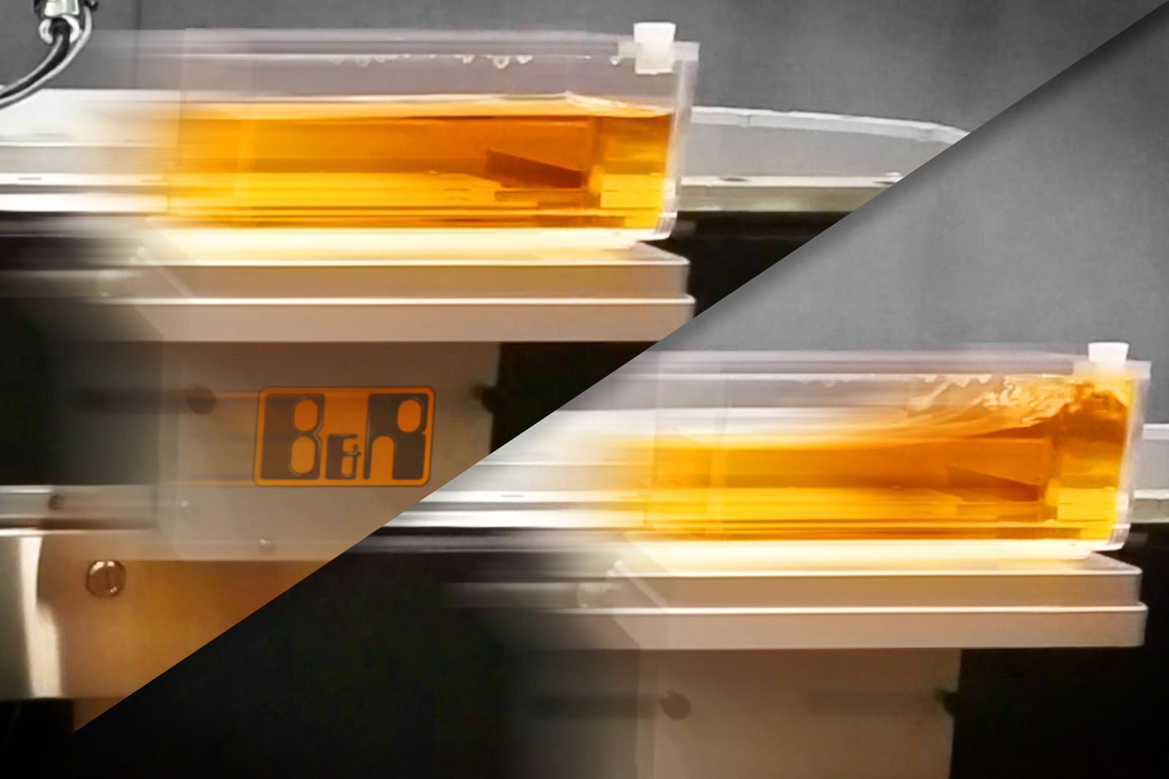
As the only system on the market, SuperTrak offers anti-sloshing technology that suppresses the formation of surface oscillations to prevent liquids from spilling during transport.

About B&R
B&R, a division of ABB Group, is a global leader in industrial automation headquartered in Austria. B&R combines state-of-the-art technology with advanced engineering to provide customers in virtually every industry with complete solutions for machine and factory automation, motion control, HMI and integrated safety technology. With Industrial IoT communication standards including OPC UA, POWERLINK and openSAFETY as well as its Automation Studio software, B&R is constantly redefining the future of automation engineering. The innovative spirit that keeps B&R at the forefront of industrial automation is driven by a commitment to simplifying processes and exceeding customer expectations.
For more information, visit www.br-automation.com.

