Fra simulation til drift med blot et klik med musen
Optimized engineering with 3D SuperTrak simulation
A new visualization tool from B&R accelerates development of automation solutions featuring its SuperTrak industrial transport system. The tool displays a 3D simulation of all SuperTrak shuttle movements, as well as synchronized subsystems such as robotics and CNC. Machine builders and operators can accelerate the commissioning process by validating their designs and sequential programming in advance.
3D simulation with machine code
The visualization tool and extensive simulation options are fully integrated in B&R's Automation Studio software development environment. All simulations are based on real machine code and no additional simulation software or interfaces are required.
In simulation mode, a 3D visualization in the development environment allows processes to be fine-tuned prior to commissioning. With a few clicks of the mouse, the optimized machine code is then transferred to the target hardware.
At runtime, the visualization tool processes sensor signals to display machine movements on the HMI screen in real time. 3D visualization is the perfect way to monitor your manufacturing processes.

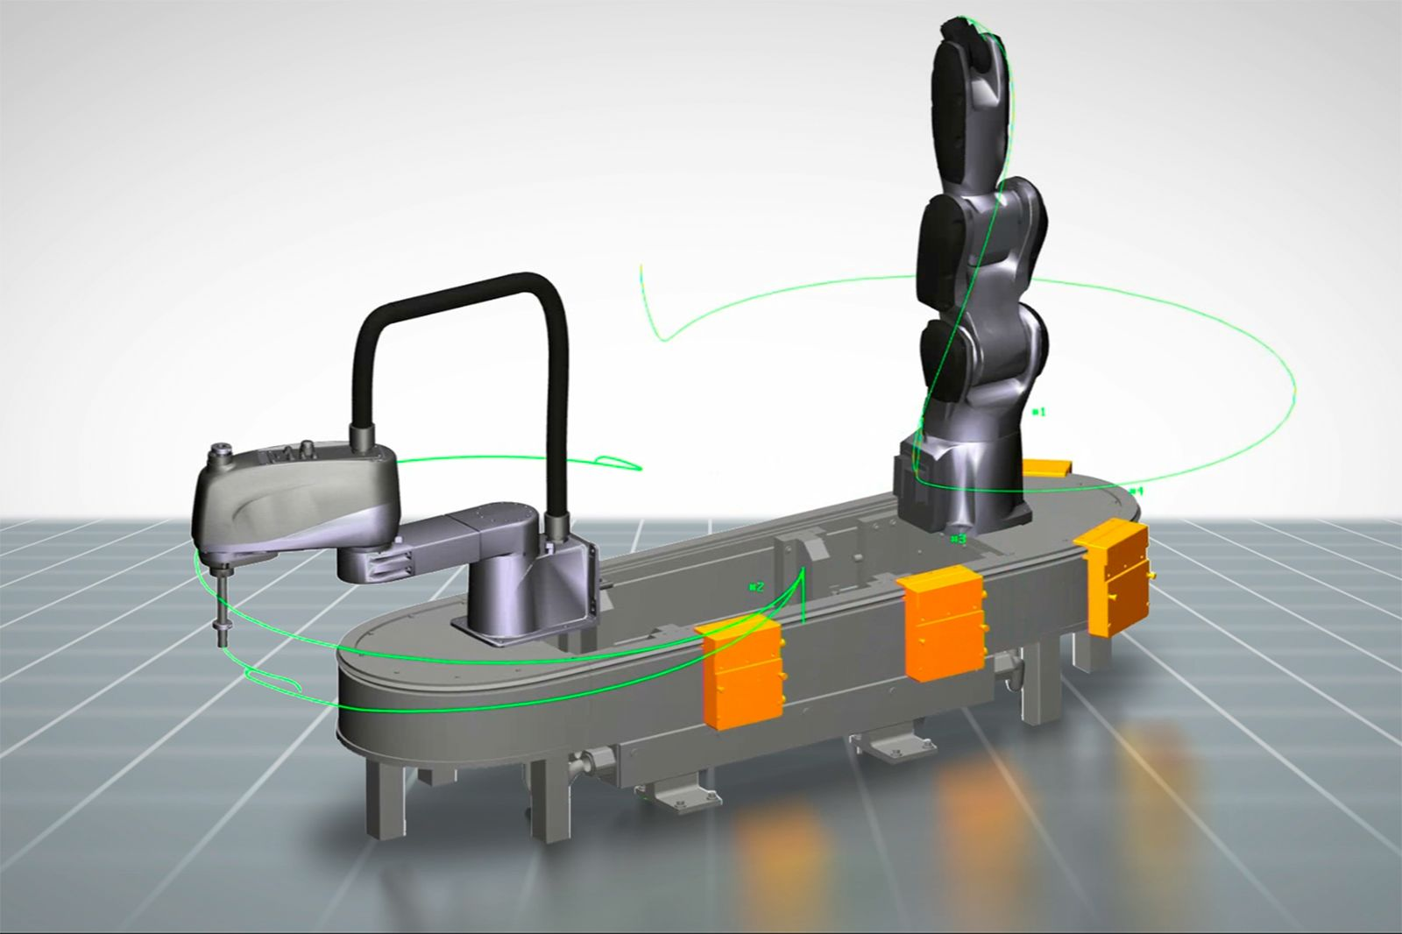
3D simulation shows the behavior of all shuttles in combination with synchronized subsystems like robotics and CNC.

Om B&R Industrial Automation i Danmark
B&R i Danmark er et datterselskab af B&R Industrial Automation, som er en innovativ automationsvirksomhed med hovedkontor i Østrig og kontorer i hele verden. Den 6. juli 2017 blev B&R en selvstændig forretningsenhed i ABB Group. Som global markedsleder i industriel automatisering kombinerer B&R den nyeste teknologi med avanceret ingeniørarbejde for at forsyne kunder i stort set alle brancher med de mest optimale løsninger inden for automation og proceskontrol. Firmaets styrings- og drevløsninger samt industri PC’er og visualiseringssystemer sætter nye standarder inden for industriel automation. Med Industrial IoT kommunikationsstandarder som OPC UA, POWERLINK og openSAFETY såvel som den effektive software platform Automation Studio, skubber B&R konstant grænserne for hvad der er muligt inden for automatisering. Den nyskabende ånd og en klar forpligtelse af skabe simple processer sikrer B&R til at være på forkant med industriel automatisering og overstige kundernes forventninger.
Ved genoptryk af denne pressemeddelelse, venligst send en kopi til:
B&R Industrial Automation A/S
Marketingafdeling
Rolundvej 17-19
5260 Odense S
office.dk@br-automation.com

