Advanced rotational control
New software package suppresses rotational sway.
B&R has introduced a new function for crane control. Cranes that transport payloads suspended from sling systems can be particularly sensitive to rotation about the vertical axis. If left unchecked, this can lead to uncontrollable sustained oscillations. The new mapp Crane solution successfully damps this effect.
Fast and safe payload delivery
It is also possible to execute a controlled rotation, which can be helpful in cases where a payload needs to be positioned at a specific angle. With simultaneous control of both skew and sway, payloads can be brought to their destination with maximum speed and precision.
Automatic path correction
mapp Crane also offers automatic path correction, which adjusts for changes to the end position while the crane is in motion. This is an especially challenging task with regard to path planning, because the recalculations must account for the system's oscillation dynamics in addition to its axis boundaries. With mapp Crane, this function can now be implemented with very little programming.

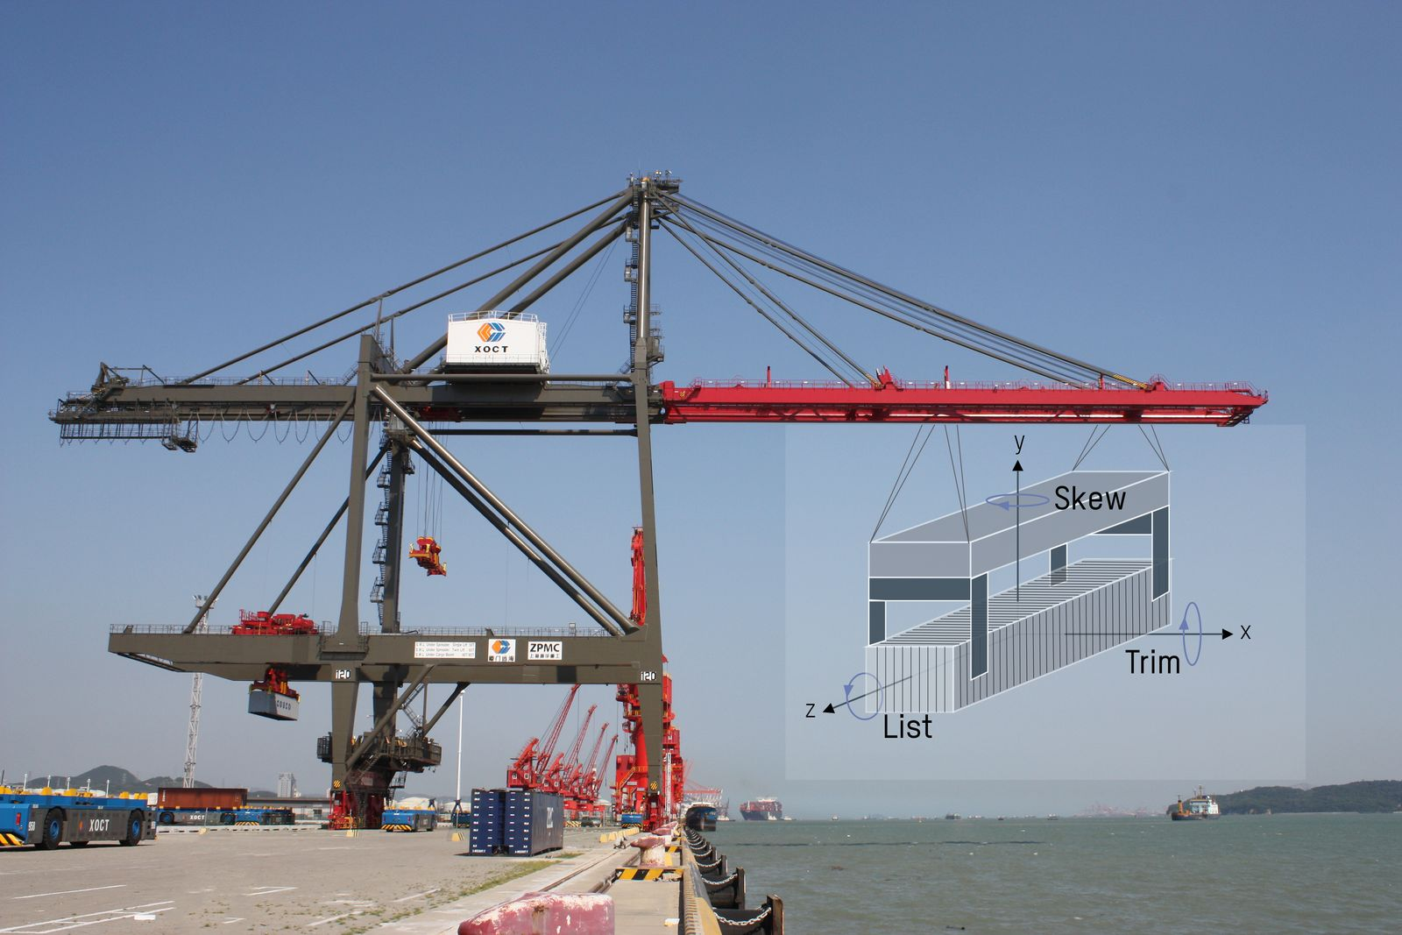
mapp Crane actively controls rotation about the vertical axis to prevent unwanted rotational sway.

About B&R
B&R, a division of ABB Group, is a global leader in industrial automation headquartered in Austria. B&R combines state-of-the-art technology with advanced engineering to provide customers in virtually every industry with complete solutions for machine and factory automation, motion control, HMI and integrated safety technology. With Industrial IoT communication standards including OPC UA, POWERLINK and openSAFETY as well as its Automation Studio software, B&R is constantly redefining the future of automation engineering. The innovative spirit that keeps B&R at the forefront of industrial automation is driven by a commitment to simplifying processes and exceeding customer expectations.
For more information, visit www.br-automation.com.

