Performance boost for the Automation PC 910
B&R industrial PC now available with Intel XEON processor
B&R's Automation PC 910 is now optionally available with an Intel Xeon processor. The new microarchitecture provides a 50% increase in performance compared to the previous high-performance Core i processors. This level of performance allows effective handling of all applications that require fast analysis of large amounts of data, such as machine vision, data preparation for cloud applications and data mining for collection and analysis of quality data.
Maximum performance for complex tasks
The whole range of processors available for the Automation PC 910 provides maximum computing power for the most complex tasks. The new quad-core Xeon processor now gives the Automation PC 910 a CPU option that was previously reserved for large servers.
The Automation PC 910 series continues to offer all the advantages of its fully modular and scalable design. The three available housing variants feature between one and five expansion slots, which can hold a wide variety of interface cards and data storage devices. The standard operating systems Windows 10 IoT Enterprise and Linux are available for the new processor.

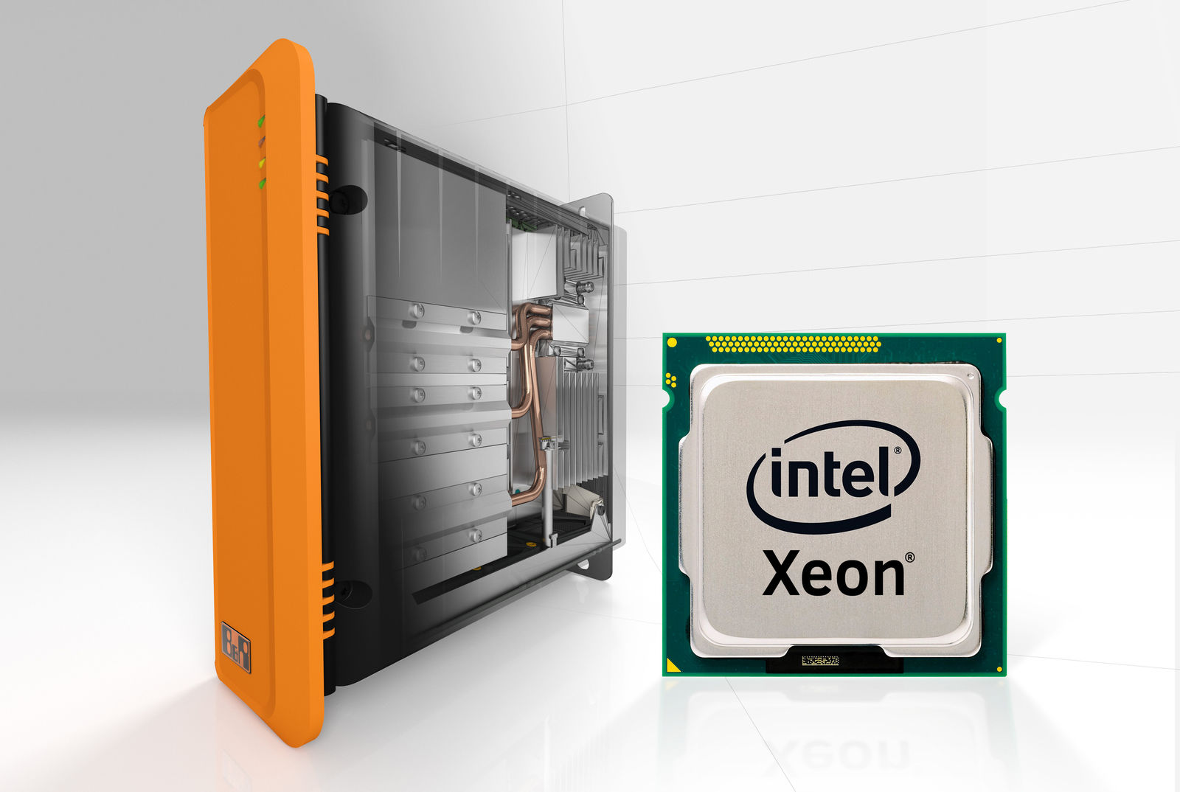
B&R's Automation PC 910 is now optionally available with an Intel Xeon processor. The high performance is ideal for demanding applications such as machine vision.

About B&R
B&R, a division of ABB Group, is a global leader in industrial automation headquartered in Austria. B&R combines state-of-the-art technology with advanced engineering to provide customers in virtually every industry with complete solutions for machine and factory automation, motion control, HMI and integrated safety technology. With Industrial IoT communication standards including OPC UA, POWERLINK and openSAFETY as well as its Automation Studio software, B&R is constantly redefining the future of automation engineering. The innovative spirit that keeps B&R at the forefront of industrial automation is driven by a commitment to simplifying processes and exceeding customer expectations.
For more information, visit www.br-automation.com.

