EU competition authorities give the green light
Find out more about B&R and our pursuit of "Perfection in Automation":
It's official: B&R now ABB's center for machine and factory automation
B&R is now ABB's global center for machine and factory automation. Following approval by EU competition authorities, the acquisition of B&R by ABB became legally effective on July 6, 2017. B&R will operate as an independent business unit within the ABB Group's Industrial Automation division. Division President Peter Terwiesch and B&R Managing Director Hans Wimmer announced an array of investments that will strengthen R&D activities and expand production capacity.
Unwavering customer focus
"Building close relationships with our customers is and remains essential to who we are as a company," affirms Wimmer on announcing finalization of the acquisition process. "We will continue to work hand-in-hand with our customers to develop the most innovative solutions, and they will see no changes in their day-to-day points of contact."
B&R's primary focus will stay centered on the OEM market, accompanied by expansions to its factory automation portfolio. With B&R building on ABB's global presence and complementary offerings, customers will see substantial benefits from the merger. B&R will also be intensifying its activities in the Industrial IoT arena and expanding on ABB's industry-leading portfolio of digital solutions.
Capacity boost for both R&D and production
"ABB and B&R are united in their innovation and customer focus," adds Terwiesch. "These will be central factors as we evolve together going forward." Ensuring its ability to handle the steadily increasing demand for B&R's advanced solutions, ABB is investing in a new R&D center at B&R headquarters in Eggelsberg as well as expanded production capacity a few kilometers away in Gilgenberg. Additionally, the technical office in Salzburg is being expanded to make room for 50 new developers in the areas of control, motion control and Industrial IoT communication.

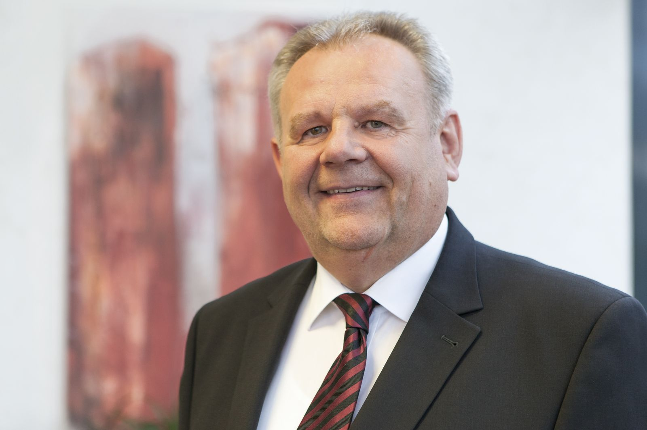
"We will be investing heavily in expanding our R&D infrastructure and adding production capacity," says B&R Managing Director Hans Wimmer.

About B&R
B&R, a division of ABB Group, is a global leader in industrial automation headquartered in Austria. B&R combines state-of-the-art technology with advanced engineering to provide customers in virtually every industry with complete solutions for machine and factory automation, motion control, HMI and integrated safety technology. With Industrial IoT communication standards including OPC UA, POWERLINK and openSAFETY as well as its Automation Studio software, B&R is constantly redefining the future of automation engineering. The innovative spirit that keeps B&R at the forefront of industrial automation is driven by a commitment to simplifying processes and exceeding customer expectations.
For more information, visit www.br-automation.com.

