Ready to use on systems from any vendor
2017 EMO: Operator panels for machine tools independent of the CNC controller
From September 18-23 at the EMO Hannover exhibition, B&R will be presenting operator panels designed for industrial use in hall 25, booth E68. The operator panels communicate with CNC systems from various vendors via OPC UA. Machine manufacturers are given the freedom to use the CNC system of their choice. In addition to standard Automation Panel series devices, there are many customization options available that also allow complex machine tools to be efficiently configured and operated.
With B&R's mapp View HMI solution, you can give your machine tool a state-of-the-art web-based user interface even without special web design training.
Program motion control the easy way
With mapp Motion, B&R provides a completely new approach to motion control programming. This solution includes components for controlling single-axis movements as well as CNC and robotics applications. As part of the mapp software framework, the new motion components can be combined as needed and easily configured. Users benefit from fast and easy project development.
Make maintenance predictable
B&R will also be presenting an X20 series I/O module for advanced condition monitoring. The module provides vibration data processing and status analysis during an active process. This allows maintenance tasks to be predicted and thus planned, which improves machine availability.

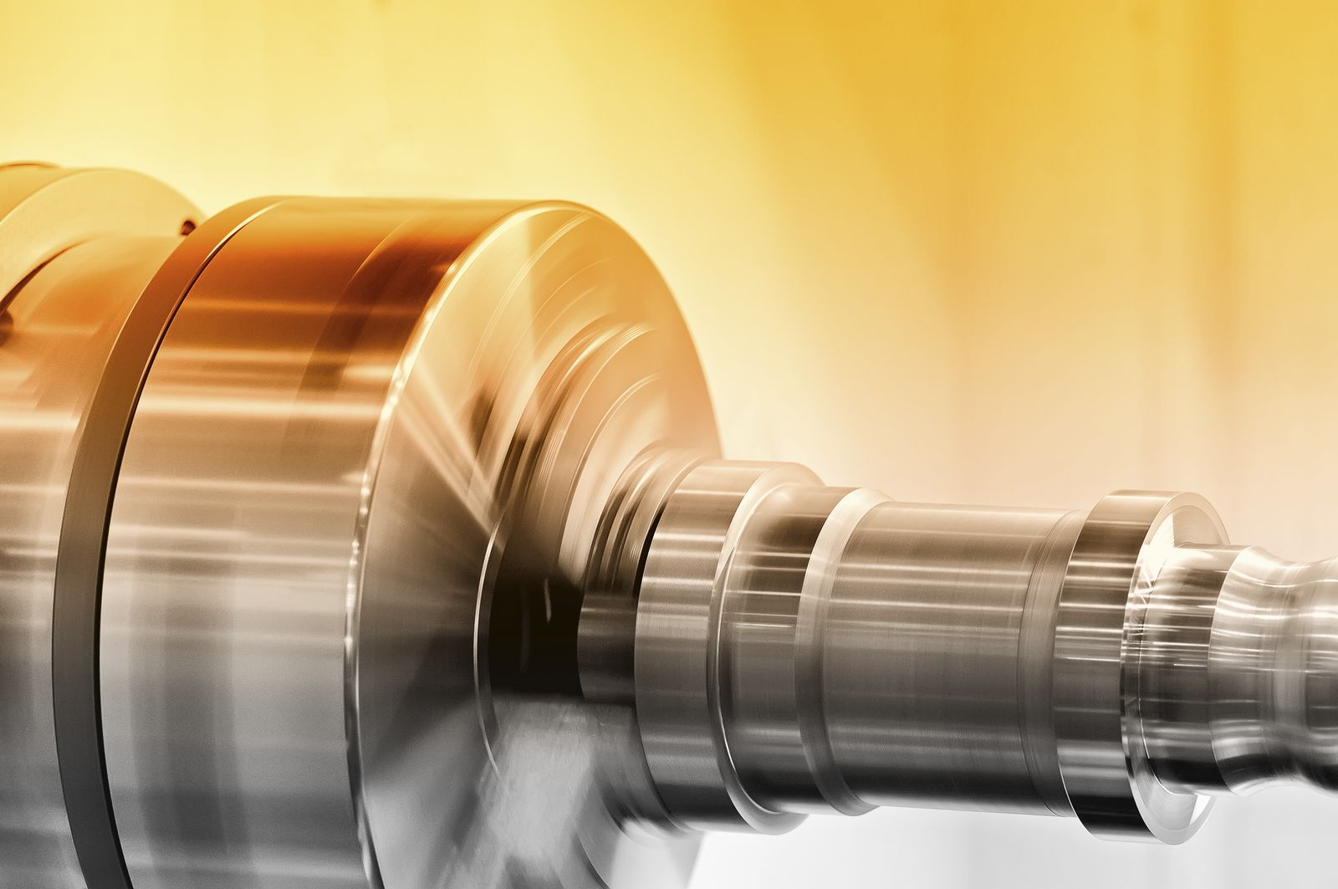
At the EMO, B&R will show how advanced condition monitoring has been made possible using an I/O module.

About B&R
B&R, a division of ABB Group, is a global leader in industrial automation headquartered in Austria. B&R combines state-of-the-art technology with advanced engineering to provide customers in virtually every industry with complete solutions for machine and factory automation, motion control, HMI and integrated safety technology. With Industrial IoT communication standards including OPC UA, POWERLINK and openSAFETY as well as its Automation Studio software, B&R is constantly redefining the future of automation engineering. The innovative spirit that keeps B&R at the forefront of industrial automation is driven by a commitment to simplifying processes and exceeding customer expectations.
For more information, visit www.br-automation.com.

