Fast, flexible filling with SuperTrak
B&R presents high-speed, no-spill transport technology at drinktec
B&R offers beverage and liquid food producers a new generation of high-speed, slosh-free transport with exceptional versatility for fast format changeovers. At this year's drinktec exhibition from September 11-15, visitors to Booth 328 in Hall A3 can learn from B&R's industry experts how to make the most of the smart manufacturing revolution.
All the speed without the spills
Industrial-grade, service-friendly SuperTrak is the only long-stator linear motor based system on the market to feature anti-sloshing technology. This prevents spills during transport and positioning and allows filling lines to be operated at higher speeds. Independent SuperTrak shuttles allow mass customization with minimal time lost on stoppages and changeover.
Web-based HMI made easy
Another highlight will be mapp View, which allows developers to create powerful web-based user interfaces right from the engineering environment without any knowledge of the underlying web technology. Authorized users gain intuitive access to advanced control and diagnostics – whether on an IP69K multi-touch panel, smartphone or tablet.
Industrial IoT ready
Whether visitors are starting a greenfield project or considering a brownfield upgrade, they will find a smart manufacturing solution that perfectly fits their needs at the B&R booth. With dedicated technology and global communication standards like OPC UA, B&R is the right partner for implementing Industrial IoT solutions in both new and legacy equipment.

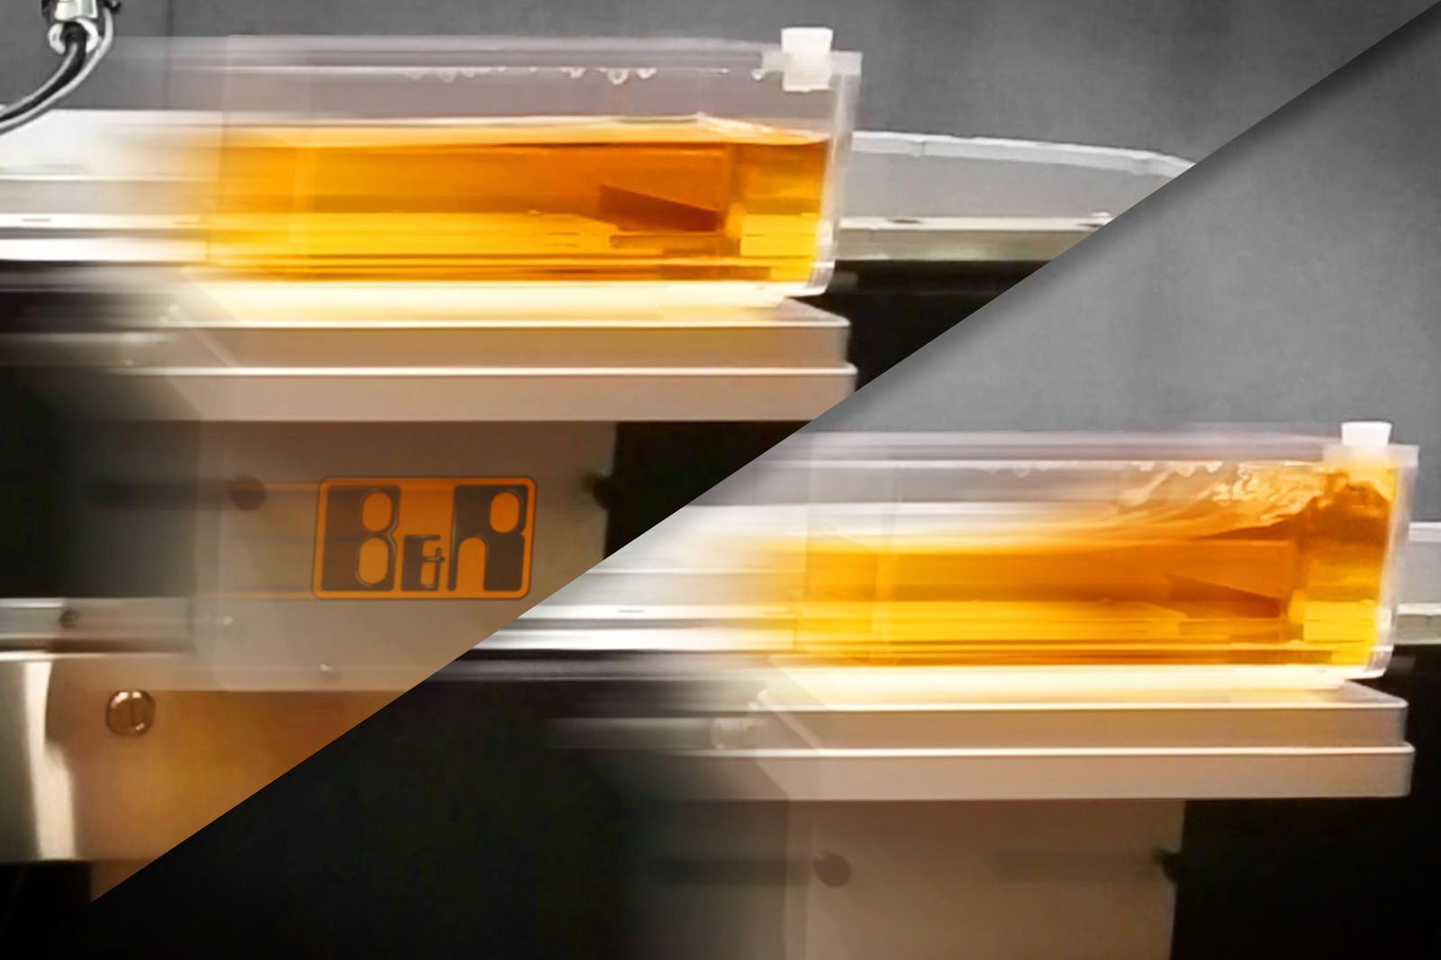
At drinktec 2017 (Booth 328, Hall A3) B&R will showcase its industrial-grade, service-friendly SuperTrak transport system, featuring anti-sloshing control to prevent spills during high-speed transport and positioning.
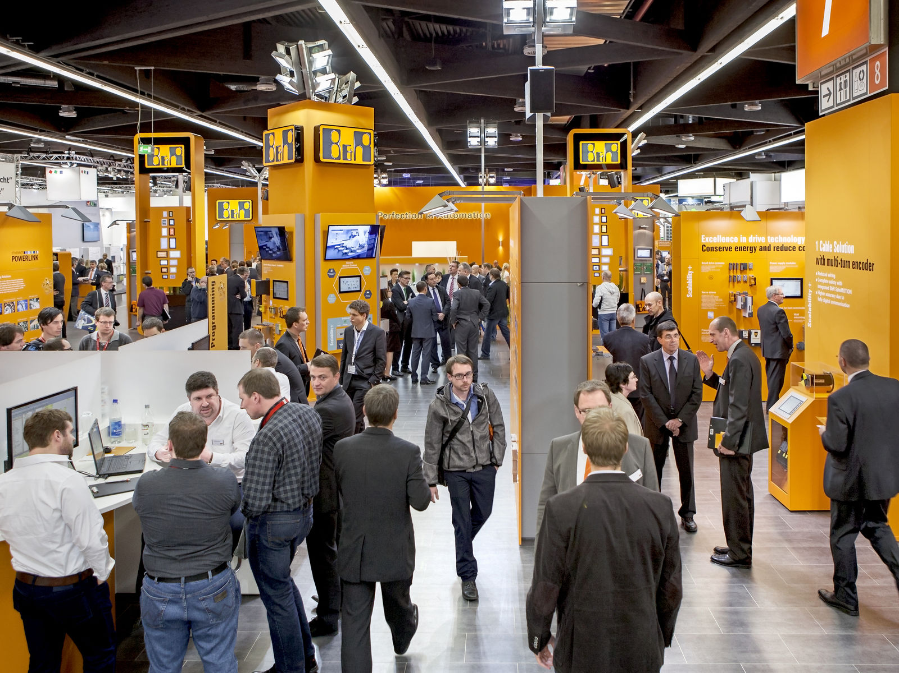
At drinktec 2017 (Booth 328, Hall A3) B&R will showcase its industrial-grade, service-friendly SuperTrak transport system, featuring anti-sloshing control to prevent spills during high-speed transport and positioning.

About B&R
B&R, a division of ABB Group, is a global leader in industrial automation headquartered in Austria. B&R combines state-of-the-art technology with advanced engineering to provide customers in virtually every industry with complete solutions for machine and factory automation, motion control, HMI and integrated safety technology. With Industrial IoT communication standards including OPC UA, POWERLINK and openSAFETY as well as its Automation Studio software, B&R is constantly redefining the future of automation engineering. The innovative spirit that keeps B&R at the forefront of industrial automation is driven by a commitment to simplifying processes and exceeding customer expectations.
For more information, visit www.br-automation.com.

