B&R features automation advances to maximize packaging productivity at PACK EXPO 2017
Highlights include HTML5 based HMI, Industrial Internet of Things connectivity, flexibility, open robotics integration with SuperTrak™ industrial transport, Augmented Reality and networked safety
At this year’s PACK EXPO International show, September 25- 27, Las Vegas Convention Center; Las Vegas, NV, B&R Industrial Automation Corp. will exhibit automation technologies that are trending in packaging machinery design at booth S-6163. B&R specializes in standards-based, scalable and modular control systems integrating logic, motion, open and mapp robotics, human-machine interface (HMI), networked safety, I/O and data acquisition in a unified software development environment.
Highlights of featured B&R technologies include:
Increased product and package transport, efficiency, value-added processing and machine-to-machine integration through synchronization of SuperTrak™ linear industrial transport technology with open robotics. Some industry leading features of the SuperTrak include new anti-slosh control for liquid transport, batch-of-one manufacturing and packaging, rapid changeover and greatly reduced footprint.
Industrial IoT for Brownfields: B&R’s Orange Box enables machine data collection and analysis from previously isolated machines and lines.
Increased machine availability: B&R continues to expand its mapp Technology software framework. With the new mapp Tweet function, a machine application can now send information via text message or email.
Full safety functionality following network failure: B&R has set yet another benchmark in integrated safety technology with its new blackout mode. This feature allows safety applications to continue to run after a failure of the network or main controller.
Support CPG makers’ corporate Internet of Things strategies through standards such as PackML, OPC UA and best practices being identified by the Industrial Internet Consortium (IIC). B&R co-chairs the IIC’s new Smart Factory Task Group.

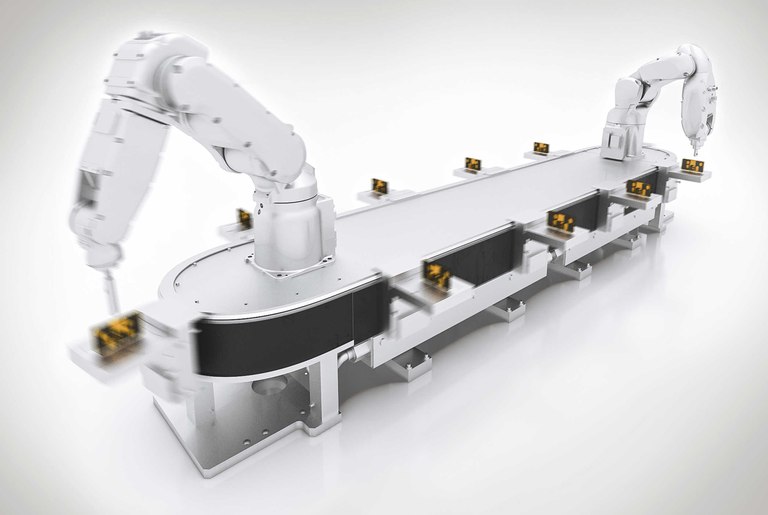
At Pack Expo 2017, SuperTrak™ will be featured at the B&R booth, S-6163; which aims to increase product and package transport, efficiency, value-added processing and machine-to-machine integration through synchronization

About B&R
B&R, a division of ABB Group, is a global leader in industrial automation headquartered in Austria. B&R combines state-of-the-art technology with advanced engineering to provide customers in virtually every industry with complete solutions for machine and factory automation, motion control, HMI and integrated safety technology. With Industrial IoT communication standards including OPC UA, POWERLINK and openSAFETY as well as its Automation Studio software, B&R is constantly redefining the future of automation engineering. The innovative spirit that keeps B&R at the forefront of industrial automation is driven by a commitment to simplifying processes and exceeding customer expectations.
For more information, visit www.br-automation.com.

